7:00 pm Call to order, adopt agenda and approve previous meeting’s minutes.
7:05 Community Comments (2 minutes each)
7:12 Community Presentation: Ken Walsh – Capitol Hill Rotary Club

7:15 Officer Reports:
Chair (2 minutes)
  - Commission goals for the two-year term
Vice-Chair (2 minutes)
Secretary (2 minutes)
Treasurer (2 minutes)
- Approve treasurer’s report and previous month’s disbursements.
- Approve monthly photocopying expenses.
- Approve 1st Quarter FY07 report, starts on pg. 16
- Approve revised 4th Quarter FY06 report

7:25 Single Member District reports (2 minutes each)

7:35 Standing Committee Reports:
Alcohol Beverage Licensing (5 minutes) – starts on page 22
- Overview of H Street Moratorium hearing before ABRA on Jan 17, 2007
- Recommendation: The Commission enter into a standard voluntary agreement with Mr. Joe Englert for H Street Country Club (1335 H Street).
- Next meeting: February 20, 2007. (third Tuesday)
- Accept Committee Report
Economic Development and Zoning (7 minutes) – starts on page 25
- Approve Nomination:
          - Ms. Heather Scott
- Recommendation: Adopt goals for the ED&Z Committee presented
- Recommendation: ANC write a letter to the Mayor and all City Council members opposing Mr. Griffis' nomination to the Zoning Commission.
- Recommendation: Send letter to surveyor's office requesting a time extension for comments on the proposed alley closing located at 1300 block of H Street NE, if extension is denied, send letter opposing alley closing.
- Recommendation: Send a letter in support for adopting the text amendment for Zoning Commission Case 06-47 in order to forbid the subdivision of buildings on lots with less than 900 sq. feet per proposed unit.
- Recommendation: Seek Party Status for the PUD deliberations for Capitol Place on Square 752 (200 block of H Street NE) and appoint Mr. Jeff Fletcher as the ANC 6A's designated representative.
- Next meeting: 7:00 p.m., February 22, 2007 (last Thursday).
- Accept Committee Report
Community Outreach (5 minutes) – starts on page 30
- Approve Nominations
- Maurice Cook
- Richard Carlson
- Recommendation: Request that the city include interpretive services on the support list for ANCs. Failing that, request the city negotiate a contract for services.
- Recommendation: Allocate $820 to cover projected needs for interpretive services and authorize the COC to make arrangements for services when requested.
- Recommendation: Defer a decision on the "newsletter" proposal until the COC completes consideration of the topic at the February meeting.
- Next meeting – 7:30 p.m., February 19, 2007 (third Monday)
- Accept Committee Report.
Public Safety (7 minutes) – starts on page 34
- Recommendation: Adopt goals for the Public Safety Committee presented
- Recommendation: Send a letter to MPD, FEMS, and Council about need for enforcement and possible enhancement of current firework/firecracker code.
- Recommendation: Send a letter to MPD General Counsel expressing the need to share information with ANCs and the laws about such sharing.
- Recommendation: Send FOIA request to MPD General Counsel for information regarding criminal activity in the vicinity of 1637 E Street.
- Recommendation: Send FOIA request to Office of the Attorney General for information regarding criminal activity in the vicinity of 1637 E Street.
- Next meeting – 7:00 p.m., February 21, 2007 (third Wednesday)
- Accept Committee Report.
Transportation and Public Space Committee (7 minutes) – starts on page 42
- Recommendation: Adopt goals for the Transportation and Public Space Committee as presented
- Recommendation: Send letter to DDOT Public Space Administrator regarding public space violation (utility meters not installed on building) at 29 15th Street NE.
- Recommendation: Send letter to DDOT following up on November 2006 letter regarding H Street/Benning Road construction scheduled to begin this Spring.
- Recommendation: Solicit community members interested in becoming SMD captains to monitor zoning, public safety, and public space violations.
- Next meeting – 7:00 p.m., February 26, 2007 (4th Monday)
- Accept Committee Report.

8:05 Unfinished Business - None
8:05 New Business
- Approve Initiatives for Councilmember Wells
  - Improve recreation center management and facilities: buildings, grounds, programs, id check, partnerships with volunteer groups
  - Approve funding for the light rail cars in the FY 2008 budget
  - Adjust nuisance property policy
  - Eliminate publicly owned, abandoned housing
  - Improve alleyway condition
  - Improve lighting – more pedestrian/residential friendly
  - Facilitate traffic calming request and guide systematic implementation
  - Public space improvements – locate and provide for dog parks, recreation areas, play equipment, passive pedestrian green space
  - Ward 6 singles moratorium
  - Loitering legislation
  - Improve enforcement of illegal construction
  - Improve transparency of DCRA and DDOT public records and decision making processes
  - Ensure H Street Overlay and design guidelines are enforced
  - Improve transportation demand management strategies for new development
  - Expand Capitol Hill Historic District
  - Ensure even distribution of social services across the city
- Approve joint ANC resolution supporting DC voting rights (Holmes)
- Approve letter for funding to improve Rosedale Recreation Center (Mack / Nixon)
- Request BZA reconsider decision on appeal #17532 (AppleTree Institute) (Alberti/Holmes)
- Request Zoning Commission revisit their recently promulgated rules in light of recent action of the BZA in #17532 (Holmes / Alberti)
- Approve letter to DG OAG regarding potential fraudulent permits issued by DCRA for 1405 North Carolina Avenue, NE (Alberti)
- Discussion of joint ANC 6A and 6C meetings regarding the expansion of the Capital Hill Historic District and residential tax protection (Fengler/Holmes).

8:50 Community comments – Round 2 (if time permits)

9:00 Adjourn
Minutes
January 11, 2007
The meeting was called to order at 7:00 p.m.
Present: Commissioners Alberti, Fengler, Holmes, Mack, Marshall, Nixon, and Schultheiss.
Absent: Commissioner Beatty
- Special Orders/Election of Officers

  - Swearing in of Commissioners Fengler and Nixon by Councilmember Tommy Wells
  - Nomination of Commission Officers
    - Chair
Commissioner Fengler nominated by Commissioner Alberti, seconded by Commissioner Schultheiss, approved unanimously
    - Vice Chair
Commissioner Holmes nominated by Commissioner Schultheiss, seconded by Commissioner Mack, approved unanimously
    - Treasurer
Commissioner Alberti nominated by Commissioner Marshall, seconded by Commissioner Holmes, approved unanimously
    - Secretary
Commissioner Schultheiss nominated by Commissioner Alberti, seconded by Commissioner, approved unanimously

  - Nomination of Committee Chairs for Standing Committees

- Alcohol Beverage Licensing Chair
Commissioner Beatty nominated by Commissioner Nixon, seconded by Commissioner Alberti, approved unanimously
- Economic Development and Zoning Chair
Drew Ronnenberg nominated by Commissioner Holmes, seconded by Commissioner Alberti, approved unanimously
- Public Safety Chair
Commissioner Nixon nominated by Commissioner Mack, seconded by Commissioner Schultheiss, approved unanimously
- Community Outreach
Elizabeth Nelson nominated by Commissioner Fengler, seconded by Commissioner Alberti, approved unanimously

  - Vote to establish working committees and to nominate committee chairs

    - Transportation and Public Space

Motion: Commissioner Schultheiss moved that a Transportation and Public Space Committee be established for a two year period. It was seconded by Commissioner Holmes, and approved unanimously

Election of chair

Motion: Commissioner Schultheiss moved to nominate Omar Mahmud as Chair of the Committee; it was seconded by Commissioner Alberti and approved unanimously.

    - Schools and Libraries Committee

Commissioner Fengler asked about the establishment of a Schools and Libraries Committee for a two year period. No Commissioner moved the establishment of the committee, and it was discontinued.

  - Appointment of Committee Membership

A slate of citizen candidates was submitted for the following committees. They were approved unanimously. (list is located on page 11)
    - Alcohol Beverage Licensing
    - Economic Development and Zoning
    - Public Safety
    - Community Outreach
    - Transportation and Public Space

Motion: Commissioner Holmes moved to nominate Jesse Rauch to serve on the Community Outreach Committee; it was seconded by Commissioner Schultheiss and approved unanimously.
- Approval of agenda
The agenda was adopted without objection.
- Minutes
The following items were submitted as modifications to the December ANC minutes:

  - Commissioner Ibangha was present for the December ANC meeting.

  - Commissioner Mack abstained from the vote to approve $1000 for a full-page advertisement in the Voice of the Hill for a Crime Summit.

  - A typographic error was corrected in the treasurer’s report to reflect that $209.02 was authorized to pay for Kinko’s copying expenses.

  - The community comment section was revised to replace the word phrase “Owner of the B&B said...” to “the owner of the residence said…”
The minutes for the December meeting were adopted, as amended, without objection
- Community Comments
Vanessa Ruffin spoke about the problem of vermin control, and urged the City to come up with standards on vermin control, which don’t currently exist.
Hiram Brewton, the new Ward 6 Neighborhood Services Coordinator, introduced himself, saying that he lived on Tennessee Avenue, and was available at 727-7975, e-mail: hiram.brewton@dc.gov
- Single Member District Reports
Commissioner Marshall reported that there were about 17 people at his last SMD meeting, and the issues discussed included parking noise, public urination and enforcement problems in the entertainment district, as well as rodent and roach problems being caused by restaurants with uncovered garbage cans.
Commissioner Holmes reported that he had a backlog of issues remaining from Cody Rice’s departure and he is working to catch up on them. He reported that the ANC had lost its appeal in the AppleTree case by a 4-1 vote. BZA sustained the appeal of AppleTree Institute over the denial of permits by DCRA. He said however, that it should be at least six weeks before the decision reaches DCRA, giving the ANC time for additional action.
Commissioner Schultheiss reported that Phish Tea is being sold to Joe Englert, and the license transfer goes before the ABC the third week in January. He also reported that the owners of Chuck-U-Chicken are putting a lounge and club on the second floor of the building. There is concern about increased parking, and noise between 11:00 pm and when the club will close. He suggested that people who are concerned should attend the next meeting of the ABL committee.
Commissioner Fengler reported on the status of several properties in his SMD:
Sherwood Rec Center: There are lights needing replacement on the G Street side, a missing letter on the sign, the fence next to the parking lot and basketball court needs repairs and a fallen tree needs to be removed. He is working with the new director and maintenance manager, but efforts seem to be stalled. He’s working with Marcus Ellis, Ward 6 DCPR Manager, Marcus Ellis, to get a timeline on repairs.
710 10th Street NE and the H Street Moratorium are elsewhere on the agenda
Pickford Place/701 Block of G Street. He reported an upswing in crime on the block, including a robbery, and drug dealing in the alley running east and west between Pickford Place and 8th Street. He said he is working with MPD to provide additional focus on the street.
Text amendment to eliminate amplified speech. He reported he is working with Councilmember Wells to set up a meeting with Councilmember Mary Cheh, who has oversight over the issue.
616 11th Street. There is apparently drug dealing taking place on the property. He is working with PSA 102 and MPD to develop a strategy for dealing with the problem.
1123 H Street NE. He reported he is working on a voluntary agreement with Commissioner Beatty for the proposed new club above the restaurant.
1320 G Street NE: He reported that there is after hours work going on, and had DCRA send an inspector.
630 10th Street NE: He reported that he is still wants a response to the letter the ANC sent last month.
1125 G Street NE: The contractor was fined for violating public space by installing an electrical box not affixed to the house. A non-attached box requires a public space permit.
612, 614, and 616 11th Street NE: He reported that there was illegal dumping in the alley behind those houses, and he is working with Bernice Bush of the Ward 6 office, but the dumping continues.
Commissioner Alberti reported that there would be an open house for its pre-school on Friday, February 9 from 9:30-10: 30 a.m. He also reported that the permit problem with 1405 North Carolina Avenue had not been resolved, and there would be a BZA hearing on January 30th.
Commissioner Mack thanked DPR for keeping the lights operating at the Rosedale Recreation Center. She said that WASA had replaced all the fire hydrants in her SMD.
- Community Presentation: Question and Answer Session with Council Member Wells
Councilmember Wells began by saying he had a very full plate working with an energetic Mayor. He said he was working closely with Lisa Raymond, his replacement on the School Board. He thanked Commissioner Nixon for putting together the Crime Summit. He mentioned that the new construction is bringing up all the rats and people have to make sure their garbage is covered.
He said he was going to be Chair of the Human Services Committee, and that Adam Maier, a longtime Council staffer, would be his Committee Clerk. He said he asked to be on Consumer and Regulatory Affairs because of the number of issues in Ward 6.
He reported that he has started working on the noise issue on 6th and H Streets, and let both the minister and unions know that he will be introducing legislation, on which he is working with Councilmember Cheh who is a professor of constitutional law. He will have something to introduce within ten days. The unions are prepared to oppose any bill.
Commissioner Marshall asked about having a police presence on the north side of H Street. The Councilmember said that he has a briefing set up with Police Commander Groomes and he will ask her about deployment of officers in that area. He said he will be setting up a monthly coffee hour at Sidamo so these issues can be discussed.
Commissioner Schultheis commented that Parks and Recreation needs lots of improvement, that there is poor maintenance in the parks. He said there needs to be a balance between the needs of dogs and the needs of kids, and the creation of dog parks seems to be stuck in an inter-agency review. The Councilmember spoke about the massive land transfer to DC from the federal government, and it provided an opportunity to review the status of local parks. The Commissioner also raised the question of visitor parking in the area. Councilmember Wells said he had talked with DDOT, which is working on new plans for parking permits, including downloading permits or selling booklets of visitor permits. It is an issue still being worked on.
Commissioner Fengler asked about the streetcars for H Street, and the Councilmember said he mentions them every time he sees Dan Tangherlini.
Commissioner Alberti said that the BZA has its own interpretation of the zoning laws, and said he would like to brainstorm with the Councilmember to see how the zoning laws can be changed.
Commissioner Mack asked about the Department of Parks and Recreation, and particularly the condition of the Rosedale Rec Center. The Councilmember said he is committed to a new Rosedale Rec Center.
Vanessa Ruffin asked about the proliferation of housing, and asked when a critical mass of housing will have been achieved. The Councilmember responded that there are areas, such as Southwest, where there can be more housing. He said that 400,000 people come to work here, but don’t pay taxes, and the District has a great deal of untaxable land, so there is pressure to do infill development. There is a need, he said, for family-based housing, and there should be more workforce housing, and more people living downtown.
Drew Ronnenberg asked about the vacant properties on H Street and said he was working on a catalogue of those properties. Councilmember Wells said he wants to go property by property and bring in the owners and tell them they’ll be fined, and remove the prospect of speculators. The zoning overlay should be held to 100% he said. Mr. Ronnenberg said that there are existing renovations that are not observing the overlay, and was told that there should be a thriving, healthy streetscape.
In answer from a question about AppleTree School from a resident, he said that there should be public input when charter schools decide to open. There are more charter schools per capita in the district than anywhere else. Charter schools were mandated by Congress, and if he has to go to Congress to get changes in the chartering process, he will, particularly since this is a different Congress. Mr. Alberti added that the Council and agencies have very little control, and there should be more direct oversight.
- Officer Reports:

Treasurer

Commissioner Alberti presented the Treasurer’s Report. The report shows that the opening checking account balance was $19,014.37, and that the savings account balance was $4,162.92. There was an interest payment to the savings account of $1.29. There were disbursements of $120 to Roberta Weiner for transcription of minutes (Check #1293); $203.28 to Kinko’s for copying (Check #1292; and $498.21 to Politics & Prose (START grant) (Check #1294), leaving a balance of $18,192.88 in the checking account, and $4,162.92 in the savings account. Motion: Commissioner Alberti moved to approve the Treasurer’s Report. It was seconded by Commissioner Fengler, and approved without objection.

Motion: Commissioner Alberti moved that the ANC approve the expenditure of $25 for the ANC Security Fund. It was seconded by Commissioner Holmes and accepted without objection.

Motion: Commissioner Alberti moved that $600 be approved for copying for ANC materials, and that up to $60 be approved for copying for each Committee’s materials and each SMD’s materials for the next month. The motion was accepted without objection.

Motion: Commissioner Alberti moved that Kinko’s privileges be extended to ANC Committee Chairs, and they be given their own cards. It was seconded by Commissioner Schultheiss and approved without objection.

Motion: Commissioner Alberti moved that the expenditure of $8.77 be approved to reimburse Omar Mahmud, Chair of the Transportation Committee, for registered mail. The motion was approved without objection.
- Committee Reports
Alcoholic Beverage and Licensing

The committee held no meeting in December, but Commissioner Alberti announced that the ABC hearing on the H Street moratorium would be held on January 117th, and urged members of the community to attend.

Economic Development and Zoning

122 15th St. NE. ( BZA 17570)

Motion: Commissioner Fengler moved that the ANC send a letter of support for a variance to allow conversion of the basement property at 122 15th St NE to general office use, subject to the seven enumerated restrictions and an additional restriction that the site not be used for a drug treatment center. Amendment: Commissioner Alberti offered an amendment to limit business to 16 customer visits per day. The amendment was accepted and the motion passed without objection.

Improving Access to the DC Municipal Code and the Transparency of DCRA Permitting.

Motion: Commissioner Fengler moved that the ANC accept the Committee’s recommendation to send a letter to the Mayor's office to request that the current DC Municipal Regulations be made available online and updated as the Regulations change. The letter should include that the Code be available in a text searchable format; and that the ANC send a letter to the Mayor's office to request that building permits and building plans be publicly available online in an easily searchable format and that Certificate of Occupancy applications and permits be available online in an easily searchable manner. It was seconded by Commissioner Holmes. Amendment: Commissioner Alberti moved to amend the motion to include a request that ANCs be given advance search privileges free of charge. The amendment was accepted, and the motion passed without objection.

Motion: Commissioner Fengler moved that the report of the Economic Development and Zoning Committee be accepted. It was accepted without objection.

Community Outreach

Grant to the Health and Medical Science Academy at Eastern High School

Motion: Commissioner Fengler moved that the ANC accept the recommendation of the Community Outreach Committee and approve funding for a grant request in the amount of $3,075 to the Eastern High School PTA to pay for equipment and supplies needed to support the Health and Medical Sciences Academy students in their participation in Health Occupations Students of America’s National Leadership Conference. It was seconded by Commissioner Alberti.

Elizabeth Nelson introduced Craig English, the program’s director, and talked about the success of the program under his direction. She said the program now has 60 students, a significant increase. The motion passed without objection.

Commission meeting locations and schedules.

Ms. Nelson requested that Committee chairs provide their meeting locations and schedules to Ms. Nelson immediately following the January ANC meeting so that the information can be included in the Fagon Guide ad for 2007...

Commission Flyers.

Motion: Mr. Fengler moved that the ANC approve funds to reproduce ANC flyers, not to exceed $1,000, for Commissioners to distribute within their SMDs and for Committee chairs to provide at their meetings. It was seconded by Mr. Alberti, and passed without objection.

Motion: Commissioner Fengler moved that the report of the Community Outreach Committee be accepted. It was accepted without objection.

Public Safety

Citizens 1D Crime Summit.

Committee Chair Stephanie Nixon reported on plans for the 1D Crime Summit she has organized. It will be on Saturday February 3rd, from 10 a.m. to 3:30 pm and will feature public officials, including Commander Diane Groomes, and Councilmember Tommy Wells.

Motion: Commissioner Nixon moved that the ANC send a letter endorsing this event to other ANCs in Ward 6 and ANC7D01, urging their attendance and publicizing of the summit. It was seconded by Commissioner Fengler and passed without objection.

Court Reports on ANC 6A website.

Commissioner Nixon reported that people had objected to having the court reports on the ANC website because of privacy concerns. However, she feels that the ANC should maintain those records, as they are not kept by the Attorney General’s office for more than a year.

Motion: Commissioner Fengler moved to accept the Public Safety Committee’s recommendation that all court reports be saved to a DVD-ROM, and a link be provided to the US Attorney’s office website for current information. It was seconded by Commissioner Nixon and passed without objection.

Commissioner Nixon moved acceptance of the Public Safety Committee report. It was accepted without objection.

Transportation

One-way sign on Tennessee Ave NE.

Motion: Commissioner Fengler moved that the ANC support the Committee recommendation to send a letter to DDOT informing officials of the lack of one-way signage on Tennessee Ave. near Miner Elementary, and requesting proper signage be installed. It was seconded by Commissioner Holmes and passed without objection.

701 10th Street, NE.

Motion: Mr. Fengler moved that the ANC support the Committee’s recommendation to appeal DDOT’s decision to grant a curb cut to the developer of the property at 701 10th Street NE. It was seconded by Commissioner Holmes and passed without objection.
.
Motion: Commissioner Fengler moved that the report of the Transportation Committee be accepted. It was accepted without objection.
- New Business

Commission Communications:

Commissioner Fengler raised the issue of expanding the communication capacity of the ANC., and explore the possibilities of a Commission newsletter, webcasting of Commission meetings with closed caption service. He suggested referring the issues to the Community Outreach Committee.

Commissioner Schultheiss suggested that mailing be looked at as a means of distributing a newsletter, and suggested placing it in stores and other distribution points. Commissioner Marshall suggested walking to the individual residences in each SMD to distribute the newsletter.

Ms. Nelson said it was already on the agenda of her committee, and she was also planning to look at interpreters for the meetings.

1637 E Street NE

Commissioner Nixon reported that the Martin Pollack Project and DC Child and Family Services are planning a residential Teen Bridge Program at 1637 E Street NE for 10 “difficult to place” males. It is in an R-4 area, and the Zoning Committee will look into the zoning aspects of the project. The building has a Certificate of Occupancy for a four-unit residential building Motion: Commissioner Nixon moved that the ANC write a letter to DCRA seeking a clarification of the status of the building. It was seconded by Commissioner Fengler and passed without objection

Motion: Commissioner Nixon asked the ANC to make a FOIA request from the MPD for crime information specific to the area surrounding the proposed project. It was seconded by Commissioner Mack. It passed without objection. However, Commissioner Fengler said that the information was available without making a FOIA request, which would only delay receipt of the information.
- Community comments
Omar Mahmoud thanked Drew Ronnenberg and Rich Luna for their work and expertise on the curb cut at 710 10th Street.
- List of Committee Members Approved for Service
  - Alcohol Beverage Licensing Committee
Commissioner Mary Beatty, Chair
Tish Olshefski, Secretary
Michael Herman
Malcolm Ross
Mary Kosinski
  - Community Outreach Committee
Elizabeth Nelson, Chair
Louis Barbash
Barbara Anderson
Astri Klievdal
Jesse Rauch
Rose Williams
  - Economic Development and Zoning Committee
Drew Ronneberg, Chair
Jeff Fletcher
Vanessa Ruffin
Queen Laney
Rich Luna
Linda Whitted
  - Public Safety Committee
Commissioner Stephanie Nixon, Chair
Michael Seneco
Joe Bellino
Laura Brown
Mark Laisch
  - Transportation and Public space Committee
Omar Mahmud, Chair
Commissioner William Schultheiss
Diane Hoover
DeLania Hardy
Lance Brown
Aryeh Fishman
Jennifer Flather
Sean Lovitt
Victor McKoy
Claire Rodriguez
Marlon Smoker
Warner Sterling

The meeting was adjourned at 8:50 pm.

January 24, 2007

Diane Hall-Simpson
Freedom of Information Act Officer
Child and Family Services Agency
400 6th Street, SW, 5th Floor Washington, DC 20024

Dear Ms. Simpson,

At our regularly scheduled public meeting on January 11, 2007, our Commission voted to request information regarding the Martin Pollack Project and the District Columbia’s Child and Family Services Agency. We make this request under two separate authorities.

First, according to the District of Columbia Municipal Regulation (DCMR), each Commission shall have access to District government officials and to all District government official documents and public data pursuant to § 2-531 et seq. that are material to the exercise of its development of recommendations to the District government. We posit our Commission does not need a Freedom of Information Act (FOIA) request to seek these documents to aid our discussions of this project.

Second, and if the above DCMR is insufficient, our Commission supports the following FOIA request about the Martin Pollack Project and DC Child and Family Services Agency regarding to the proposed Teenage Bridge Project at 1637 E Street, NE:

- Is the Martin Pollack Project licensed in our city as counseling or foster care services? If so, please respond with a copy of their license(s).
- Is the Martin Pollack Project licensed to operate a transitional facility at 1637 E Street NE ? If so, please respond with a copy of their license or permit.
- How was the proposal for 1637 E Street NE qualified?
- If the project as been approved and awarded, then please send copies of all permits.
Thank you in advance for your time on this matter. If you have any questions, please contact Commissioner Stephanie Nixon at (202) 222-8570.

On behalf of the Commission,

Joseph Fengler, Chair
Advisory Neighborhood Commission 6A

Cc: Uma Ahluwalia (Child and Family Services)
Bill Crews, DCRA
Eric Rogers, DCRA
January 19, 2006

Board of Zoning Adjustment
441 4th St. NW, Suite 210 Washington DC 20001

Re: BZA Case 17570 ( 122 15th St NE )

At a regularly scheduled and properly noticed meeting on January 11, 2007, our Commission voted 7-0-0 (with 5 Commissioners required for a quorum) to support the above referenced application with conditions.

The property at 112 15th St NE is located in an R-4 zone so all commercial uses are non-conforming. The applicant is seeking a variance from Section 330.5 of the DC Zoning Regulations to permit conversion of the basement from a beauty salon to general office use.

We support the use variance because 1) the is unsuitable for residential use because small floor area and low ceilings and 2) the residential character of the neighborhood will be impacted less by the proposed general office use than the use as a beauty salon. Our Commission supports the application for a variance from Section 330.5 of the DC Zoning Regulations subject to the following seven conditions outlined in the owner's BZA application and two additional conditions proposed by the ANC. The conditions proposed by the applicant include:

- There will be no display other than a small sign limited to 288 square inches.
- There will be no structural alterations and no significant modification to the exterior
- Normal hours of operation will not begin before 8:00 a.m. nor extend past 8:00 p.m.
- There will be no more than three employees on the premises at any time.
- Clients/visitors will be limited to 6 at any one time.
- The proposed use will not adversely affect the present character or future development of the surrounding area (300 feet in all directions.)
- The proposed use will not create any deleterious external effects including, but not limited to noise, traffic, parking and loading considerations, illumination, vibration, odor, design, and siting effects.
In addition, we believe that the following two conditions should be applied to the use variance in order insure that the property does not negatively impact the residential character of the surrounding neighborhood: (1) the proposed use will not include a drug treatment center and (2) the number of customer visits is limited to 16 per day. Multiple persons being served as a single party to one transaction would constitute one customer visit.

On behalf of the Commission

Joseph Fengler
Chair, Advisory Neighborhood Commission 6A
January 23, 2006

Mayor Adrian Fenty
John A. Wilson Building
1350 Pennsylvania Avenue, NW Washington , DC 20004

Re: Improving Citizen Access to DCRA Public Records

Dear Mayor Fenty,

At a regularly scheduled and properly noticed meeting on January 11, 2007, our Commission voted 7-0-0 ( with 5 Commissioners required for a quorum) to request that the Mayor's office undertake an initiative to modernize the Department of Consumer and Regulator Affairs record keeping so that Commissions and individual citizen can more easily access public records.

Currently, we have a limited 60 day window to appeal Zoning Administrator decisions. Often the window of appeal closes before the ANCs are aware of a Zoning Administrator decision. For example, there currently is no system for reporting the issuance of Certificates of Occupancy (C of O). An ANC or a citizen requires prior knowledge that a C of O was issued in order to request copies of the application and the granted C of O. We believe that several C of O in our community were issued in error but could not be contested as the appeal window had closed.

In order to make DCRA records more transparent and accessible to the public, ANC 6A requests that the following initiatives be researched and implemented.

- A web-enabled publicly searchable database (much like the property assessment database) for issued C of Os that allows searching by address, Ward and ANC.
- A web-enabled publicly searchable database (much like the property assessment database) for building permits that contains the applications and scanned copies of the building plans that allows searching by address, Ward and ANC. Currently, DCRA sends out bi-monthly lists of issued building permits that is very helpful, but it is often impossible to catch Zoning Administrator errors without viewing the plans. It is a very time consuming process to pull plans and many errors aren't discovered in the 60 day windows because of the burden of finding this information.
Because the current system is not transparent, developers are able to exploit it to build illegal structures and occupy them with nonconforming uses. Both of these suggestions would allow the public to access publicly available documents in a manner that promoted transparency and good governance.

On behalf of the Commission,

Joseph Fengler
Chair, Advisory Neighborhood Commission 6A
January 23, 2006

Mayor Adrian Fenty
John A. Wilson Building
1350 Pennsylvania Avenue, NW Washington , DC 20004

Re: Improving Citizen Access to the DC Municipal Code

Dear Mayor Fenty,

At a regularly scheduled and properly noticed meeting on January 11, 2007, our Commission voted 7-0-0 ( with 5 Commissioners required for a quorum) to request that the Mayor's office undertake an initiative to modernize the system for accessing the DC municipal code so that citizens of the District of Columbia can easily find the City's current regulations.

The last time that the full set of DC Municipal Regulations was published was more than 10 years ago. Some of these regulations have been put on-line (e.g. Zoning Regulations) but other are only available in hard copy at a library. The published regulations include many sections that have been repealed or modified and do not contain sections which have been incorporated into the DCMR.

In order for citizens to find out whether a published regulation is current, he or she must undertake the time-consuming task of searching through all volumes of the DC Register published since the last date of publication of the DCMR to determine if the section had been repealed or altered. Furthermore, it is very difficult for a citizen to learn about current regulations that only available in the past issues of the DC Register.

In short, it is difficult for our City to operate on the principal of Rule of Law, when it is almost impossible to determine the city's governing regulations. Accordingly, we request your Office modernize the current Byzantine system of accessing the DCMR by taking the following steps:

- Placing up-to-date regulations for the DCMR on-line in a text searchable format.
- Updating the on-line regulations when changes are published in the DC Register.
- Tracking the changes to the DCMR to detail how the regulations have changed over time.

In the meantime, we request that ANCs be granted free-of-charge access to DCMR Advanced Version which allows advanced searching functions of the on-line Titles of the DCMR.

On behalf of the Commission,

Joseph Fengler
Chair, Advisory Neighborhood Commission 6A

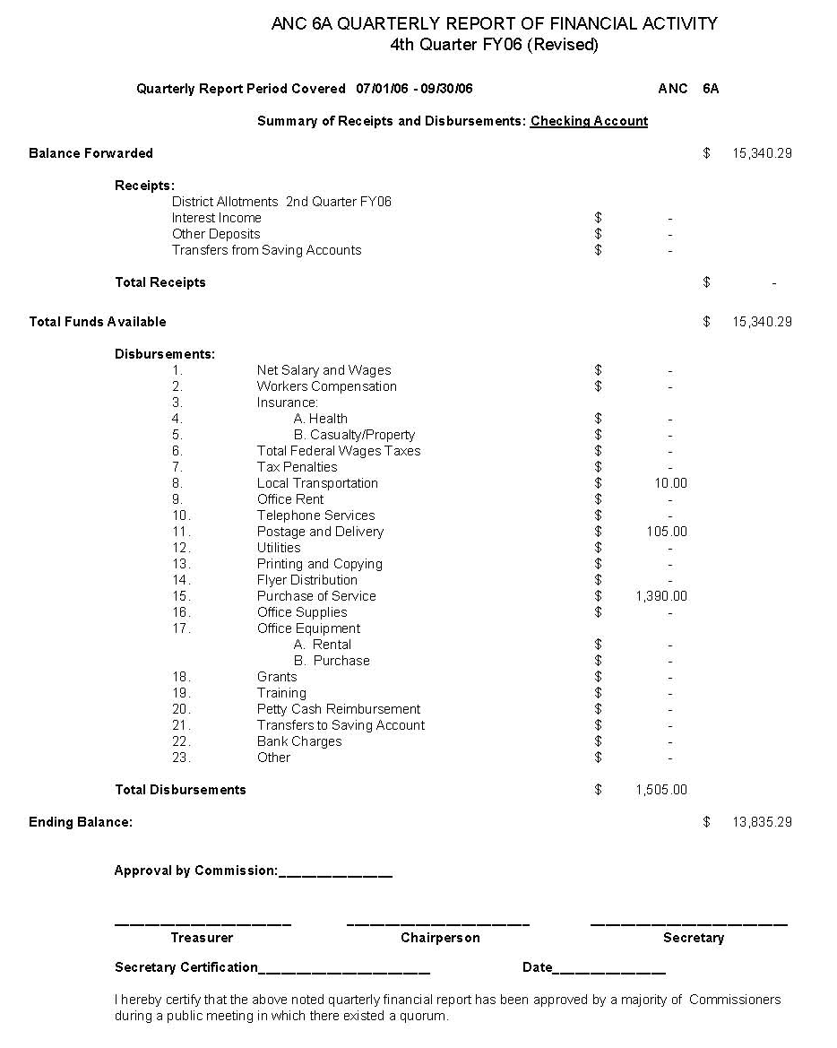

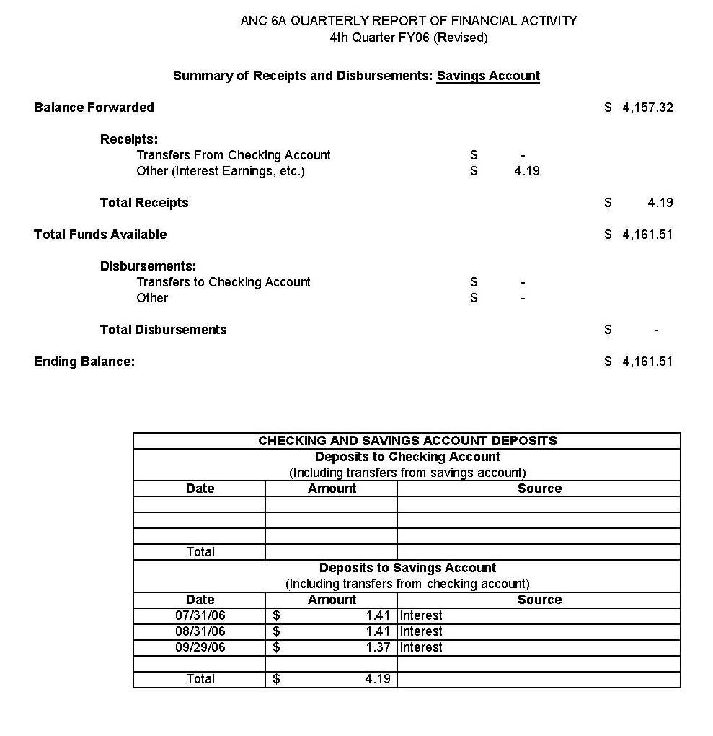
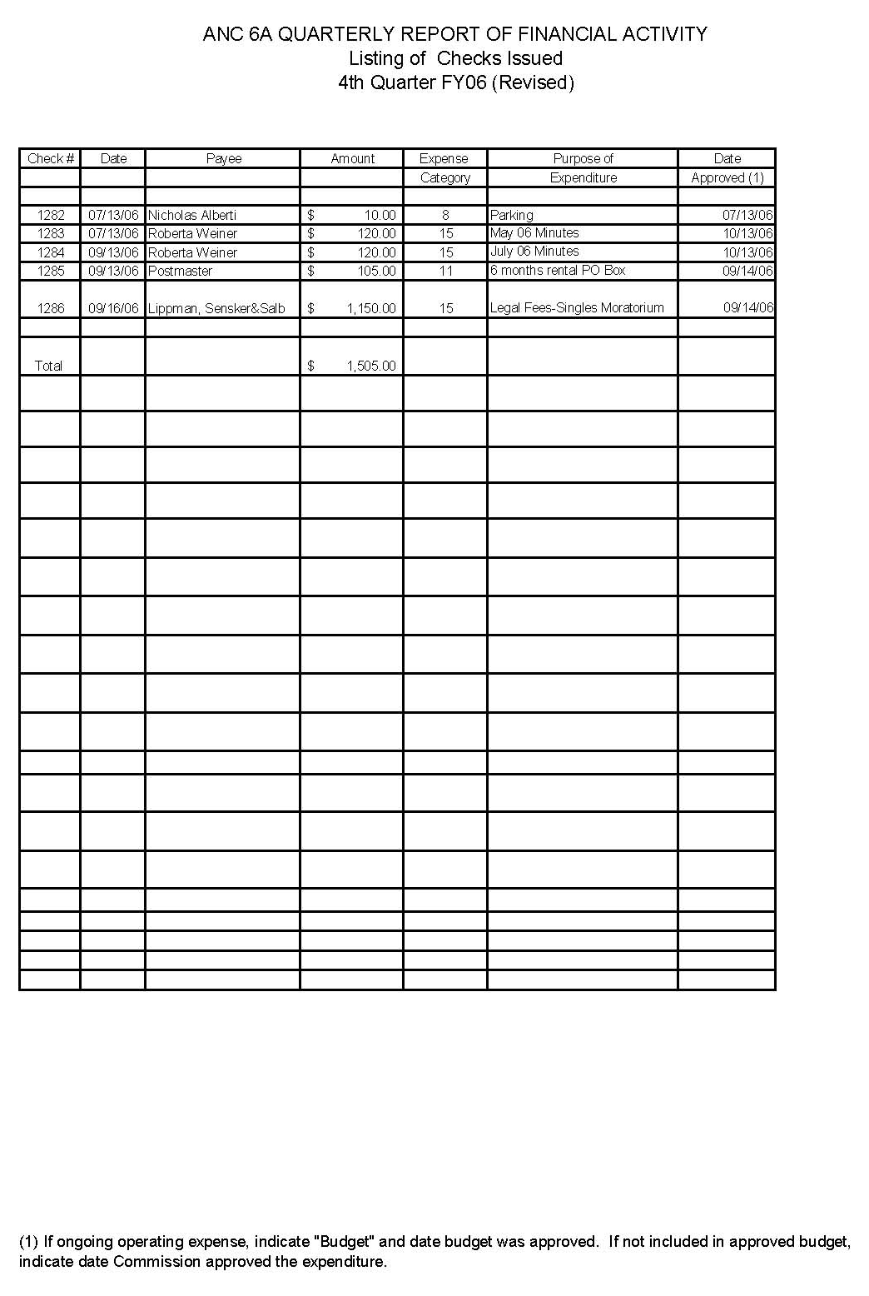

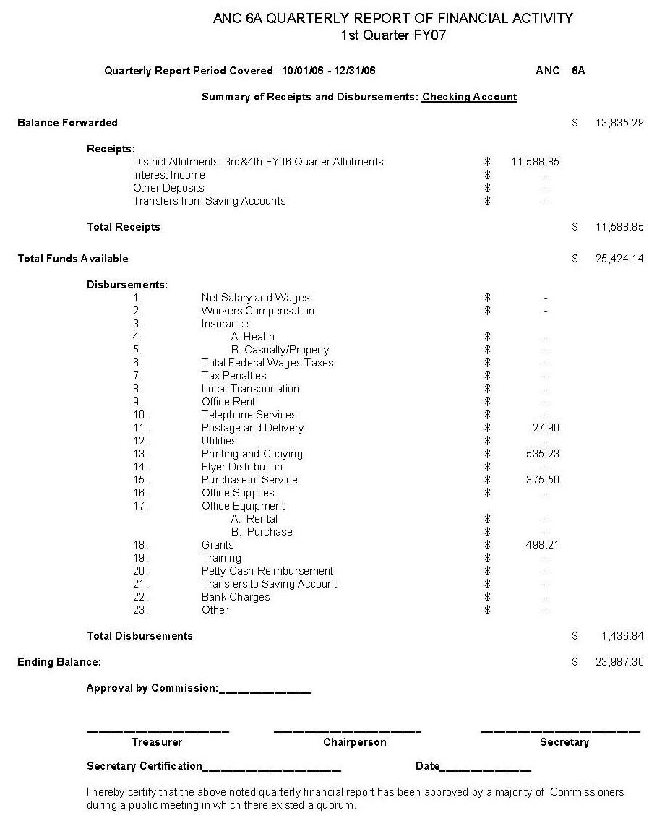

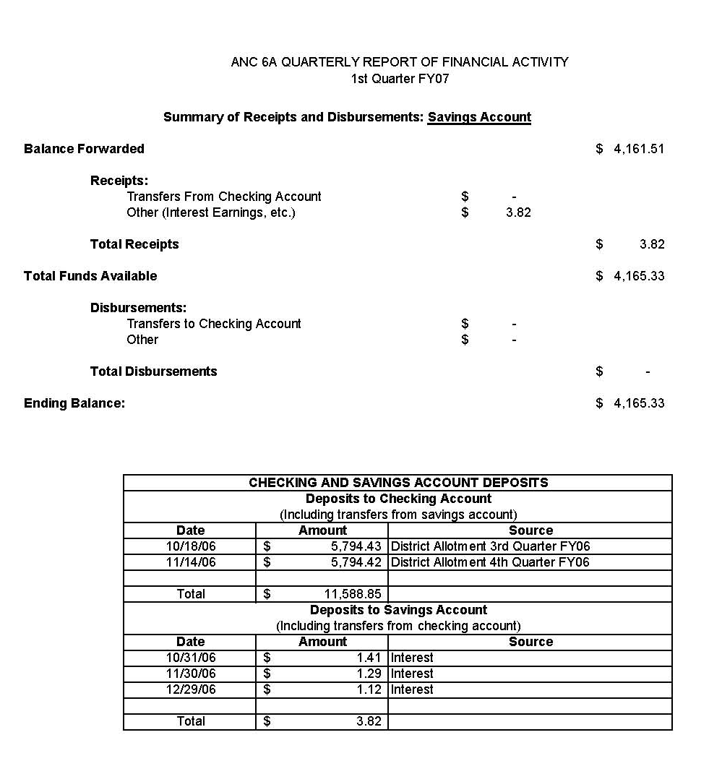
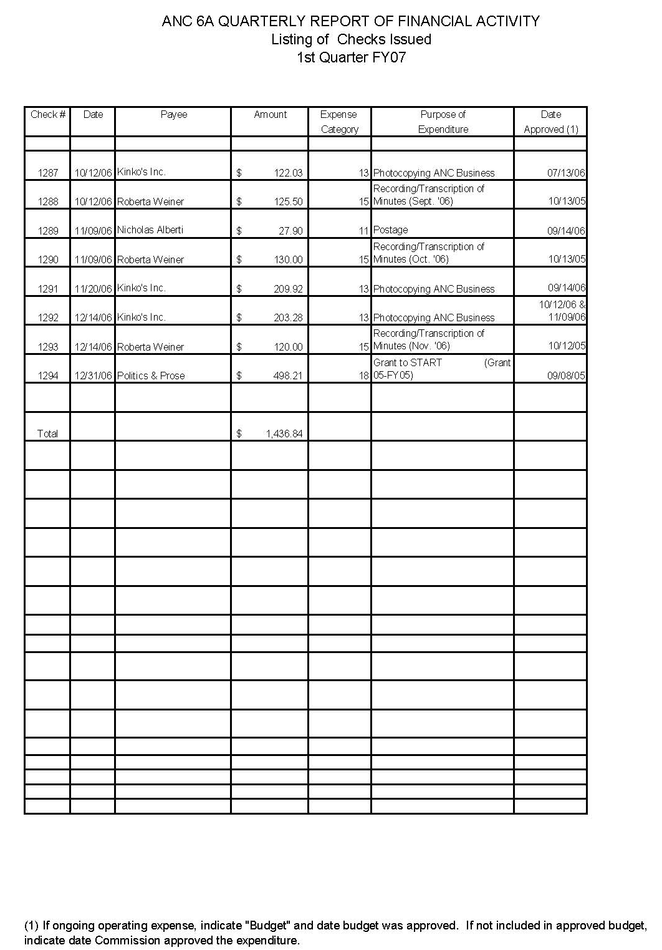
ANC 6A ABL Committee
January 16, 2007
Minutes

Meeting called to order at 7:10 pm.

Committee members present: Mary Beatty; Tish Olshefski; Mary Kosinski;
Committee members absent: Malcolm Ross (arrived after meeting adjourned); Michael Herman
ANC Commissoners: Bill Schultheiss, ANC6A06
Community members present: Bernard Gibson (BEG Investment); Joe Englert (H Street Country Club); Maurice Evans (BEG Investments); Richard Lyons; Jeremy Marcus; Robert Pittman.

I.
a. Welcome/Introductions - Committee members introduced themselves.
b. Agenda - Chair Beatty moved to accept the agenda. No objections.
c. Minutes - Chair Beatty moved to accept minutes of November meeting. No objections.

II. Community Comment
Chair Beatty asked for community comment on any issues not already on the agenda.

None.

III. Old Business

- Viggy’s Liquor Store Renewal Protest. January 17 Hearing. We have been in negotiations with Viggy’s for approximately 3 or 4 months and are still stuck on the sale of singles. Community feels very strongly that they should not be selling singles. Owners feel it’s an important/critical part of business. Status hearing on January 17 at which we’ll report we are not able to work out differences. This will likely be set for a protest hearing sometime in the next month or so.

IV. New Business

1. CT Liquor License Application – 1335 H Street NE—tentatively named H Street Country Club
Mr. Joe Englert shared his plans for a renovation of the former PhishTea property at 1335 H Street NE. He is in the process of buying the building. Plans are for a restaurant/bar with seating for 30 to 40 serving American food. Establishment will have 6 pool tables downstairs and an 18 hole miniature golf course upstairs. Mr. Englert will be applying for a tavern license with 299 occupancy. There will be no dancing or dj but there will be recorded music contained within soundproofing of the building. In the process of studying what similar restaurants do with kids but expects to be open as follows: M,T,W,Th-5:00 pm – 2:00 am; F-5:00 pm – 3:00 am; Sat-1:00 pm – 3:00 am; Sun-11:00 am – 2:00 am. Sat & Sun during the day is for families and birthday parties with no children after 6 or 7:00 pm.

Mr. Englert is willing to agree to the language of the standard voluntary agreement.

Committee & Community Questions:

How long will it take? About 5 months.
What about parking? Mr. Englert is working on expanding cab service and a van and the trolley plans are underway. Future parking lots and plans hinge on how quickly the streets can be renovated.

Motion made by Mary Beatty: Upon review of the application, if it’s substantially the same as what was presented by Joe Englert, we will seek a voluntary agreement. Seconded by Tish Olshefski. Unanimous.

2. CT Application for 12 – Discussion of Voluntary Agreement
Presentation made by Mr. Maurice Evans on behalf of Mr. Bernard Gibson. Owners have no problem with the voluntary agreement but are seeking approval for recorded music on the rooftop.

The initial plans presented to the committee in the fall were to have an outdoor café which meant securing public space. In fact, that space is already part of the property owned so it will be a “summer garden” on the property.

The owner expects to get plaquards on January 23 and the protest period extends for 45 days after.

The Voluntary Agreement presented to Mr. Gibson was not our standard agreement as language was added about mitigation of sounds. The ANC is still pursuing the possibility of ‘set back” language to further minimize the sound at the back of the building.

Committee and Community Questions:
We have continued concerns about the sound from the single member district representative whose district is immediately adjacent and the committee has been charged with getting more information about mitigating the sound. Mary Beatty will go up on the roof and take a look at the situation. How many people on the roof at one time and will they all be at tables or standing at a bar? There is a bar and the owner will provide a number.
Do you have access to the entire roof? The owners has chosen the portion that is least destructive to the community. There will be barriers to prevent walking around on other portions of the roof.

No motion to make at this time until Mary gets up on the roof and we will pursue voluntary agreement as per our last motion.

- H Street Moratorium Hearing January 17.
We have received an endorsement from ANC6C; we have support from Mayor Fenty; Tommy Wells; testimony from Commander Groomes representative and a letter of support; testimony from Malcolm Ross a resident; testimony from Laurie Duncan who was responsible for the Mt. Pleasant moratorium; testimony from Adele Roby on behalf of a merchant H Street Playhouse; and testimony from Mary Beatty, committee chair.

The hearing is at 11:00 am on January 17. We welcome anyone who wants to make any comments as it is a public hearing.

V. Adjourn. Move to adjourn 7:45 pm. Next meeting: February 20, 2007.
REPORT OF THE ECONOMIC DEVELOPMENT AND ZONING
COMMITTEE OF ANC 6A
January 30, 2007

Present: Resident Members: Drew Ronneberg, Vanessa Ruffin, Linda Whitted, Jeff Fletcher, Queen Laney
Commissioners: Nick Alberti, Gladys Mack, Stephanie Nixon, David Holmes

Drew Ronneberg chaired the meeting.

Community Comments

Nick Alberti introduced Heather Scott. Ms. Scott will be nominated at the next ANC meeting to serve as the ANC 6A05 representative on the ED&Z committee.

2007 Goals

The committee deliberated 2007 goals and voted unanimously to adopt the following goals:

- Provide a regular public forum for Commissioners and residents to obtain information and discuss land use issues in the ANC 6A area or that affect the ANC 6A area.
- Review and report to the ANC on all significant activities by the Board of Zoning Adjustment, Zoning Commission, Historic Preservation Review Board, Office of Planning, National Capital Planning Commission, and other agencies that affect land use in the ANC 6A area.
- Make timely recommendations to the ANC that permit informed participation in city decisions on zoning, historic preservation, economic development, and other topics related to land use in the ANC 6A area.
- Monitor public and private development activities on H Street NE for consistency with the Strategic Development Plan and Neighborhood Commercial Overlay.
- As needed, schedule speakers from city or federal agencies who can address the interests or concerns of residents related to land use in the ANC 6A area.
- Develop a SMD captain with the Transportation and Public Space Committee to systematically collect and report all 1) vacant and nuisance properties, 2) building permit violations and 3) public space violations.
- Major topical focus areas will be a) making sure DCRA applies the provisions of the H Street NE NC Overlay district to all properties on H Street, b) working with other groups to pass legislation to insure that City-funded social services are spread fairly and evenly across DC and c) expansion of the Capitol Hill Historic District.

Recommendation: The committee unanimously recommends that the ANC adopt the ED&Z committee 2007 goals.

1637 E. St NE (Martin Pollack Project)

Mr. Jamison of the Martin Pollack Project described plans to operate a transitional home for males between the ages of 18 and 21. The residents of the facility would be under the charge of DC's Child and Family Services Agency and the goal of the program is to transition them from foster care to living on their own as productive citizens. Mr. Jamison said that under DC law, DC government is responsible for foster children until they reach the age of 21.

According to Mr. Jamison, there will be 10 males at the site, and each resident must meet certain standards in order to be accepted into the program. There will be on-site staffing and a security system to monitor movements in and out of the facility. The organization will be leasing the space from Mr. Terry Williams and Mr. Jamison claimed that the site already has a C of O for a Community Based Residential Facility. Mr. Jamison also claimed that there were no other CBRFs on the same square. The Martin Pollack Project is in the process of obtaining the proper licenses from Child and Family Services to operate the facility.

Mr. Jamison said that the emphasis of the program will be on developing the life skills of the residents in a structured environment. Residents will be required to be at school or work apprenticeship programs between the hours of 9 to 5 and there will also be a mandatory once-a-month community service requirement.

Nearby residents expressed concerns that the property was in a high crime area and that there had been five homicides within 500 feet of the property within the last year. Stephanie Nixon said that Commander Grooms thought that locating the program at 1637 E. St. NE would be a bad idea. Nick Alberti also expressed concern that some residents would drop out of the program and remain in an area that was not conducive their personal development.

Mr. Jamison claimed the Martin Pollack Project would be seeking a special exception from the BZA to operate a youth rehabilitation home. Because the community would have another chance to review the project during the special exception process, further discussion was tabled.

***On the day after the meeting, the lawyer for the Martin Pollack Project informed Drew Ronneberg that the organization would not be seeking a special exception because the facility did not qualify as a youth rehabilitation home. ***

SO 06-6762

Ms. Shante Parker spoke on behalf of the owner of 1359 H St. NE, who has applied for the closure of a small portion of the alley behind his properties. Ms. Parker said that the owner wanted to close the portion of the alley behind his properties because of problems with loitering and abandoned cars. Ms. Vanessa Ruffin thought that they alley could not be closed through a short administrative process and that it required the support of two-thirds of the property owners on the square. She also thought that the application form was defective because it ignored the requirements of DC Public Law 4-201 and 7-106. Nick Alberti expressed concern about setting precedents for closing alleys in other places in ANC 6A. David Holmes mentioned that the ANC could request a time extension so that it could review the laws and gather more community input.

Recommendation: The committee unanimously recommends that the ANC ask the Surveyor's Office for a 45 day time extension to comment on the proposed alley closing on the 1300 block of H Street NE (SO 06-5762) because of concerns that DCRA's procedures for alley closings do not follow public law and its application form is defective. If the time extension is not granted, the committee unanimously recommends opposing the alley closing on the basis that there had been insufficient community deliberation and comment.

BZA 17521 (601-645 H St. NE)

Drew Ronneberg presented the latest renderings for the 601-645 H St. project to the committee. Dr. Ronneberg said that the developer had responded to most of the proposed recommendations of the community to improve the architecture of the project and viability of the retail space. As a result, Dr. Ronneberg, as the designated ANC 6A representative for BZA case 17521, had written a letter to the BZA in support of granting the special exception to Section 1320.4 for compliance with the design requirements and design guidelines. The ANC's letter of position was unfortunately due at the BZA at 5pm on January 30^{th.}

Geoffrey Griffis nomination to the Zoning Commission

Mr. Griffis’ nomination to the Zoning Commission is being opposed by Phil Mendelson, Tommy Wells and a number of community groups across the city because of the perception that Mr. Griffis, in his role as the Chairman of the Board of Zoning Adjustment, favors the interests of developers over the interests of the community. In the past 4 years, ANC 6A has lost a number of cases before the BZA including the subdivision of units in an apartment building (1124 E. St. NE), the appeal of side yard requirements at 920 and 922 Constitution Ave, the appeal of enforcing parking for converting single family homes to flats (BZA case #17526), and the flouting of the new regulations promulgated by the Zoning Commission so as to permit AppleTree Institute charter school to move forward with construction. There is concern that Mr. Griffis believes that the zoning code exempts the expansion of nonconforming uses in structures built before 1958, and has dismissed appeals based on technical errors that could have easily been corrected.

Recommendation: The committee unanimously recommends that that the ANC write a letter to the Mayor and all City Council members opposing Mr. Griffis' nomination to the Zoning Commission.

2nd and H Street NE. Development (Capitol Place)

A very large development (> 400,000 sq. feet, 65-104 ft. in height) is proposed for Square 752 which is the bounded by 2nd, 3rd, G and H St. NE. The developers have proposed an upzoning of a portion of the site to C-3-C and a Planned Urban Development (PUD) which will add more than 160,000 sq. feet to the project above what is allowed as a matter of right. Neighbors are very concerned that the development is too big and will negatively impact the residential character of the square. In addition, residents are concerned that 14 historic structures will be demolished, the proposed community amenities are inadequate, and that the architecture of the project is uninspiring and doesn't meet the standards outlined in design guidelines of the H Street NE Commercial overlay. Given ANC 6A's success in helping to improve the 600H project, and the need to enforce the design guidelines throughout the Corridor, and the need to understand the PUD process for developments that will occur in ANC 6A's portion of H Street, Drew Ronneberg suggested that ANC 6A seek party status for the 200 H project.

Recommendation: The committee unanimously recommends that the ANC seek party status for the PUD deliberations for Capitol Place on Square 752 (200 block of H Street NE) and appoint Mr. Jeff Fletcher as the ANC 6A's designated representative.

Cataloging Vacant/Nuisance Properties in ANC 6A/SMD Captain System with Transportation Committee

Many owners of vacant and nuisance properties on H Street and the rest of ANC 6A have low property taxes because their properties are worth less than occupied properties. The city has responded to this problem by changing the tax rate for vacant properties from 0.88% to 5%. However, the vacant property list that is maintained by the city is incomplete.

The committee continued to discuss assembling a list of vacant/nuisance properties in ANC 6A and working with the Transportation Committee to develop an SMD captain system to monitor vacant properties, illegal construction and public space violations. The committee thought that it would be best to write simple one page guides for citizens to explain the relevant laws and the need for ANC 6A wide monitoring before creating a SMD captain system.

Recommendation: The committee unanimously recommends that the ED&Z committee work with the Transportation and Public Space committee to develop a citizen's guides for recognizing an reporting 1) illegal construction, 2) building permits issued in error, 3) nuisance/abandoned properties, and 4) public space violations.

Next Scheduled ED&Z Committee Meeting:
Tuesday, February 27, 2007
7-9 PM
900 G Street, NE
Community Room of the Capitol Hill Towers

[Insert Date Here]

Dept of Health – Licensure Division

To Whom It May Concern:

At our regularly scheduled public meeting on February 8, 2007, our Commission voted to request information regarding the Martin Pollack Project and the District of Columbia’s Department of Health. We make this request under two separate authorities.

First, according to the District of Columbia Municipal Regulation (DCMR), each Commission shall have access to District government officials and to all District government official documents and public data pursuant to §2-531 et seq. that are material to exercise its development of recommendations to the District government. We posit our Commission does not need a Freedom of Information Act (FOIA) request to seek these documents to make a recommendation to the Department of Health, the Department of Consumer and Regulatory Affairs, and the Child and Family Services Agency.

Accordingly, we request copies of licensure held by the Martin Pollack Project in the District of Columbia for counseling or foster care services. We further request information related to the possible request of such information with regards to the Martin Pollack Project and 1637 E St NE.

As this is a time-sensitive matter, we would appreciate your immediate assistance.

Thank you in advance for your time. If you have any question, please contact Commissioner Stephanie Nixon at 202-222-8570.

On behalf of the Commission,

Joseph Fengler, Chair
Advisory Neighborhood Commission 6A

CC: Uma Ahluwalia, Child and Family Services
Bill Crews, DCRA
Eric Rogers, DCRA
ANC6a Public Community Outreach Committee Meeting
Church of the Lord Jesus Christ of the Apostolic Faith annex, 1235 C St. NE
Wednesday, January 17, 2007 at 7:30 pm

The Committee convened at 7:30 PM, at the

Attending COC members: (quorum)
Louis Barbash, Rose Williams, Jesse Rauch, Elizabeth Nelson (chair)

Absent COC members:
Barbara Anderson, Astri Klievdal

Community members: Maurice Cook
Rich Carlson, Brenda Artis

I. Feedback from January ANC meeting/Old business:
  - The grant application from the PTSA at Eastern SHS on behalf of the Health and Medical Sciences Academy (HMSA) was approved.
  - ANC 6A flier was approved. A draft document has been created. A message was sent to the commissioners asking for the list of locations where they will made agendas available. When the list is final, Ms. Nelson will send the completed draft to the COC for their review; subsequently to the commissioners for their review, prior to printing.
  - The Public Safety Committee requested (and ANC approved) changes to the website; the USDA 1D Court reports will be taken off the website and a link to a subscription page for crime statistics will be added. [Note: subsequent to the meeting these changes were made.]
  - Draft ads for The Hill Rag, Voice of the Hill and Fagon Guide were sent to the respective publishers who have been requested to send their drafts of the “type set” articles for our review prior to publication. This is more critical with the Fagon Guide as it is published only once per year. The other ads can be updated monthly, as needed.

II. Fulfilling responsibilities to deaf community with regard to the Americans with Disabilities Act (ADA)
- For several years, the COC has been endeavoring to identify free/low cost interpreting services in the hopes that we could encourage the deaf community to become more involved in the ANC. To date, such services have not been identified (including at Gallaudet).
- Most recently, Ms. Nelson has been in touch with Gottlieb Simon. He confirmed that the ANC is required, by the ADA, to provide services and that, currently, ANCs are responsible for identifying and paying for these services themselves. He indicated that he was able, in the past, to arrange for student volunteers but that they have since graduated. He will renew his efforts to identify new volunteers. He also agreed to investigate what service providers are used by other agencies of District government.
- Ms. Nelson also researched services for hire, both ASL interpreters and open captioning (CART). There appear to be few providers who operate in our immediate area. CART has the advantage of being useful to hard of hearing persons who do not know sign language and the transcription can be stored. However, it is more expensive and does not readily provide for a deaf person to express himself – only to know what is said by others. ASL interpreters are therefore preferable.
- Partners in Sign will provide this service in our area at a rate of $205 per 2 hour session (2 hr. minimum) if given adequate notice. There are additional fees for short-notice and/or longer sessions but this is not expected to be necessary.
- Meeting the ADA requirements could potentially absorb a large portion of an ANC budget and places a potentially disproportionate burden on those ANCs who represent a large deaf community. Also, it would be desirable to go beyond the ADA requirement of providing services upon request, by encouraging the participation of deaf members of the community. The group believes that the District should provide this service for the ANCs. Failing that, it should negotiate a contract, with favorable rates, that ANCs can access at their own expense. ANC 6A should add this to the list of services (office space, legal representation) it plans to request from the District.
- We have already been contacted by a deaf resident who will have business before the ANC within the next few months. He will need an interpreter for both the relevant ED & Z meeting and the subsequent ANC meeting. Interpretation for the two meetings will cost $410. Additional funds should be budgeted to provide for future needs, enough for two additional sessions.

Committee recommendation (unanimous): that ANC 6A
- Add the provision of Interpretive Services to the list of support requested from the District Government. And, failing that, that the District negotiate a contract for reduced cost services, even if the ANC must pay for these services.
- Allocate $820 to cover projected needs and give COC permission to make necessary arrangements to provide such services, when requested.

III. Progress report on outreach to potential grant applicants
- Mr. Barbash reported that he has continued discussions with Larry Kaufer and John Parker of Sports on the Hill with respect to grant opportunities. The organization has indicated an interest grant support for bleachers to be placed on Kingsman Field, one of their venues under the control of District Parks and Recreation (DPR). However, it is not clear that the neighbors of the field or DPR would welcome this addition or if the request would meets the statutory guidelines for ANC grants. Ms. Nelson has contacted Gottlieb Simon, the ANC coordinator to solicit his views. Mr. Barbash will get back in touch with Sports on the Hill and remind them that, if they intend to pursue the bleachers proposal, they need to first present a clear case that all parties are in agreement. He will also suggest that they consider applying for funding for equipment (eg. baseball mitts) instead.
- Ms. Nelson reported that she has spoken with Mr. Walter Whitley of the William Ross Education Foundation of Alpha Phi Alpha Fraternity. She offered assistance with the grant application process and discussed the statutory guidelines for grants, directing his attention to the requirement that the grant benefit people who live or work in ANC 6A. She also noted that grants were considered monthly and throughout the year. Mr. Whitley said that he would be back in touch.

IV ANC 6A "Newsletter"
- The COC was directed, by the ANC, to consider the publication of a newsletter. Commissioner Holmes drafted the original proposal. The COC began consideration of these sub-topics:
- Frequency of publication: The COC unanimously agreed that largely due to cost considerations, the publication should be done (at most) twice a year to start.
- Type of publication:
- There was a suggestion made to use a postcard, rather than the larger size (11 x 17, folded in half) proposed by Commissioner Holmes, for cost reasons and because recipients, not having to invest much time in understanding it, might be more inclined to read it. However, the group agreed that a postcard could not include enough information to be worthwhile (given the amount of information already available in the free press) and that it was not what the commissioners were interested in.
- Commissioner Holmes provided two cost estimates for 10,000 copies, both of which involved color printing, one for $983.68 (color on pages 1 & 4) and another for $1,046.17 (color on all 4 pages). A black and white only estimate was not provided.
- We would like to consider a black & white only quote, if Commissioner Holmes provides one.
- Content:
- There was considerable discussion of what purpose a publication might serve that would not be duplicative of other publications – the ANC flier, or articles/ads in the free press. Specifically the group did not feel that the information published in the flier should be duplicated, eg. the meeting schedule and contact information for the commissioners and committees, ANC map, etc. The website probably should be referenced as that can be done very briefly and most, if not all, residents have access to it.
- Also, a calendar of events did not seem workable. Even if the publication occurred quarterly, which the COC does not support, it would be nearly impossible to have dates and locations for many of the most important events established far enough in advance for inclusion. Ms. Nelson remarked that she often has difficulty establishing these facts even a month in advance of an event – for example the location for the upcoming Crime Summit was finalized not quite a month in advance.
- The group also felt that it would be inappropriate for the ANC to include articles about local businesses. This is already covered in the free press. The ANC shouldn't be spending money to promote businesses and there could be concerns about apparent bias if some businesses and/or organizations receive more coverage than others.
- Coverage of Single Member Districts should be extremely limited. Any item that addresses a single SMD is of little interest to the majority of ANC 6A residents (each SMD representing only 1/8 of the ANC population). Commissioners have photo-copy budgets of their own and are free to publish SMD-specific newsletters or bulletins if they wish to do so.
- The committee agreed that the publication should be characterized as a "semi-annual report" rather than as a newsletter and that the report should focus on in-depth coverage of those accomplishments of ANC 6A or challenges faced by ANC 6A that are important to the ANC as a whole. These issues may not be covered to the ANC’s satisfaction in the local press.
- The meeting ended before there was time to make a formal recommendation on allocation of funds to pay for printing costs.
- Method of distribution:
- A cost estimate for a mail service was submitted by Commissioner Holmes. The COC had reservations about spending such a large sum for mailing. We also had concerns about using a mailing list unless there is a reasonable guarantee that it would actually include every household – which voter registration lists (for example) do not. There would likely be costs involved in procuring some other list – if a complete list could even be purchased.
- No plan for a delivery service (such as that used by The Voice of the Hill) was submitted for our consideration. The US Postal Service might provide "zip + 4" addressing. This would be "blunt tool" at best.
- Several commissioners have already indicated that they would prefer that distribution be left to the commissioners. Commissioner Marshall, for example, has observed that he regards walking his SMD to be one of his responsibilities and that it would not be burdensome to distribute.
- The COC agrees that the commissioners should arrange for distribution. Some will deliver it door-to-door themselves; some will engage volunteers; and some will place them with businesses and civic institutions within their SMDs.
- Selection of articles for inclusion: The COC ran out of time before this topic could be fully explored but did agree that the selection should be made based on input from all commissioners and committee chairs.
- This topic will reappear on the February COC agenda. Commissioners and committee chairs with a particular interest in the topic are encouraged to attend.

Committee recommendation (unanimous): that ANC 6A
- Defer a decision until the COC completes consideration of the topic at the February meeting.

If this recommendation is not accepted the committee makes this alternative recommendation: that ANC 6A
- Publish a semi-annual (twice/yr) report focusing on activities of ANC 6A that are relevant to the entire ANC and are not time-sensitive or duplicative of other publications.
- That the distribution of the report should be the responsibility of the commissioners and not be mailed.
- That selection of content should be a group effort with input from all commissioners and committee chairs.
- That the least expensive option be used for printing.

V. Committee Goals
The COC has been asked to draft a set of goals for 2007 and submit it to ANC 6A for approval. As there are several new members just joining, the issue is postponed until next month to give the new members time to consider the issue. Ms. Nelson distributed copies of last year's goals and asked that COC members e-mail her with suggestions. These will be compiled and distribute for discussion at the February meeting.

VI February Meeting Schedule
The third Monday in February is President's Day. Committee members agreed unanimously that we should meet anyway. This was confirmed with Mrs. Thompson, who opens the building for our use.

The meeting adjourned at 9:30 pm.
Next meeting is February 19, 2007.
Respectfully submitted,
Elizabeth Nelson

ANC6a Public Safety Committee Meeting
Sherwood Recreation Center
Wednesday, January 17, 2007 at 7 pm

Present Committee members: Stephanie Nixon (Chair), Laura Brown
Absent Committee members: Mark Laisch, Mike Seneco, Joe Bellino
Government employees: Carolyn Crank (USAO), Alphonso Coles (MPD), Simone Greene (Ward 6 Neighborhood Services Community Outreach Coordinator, work 202-442-8150 cell 202-340-8569, Simone.Green@dc.gov), Sgt Newbold (cell phone for Sun-Thurs 240-463-5985) and Sgt Jones.

Community members: 5

As of 7:25 pm quorum was not achieved.

Please review notes from past meetings for details about ongoing committee research (e.g., loitering, papering).

Committee Chair/Commissioner Stephanie Nixon called the meeting to order at 7:25 pm. There was quite a bit of pre-meeting discussion on public safety issues. The meeting began and ended without quorum. Sgt Newbold asked several questions about the purpose of quorum and what happened to recommendations made in committee without quorum. Commissioner Nixon explained that the committee would send forward recommendations rather than motions and Commissioner Nixon would make the motion on behalf of the committee.

Neighborhood Services Coordinator of Ward 6 – Simone Green
Community Outreach coordinator is in charge of following up with the residents.
Hiram.Brewton@dc.gov is the Neighborhood Services Coordinator for Ward 6.
Naomi Mitchell (nmitchell@dccouncil.us) is Councilmember Wells’s community service coordinator. Ms. Mitchell, Mr. Brewton, and Ms. Green will be working together on these issues.

There are weekly CORE team meetings in which they follow-up with the different agencies.

Mission Statement and Goals for 2007 (the amended and recommended version of these are attached)
The ANC6A mission statement and goals for 2007 were suggested by Commissioner Nixon and discussed by the individuals present. One important addition to the mission statement and goals from last year was a goal to assist an agency or group on an activity with the goal to enhance public safety.

Recommendation: ANC6A adopt the mission statement and goals for the Public Safety Committee presented at the end of this document.

1609 Isherwood St NE
Since the December 2006 ANC6A Public Safety Committee Meeting new evidence has emerged with regards abandoned vehicles and illegal dumping at 1609 Isherwood St NE. Lt. Renato Caldwell (PSA 103) went to the location and ticketed six cars, per an email correspondence. In addition, a resident submitted a service request for illegal dumping.

Sgt Newbold (PSA 103) stated that he was unaware of this situation and had not investigated himself. He stated that since he had not seen the property he did not know if the cars were illegally parked. Commissioner Nixon pointed out that Lt Caldwell (PSA 103) issued the tickets. The cars were supposed to be towed if not moved within 48 hours, per Lt Caldwell. In addition, Ms. Green (Ward 6 Neighborhood Community Outreach Coordinator) reported filing a request for service with regards to the trash after seeing the location.

There are concerns that vacant properties provide locations for drug activity. Commander Groomes requested that ANC6A send a letter to supplement the work of MPD and DC Government. There was no committee quorum and Sgt Newbold (PSA 103) expressed his disagreement and requested that the committee allow MPD time to do their job. Commissioner Nixon noted Commander Groomes’s request and Lt Caldwell’s action to Sgt Newbold and that any letter from the committee would have been supplemental. Ms. Crank (US Attorney’s Office) questioned whether there were calls for service to the address in question regarding drug activity. Commissioner Nixon pointed out that the General Counsel for MPD will not provide statistics on specific addresses to the ANC without a Freedom of Information Act request.

Because of the lengthy discussion on this topic the committee did not have time to make a recommendation for the ANC. Since the meeting, Commissioner Nixon has corresponded with Lt Caldwell, Ms. Crank, Ms. Green, Mr. Brewton, and Mr. Ingea (DPW, Clean Sweep) about the status of this property. During a phone call on Tuesday, January 23, 2007 Mr. Brewton reported visiting the property again and taking pictures and that the owner has agreed to fence in the property in an attempt to prevent further dumping at the site. Commissioner Nixon discussed the possibility of sending a letter to the owner on behalf of 6A08 requesting that he work with the neighbors to improve the public safety and welfare of the neighborhood.

311/911 Calls for Service
Concerns were expressed about responses to 3-1-1 calls for service. These concerns have been expressed before. Sgt Newbold asked Mrs. Brown if she felt officers were not responding. Mrs. Brown clarified that she felt the calls were not dispatched. Sgt Jones discussed the CAD system that is used for prioritizing calls.

Commissioner Nixon pointed out that calls for services are lumped into different events. There have been instances when calls 30 minutes to 1 hour apart were lumped as the same event in calls for service reports which report “events” vs number of calls.

Firework and Firecracker legislation in DC
The committee and community discussed the firework and firecracker legislation (Chapter 33H DCMR) that was presented at the October 2006 Public Safety Committee Meeting. At that point the committee voted to table any motions until the outcome of the 2006 elections and until the new Mayor set up his cabinet. At this time the cabinet has a preliminary set-up so the committee has revisited this issue.

The original idea was to recommend overtime pay for Fire Marshalls on dates that historically have high rates of calls for fireworks and firecrackers. One idea that both MPD and FEMS had mentioned was having a Fire Marshall ride along with an MPD officer in a given district and respond to only calls for Fireworks/Firecrackers. Sgt Jones and Sgt Newbold expressed disagreement as Fire Marshalls have arrest powers. Commissioner Nixon asked whether Fire Marshalls have access to the same “radio channels” as MPD. The answer was that Fire Marshalls do not. As there are some fireworks/firecrackers that sound exactly like gun shots, the committee reiterated the importance of having police officers present to radio for back up in the case of gun fire that sounded like fireworks/firecrackers.

In response to the discussion about making it criminal or like possession of open container of alcohol to violate the Fireworks/Firecracker Code and maintaining the civil fine, the Sgts and Ms. Crank were not sure whether the idea would work. The committee agrees that the law needs to be enforced as fireworks and firecrackers are a nuisance and danger to life and homes.

Commissioner Nixon pointed out that the front of Elliot JHS was littered with black cats, roman candles, and other remains before school began in 2006. One community member mentioned that it would be relatively difficult to stop the illegal use of illegal fireworks and firecrackers in DC and likened this to underage drinking. There was some discussion about the existence of criminal fines in DC and Cmdr Groomes confirmed that these can be provided and when a person does not pay, warrants are given for arrest.

Please review notes from the October 2006 meeting for more background.

Recommendation: Send a letter to the Chief of Police, Cathy Lanier, Interim Chief of the Fire and Medical Emergency Services Department, Brian Lee, Ward 6 Councilmember Tommy Wells, and At-large Councilmember and Chair of the Council Public Safety Committee Phil Mendelson, copied to Lt Tony Falwell, and Cmdr Diane Groomes requesting that the Fire Marshalls and Police Officers in at least 1 District on July 4, 2007 to allow enforcement of the fire code and noise code (nothing over 55 dB in R4 zones during the evening, which would make fireworks/firecrackers illegal). In addition the committee recommends that council adjust the present code to allow fines to be criminal versus civil for use of illegal fireworks/firecrackers.

MPD General Counsel and Crime Statistics for Specific Addresses upon ANC Request
Commissioner Nixon reported on an email forwarded from Cmdr Groomes that contained the letter asking the MPD General Counsel to modify the recent policy that ANCs must submit Freedom of Information Act requests to obtain crime statistics for specific addresses. The response appeared to convey that the General Counsel would not change the police.

Recommendation: Work with Joe Fengler, but concerns legislation on ANC requests not requiring FOIA.

Fire Hydrants
Commissioner Nixon reported that Commissioner Mack had mentioned the replacement of fire hydrants in SMD6A07 during the end of 2006.

Respectfully submitted by Stephanie Nixon.
ANC6A Public Safety Committee
2007 Mission Statement and Goals

Mission:

Engage residents, community groups, the District of Columbia Government and all other public and private institutions in an effort to prevent criminal activity affecting our quality of life and promote the public safety and health of our community.

Goals:

- Act as a convenient and useful forum for residents and local businesses to discuss public safety issues and solutions.

  - Hold monthly meetings with a quorum present.
  - Increase attendance of residents, businesses, community groups at meetings.
  - Improve outreach to and participation of residents from all parts of ANC 6A.

- Provide the Advisory Neighborhood Commissioner with well-informed recommendations for changes in Federal and District legislation, and regulations and operating procedures of relevant government agencies, based on input from community members.

  - Identify at least four changes in DC or Federal legislation that will help improve the public safety of our community.
  - Recognize at least four changes in regulations that will help improve the public safety of our community.

- Improve collaboration among law enforcement agencies in our community including, Park Police, FEMS, WMATA Police, Capitol Police, MPD, and all others to address community issues at the levels of procedure, policy, and legislation.

  - Participate in PSA meetings on a monthly basis.
  - Provide reports on these collaborations.
  - Work with these agencies and council to devise appropriate methods to enhance these relationships.
  - Select at least one public safety issue for which we can work with the law enforcement agencies and community to develop and support activities that promote public safety. (e.g., youth and safe summers)

- Collaborate with the other ANC committees on the following issues:

  - Economic Development and Zoning – Abandoned/Vacant properties that are a safety hazard; illegal construction; H St NE – need for security at new properties
  - Transportation Committee – Need for speed control in areas affected by crime
  - Alcohol Beverage Licensing – Control of alcohol distribution in areas affected by narcotics and violent crime; Need for security hired at the owner’s expense in all new bars and entertainment venues
****DRAFT****

[Insert date here]

General Counsel
Metropolitan Police Department
Terrence Ryan
300 Indiana Ave., NW
Rm 4115
Washington, DC 20001
Terrence.Ryan@dc.gov

Dear General Counsel Ryan,

At its regularly scheduled meeting on February 8, 2007, with a quorum present, our Commission voted to request again that the General Counsel at the Metropolitan Police Department (MPD) change the recently implemented operational policy with regards to the release of crime statistics for specific addresses from allowing release without Freedom of Information Act (FOIA) requests to requiring FOIA requests for all individuals including Advisory Neighborhood Commissions.

The previous letter was sent dated January 4, 2007. Although we have yet to receive a formal response, we have received an informal response via email that the policy will not change. We respectfully request clarification on how the new policy adopted by MPD fits with the District of Columbia Municipal Regulation (DCMR), each Commission shall have access to District government officials and to all District government official documents and public data pursuant to §2-531 et seq. that are material to exercise of its development and recommendations to the District government. We posit our Commission does not need a Freedom of Information Act (FOIA) request to seek such information to aid our decisions about whether a property or those on or around it have posed disruptive to the neighborhood.

We respectfully request that you modify the current policy in light of the DCMR and appreciate your assistance.

If you have any questions, then please contact Commissioner Stephanie Nixon at 202-222-8570.

On behalf of the Commission,

Joseph Fengler
Chair, Advisory Neighborhood Commission 6A

***DRAFT***
[INSERT DATE HERE]

Dear Chief Cathy Lanier, Interim Chief Brian Lee, Councilmember Wells, and Councilmember Mendelson,

At its regularly scheduled meeting on February 8, 2007, with a quorum present, our Commission voted to request that both agencies and Council enforce current legislation regarding fireworks/firecrackers and test a new approach in the 1st District.

We understand and respect the difficulty enforcing the use of illegal fireworks and firecrackers in the District of Columbia. However, these fireworks and firecrackers provide distractions from gun shots and more serious crimes, particularly on and around holidays such as the fourth of July. Two codes apply to fireworks and firecrackers, Title XX of the XXXX and Title 20, Chapter 27 of the DCMR entitled Noise Control. In this manner they pose a significant public safety concern. The first code makes it a civil violation to use illegal fireworks or firecrackers in the District and the second code applies specific noise levels with which all behavior in the District must comply.

After several discussions of the concerns of residents and the legislation, the ANC6A Public Safety Committee discussed possible solutions for your consideration. First, we would like overtime pay for the at least 3 Fire Marshalls on July 3 and July 4, 2007. We would like these 3 Fire Marshalls to be paired with 1st District police officers. These teams would reply exclusively to firework and firecracker calls as well as possible gun shot calls allowing Fire Marshalls to take appropriate measures if firecrackers or fireworks are found on the scene and allowing the police officers to call for back-up over their radios if it was gun fire. We would like this done to allow full enforcement of our present laws.

Second, we would like Council to consider various ways to impede or discourage the use of illegal fireworks and firecrackers, particularly in residential zones. We would like Council to consider adapting the Title XX to make the procurement, ownership, or use of illegal fireworks and firecrackers a crime and with that consider criminal fines.

We respectfully make these requests and suggestions and appreciate your insight.

If you have any questions, then please contact Commissioner Stephanie Nixon at 202-222-8570.

On behalf of the Commission,

Joseph Fengler
Chair, Advisory Neighborhood Commission 6A

CC: Lt Tony Falwell
Cmdr Diane Groomes

[INSERT DATE HERE]

FOIA Officer
Ronald B. Harris
Deputy General Counsel
Metropolitan Police Department
300 Indiana Avenue NW, Rm. 4125
Washington, DC 20001
Dear Mr. Harris:
At its regularly scheduled meeting on February 8, 2007 with a quorum present, our Commission voted ___ to make request information about the criminal activity and concerns in the area surrounding 1637 E St NE.
First, according to the District of Columbia Municipal Regulation (DCMR), each Commission shall have access to District government officials and to all District government official documents and public data pursuant to §2-531 et seq. that are material to exercise its development of recommendations to the District government. We posit our Commission does not need a Freedom of Information Act (FOIA) request to seek these documents to make a recommendation to the other DC agencies.
If this request does not meet those requirements, then please use this as a Freedom of Information Act request under 5 U.S.C. subsection 552, for statistics, resulting from calls for service and from normal MPD patrols on adults and juveniles in the following locations; (a) 1600 block of E St NE (b) 1500-1700 blocks of E St NE, (c) 400 block of 16th St NE, (d) 400 & 500 blocks of 15th St NE, (e) 500 block of 16th St NE, (f) 400 block of 17th St NE, (g) 500 block of 17th St NE, (h) 1600-1700 block of Isherwood St NE, and (i) 1600-1500 blocks of Gales St NE from December 31st, 2004 to December 31th 2006.
We request these statistics for the general area for an evaluation of this area for types of crime committed. We need to evaluate this general area from all viewpoints to understand the breadth of influences that might be placed on youth in the area as there may be a transitional youth home placed at 1637 E St NE in the near future.
We respectfully request a waiver of any fees for copying or researching this request. If this waiver cannot be granted, please notify us as soon as possible.
If you deny all or any part of this request, please cite each specific exemption you think justifies your refusal to release the information and notify us of appeal procedures available under the law.
If you have any questions about handling this request, you may telephone ANC 6A08 Commissioner Stephanie Nixon at (202) 222-8570 or email (smnixon6a@prodigy.net).

On behalf of the Commission,
Joseph Fengler
Chair, Advisory Neighborhood Commission 6A
CC: Commander Diane Groomes

[INSERT DATE HERE]

FOIA Officer
Tarifah Coaxum
Office of the Attorney General
John A. Wilson Building
1350 Pennsylvania Avenue NW, Suite 409
Washington, DC 20004
Dear Mr. Coaxum:
At its regularly scheduled meeting on February 8, 2007 with a quorum present, our Commission voted ___ to make request information about the criminal activity and concerns in the area surrounding 1637 E St NE.
First, according to the District of Columbia Municipal Regulation (DCMR), each Commission shall have access to District government officials and to all District government official documents and public data pursuant to §2-531 et seq. that are material to exercise its development of recommendations to the District government. We posit our Commission does not need a Freedom of Information Act (FOIA) request to seek these documents to make a recommendation to the other DC agencies.
If this request does not meet those requirements, then please use this as a Freedom of Information Act request under 5 U.S.C. subsection 552, for statistics, held by your office, listing number of juvenile arrests and the criminal offenses charged for respondents in the following locations (a) 1600 block of E St NE (b) 1500-1700 blocks of E St NE, (c) 400 block of 16th St NE, (d) 400 & 500 blocks of 15th St NE, (e) 500 block of 16th St NE, (f) 400 block of 17th St NE, (g) 500 block of 17th St NE, (h) 1600-1700 block of Isherwood St NE, and (i) 1600-1500 blocks of Gales St NE from January 1, 2005 to January 1th 2007. If specific statistics records regarding juvenile arrests, in these locations, are not available we are requesting all non-identifying information, available to be released, regarding each arrest occurring within this time frame.
We request these statistics for the general area for an evaluation of this area for types of crime committed. We need to evaluate this general area from all viewpoints to understand the breadth of influences that might be placed on youth in the area as there may be a transitional youth home placed at 1637 E St NE in the near future.
If there are any fees for searching for, reviewing, or copying the records, please let us know before you task our request.
If you deny all or any part of this request, please cite each specific exemption you think justifies your refusal to release the information and notify us of appeal procedures available under the law.
If you have any questions about handling this request, you may telephone ANC Commissioner Stephanie Nixon at (202) 222-8570 or email (smnixon6a@prodigy.net).

On behalf of the Commission,
Joseph Fengler
Chair, Advisory Neighborhood Commission 6A
CC: Commander Diane Groomes
ANC 6A Transportation and Public Space Committee Meeting Minutes
Capitol Hill Towers (900 G Street NE)
January 22, 2006

- Call meeting to order at 7:10 pm

  - Committee members present: Lance Brown, DeLania Hardy, Jennifer Flather, Sean Lovitt, Omar Mahmud (Chair), Victor McKoy, Bill Schultheiss, Marlon Smoker, Warner Sterling
  - Committee members absent: Aryeh Fishman, Diane Hoover, Claire Rodriguez
  - Also in attendance were Willard Poteat from Mount Moriah Baptist Church, ANC 6A Commissioners Gladys Mack, Stephanie Nixon and David Holmes, and ANC 6A Economic Development & Zoning Committee (ED&Z) Chair Drew Ronneberg

- Committee and community members in attendance introduced themselves.
- Announcements

  - Mr. Mahmud announced that the Benning Road Corridor Land Development Plan’s first public meeting will be held Tuesday, February 6 from 6:30 to 8:30 pm at the Richard England Clubhouse (4103 Benning Road)
  - Mr. Mahmud announced that Jim Sebastian of DDOT will be at our committee’s February meeting to present DDOT’s plans for Union Station’s new bike facility.

- New Business

  - Request by Mount Moriah Baptist Church (1636 E. Capitol Street NE) to install sign on church property – presentation by architect James Burrell (matter carried over from the November and December meetings)
    - Mr. Poteat was on hand to inform the committee Mr. Burrell could not make the meeting. He also informed the committee Mr. Burrell has all the information the committee requested at the November and December meetings, except for the specific type of sign to be used since the church has yet to pick a sign manufacturer.
    - Ms. Nixon informed the committee she has discussed the sign request with the church and would be willing to help facilitate the church’s request.
    - Mr. Poteat also informed the committee he has obtained signatures from neighbors who did not object to the church’s request.
    - Additional discussion ensued regarding the characteristics of the sign (size, amber/red color of the lettering).
    - Since church representatives failed to provide the information requested by the committee at the November meeting (and again at the December meeting), it was decided the matter would have to again be reconsidered at the February meeting. Before it can make a recommendation as to whether the ANC should support the church’s sign application, the committee has asked the church to furnish it with additional information about the particular sign to be used (preferably, sales or marketing materials which explain the sign’s features) and a draft public space application.
    - Ms. Hardy suggested the committee not consider this issue again at the February meeting unless the church provides it the information requested before the meeting. All committee members in attendance agreed.

  - Electronic sign at Peace Baptist Church (18th and Gales Pl NE)
    - Mr. Brown reported that the electronic sign at Peace Baptist Church may have required a variance that was never sought or approved.
    - Discussion ensued regarding whether the sign at Peace Baptist Church required a sign variance. Ms. Mack informed the committee the church had sought a variance and presented its request before the ED&Z Committee.
    - Mr. Ronneberg informed the committee he was at the meeting Ms. Mack referred to and did not believe the church sought a variance for its electronic sign.
    - Mr. Mahmud indicated the committee needs to gain a clearer understanding of the facts and asked Ms. Mack to provide the committee with copies of the sign variance documentation she had with her.
    - Mr. Brown agreed to delve into the issue further on behalf of the committee.

  - Review of 2006 Goals and proposed 2007 Goals
    - Mr. Mahmud reviewed the committee’s 2006 goals and the committee’s progress during the prior year. He then asked for input regarding committee goals for the upcoming year.
    - Mr. Lovitt indicated the goals seem very H Street heavy and that we should consider broadening our focus to the ANC as a whole.
    - Mr. Schultheiss indicated an interest in getting more involved in public space issues like the establishment of parks on under-utilized public property and transportation issues like promoting the use of car sharing in new developments.
    - Mr. McKoy informed the committee he learned H Street Community Development Corp. is the leaseholder for the AutoZone site.
    - Other suggestions included a focus on making ANC 6A a more “walkable/liveable” community and being proactive about solving the community’s coming parking problems along H Street.
    - Mr. Mahmud informed the committee he would take these suggestions and prepare a set of committee goals for 2007. In addition, he will also create a list of specific committee tasks for the coming year and assign task leaders based on expressed interest.

  - Parking in public space
    - Possible public space violation at 800 E. Capitol Street NE
        - Mr. Holmes informed the committee the residents at this property are parking vehicles with out-of-state license plates on public space (off the street).
        - Mr. Holmes also indicated this property, as well as others in the area, may be utilizing curb cuts that run afoul of the zoning regulations (curb cut at this property was originally granted for a garage that was later torn down). However, he is more interested in the committee establishing a standard way of responding to new public space violations, and being able to monitor such cases.
        - One problem cited is the lack of police enforcement since it is difficult to get MPD to focus on this issue. Ms. Nixon informed the committee she would be available to help with any difficulties contacting the right person at MPD to help with enforcement.
        - Messrs. Brown and Mahmud of the committee agreed to work on Mr. Holmes’ request.

    - 35 8th Street NE
        - Kent Plutke informed the committee he has spent some time researching public space violations in our community, particularly those involving cars parked illegally in driveways.
        - At this property in particular, a resident is utilizing a pre-existing curb cut which once provided access to the backyard (this is no longer the case) to park a car with a Michigan license plate illegally on public space.
        - Mr. Plutke also provided the committee with photos of other neighbors in the area illegally parking their cars on driveways constituting public space.
        - The committee informed Mr. Plutke it would be best for him to present his request to ANC 6C since the properties he cited are located in that ANC. Mr. Mahmud recommended he contact Alan Kimber, commissioner in ANC 6C, if he is unsure who the commissioner is for his SMD. However, the committee indicated his concerns would also be addressed generally in this ANC as well, as was indicated earlier to Mr. Holmes.

  - Request by Ms. Nelson of ANC 6A to review possible public space violation at 29 15th Street NE
    - Mr. Mahmud passed around copies of photos provided by Ms. Nelson which show the utility meter at this property is installed on the fence, rather than on the building as regulations require.
    - The committee agreed to recommend the ANC send a letter to DDOT’s public space administrator requesting enforcement. Mr. Mahmud agreed to draft the letter.
    - Recommendation: Send letter to DDOT Public Space Administrator regarding public space violation (utility meters not installed on building) at 29 15th Street NE.

  - Follow up on November 2006 letter to DDOT re: Streetscape Project Construction
    - Mr. Mahmud informed the committee he would like an update from DDOT on planning for construction of the H Street/Benning Road streetscape project. More specifically, he would like to follow up on the letter the ANC sent in November (a copy of the letter was passed around) of last year indicating, among other things, the ANC’s desire for DDOT to formulate an effective parking mitigation strategy for H Street merchants and residents during construction.
    - The committee agreed to recommend the ANC send a letter to DDOT requesting an update on the streetscape construction schedule and the other items cited in the November 2006 letter. Mr. Mahmud volunteered to draft the letter.
    - Recommendation: Send letter to DDOT following up on November 2006 letter regarding H Street/Benning Road construction scheduled to begin this Spring.

  - Traffic calming and parking applications
    - Mr. Schultheiss informed the committee he has no applications to recommend at this time. However, he had a chance to walk SMD 6A01 with Raphael Marshall where he discovered there is concern surrounding the lack of parking for customers picking up food at Horace & Dickie’s near 12th and H Street.

  - Citywide Pedestrian Master Plan

    - Mr. Schultheiss informed the committee his employer is currently working with city government to implement a citywide pedestrian safety plan. All community members are encouraged to provide feedback on the project via a website set up for the study. Mr. Schultheiss will distribute additional information on the project via email.

  - Final Capitol Hill Transportation Study is available at the Northeast, Southeast and MLK Library branches
    - Mr. Mahmud informed the committee Chris Delfs of DDOT was kind enough to provide our committee with a copy of the final study as well. Mr. Mahmud agreed to make the plan available for interested committee members.
    - Mr. Mahmud indicated an interest in setting up a project priority list for our ANC. His hope is to get a better understanding of such things as ANC 6A’s allocated budget for specific plan projects in the coming year. Our committee will work on this issue in the coming months.

  - Proposal to establish joint Zoning/Public Space Patrols with the Economic Development & Zoning Committee
    - Mr. Mahmud informed the committee he has spoken to Drew Ronneberg, chair of ED&Z, about establishing SMD patrols for our ANC. Basically, these patrols would be responsible for reporting on such things as zoning and public space violations.
    - Mr. Lovitt indicated the committees should provide SMD patrols with a list of common violations.
    - Ms. Nixon informed the committee the Public Safety Committee would also be interested in participating in the SMD patrols.
    - The following TPS Committee members expressed an interest in volunteering for SMD patrols:
        - Sean Lovitt (6A08)
        - Lance Brown (6A07)
        - DeLania Hardy (6A02)
        - Bill Schultheiss (6A06)

- Adjourn meeting at 8:50 pm
February ___, 2007

Colleen Hawkinson, Citywide Planner
Dana Chieco, Capital City Fellow
District Department of Transportation
2000 14th St NW, 7th Floor
Washington, DC 20009

Re: H Street/Benning Road Corridor Streetscape Construction Project

Ms. Hawkinson and Ms. Chieco:

At our regularly scheduled public meeting on February ___, 2007 our Commission voted [unanimously] to request follow-up from DDOT on our November 28, 2006 letter re: H Street NE streetscape construction recommendations. Our November letter is attached for your convenience. That same day, our commission received an email from Karina Ricks indicating our concerns would be addressed by her team. This email has also been attached for your convenience.

Our hope is to learn how our concerns were addressed, particularly with respect to streetscape construction planning and parking mitigation measures to be implemented during the construction period. Our concern is heightened since the last update we received from Ms. Ricks indicated construction is scheduled to begin in the next couple months. Given that Ms. Ricks is on a leave of absence, we would greatly appreciate follow-up from one of you, or another DDOT official, on this matter.
If you have any questions regarding this matter, please contact Omar Mahmud, chair of our Transportation and Public Space Committee, at (202) 546-1520 or by electronic mail at familymahmud@yahoo.com.

On behalf of the Commission,

Joseph Fengler
Chair, Advisory Neighborhood Commission 6A

Cc: Mohamed Dahir, DDOT
Christopher Delfs, DDOT
Karina Ricks, DDOT
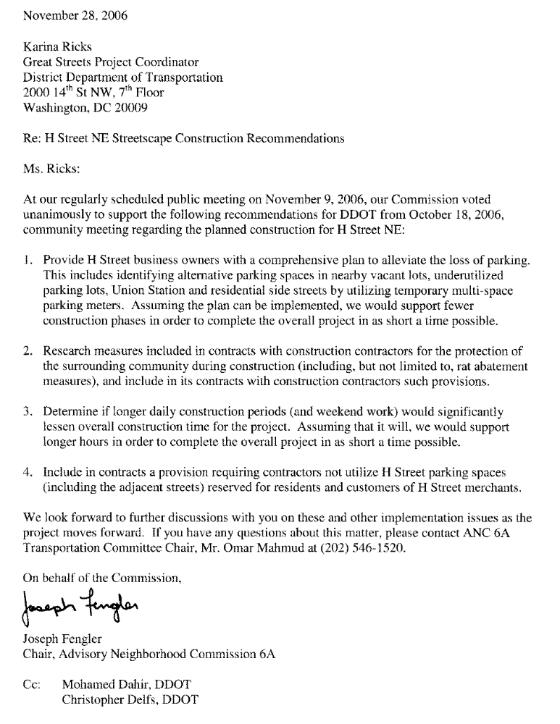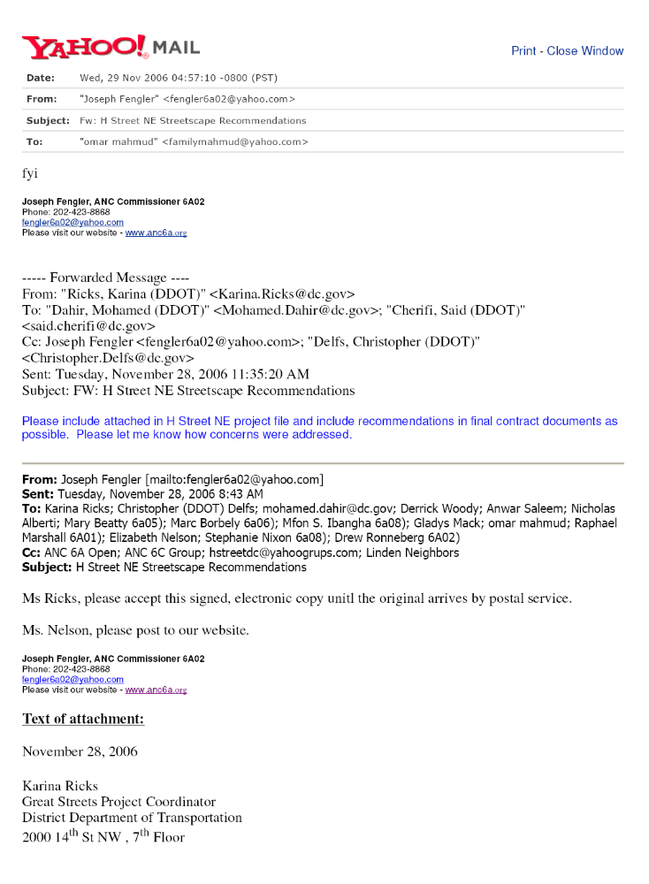
February ___, 2007

José L. Colón, Lead Civil Engineering Technician
Public Space Permits and Records Branch
District of Columbia Department of Transportation (Room 2104)
941 North Capitol Street, NE
Washington, DC 20002

Denise L. Wiktor, Manager
Public Space Permitting Division
District of Columbia Department of Transportation (Room 2104)
941 North Capitol Street, NE
Washington, DC 20002

Re: 29 15th Street, NE electrical box

Mr. Colón and Ms. Wiktor,

At our regularly scheduled public meeting on February 8, 2007, our Commission voted [unanimously] to request that the District of Columbia Department of Transportation (DDOT) investigate a potential public space violation at 29 15th Street, NE. It appears that electrical wiring and a very large electrical utility box has been installed in public space without a permit (photos attached). To our knowledge, there is no public space permit for the electrical box and no “Application to Install Electrical Wiring in Public Space” had been submitted by the property owner.

This electrical box is illustrative of a growing problem in our community of contractors treating public space as private property to the detriment of the surrounding neighborhood. Our Commission requests that DDOT investigate this case and respond in writing to the following questions:

- Does the owner have a proper public space permit for the electrical box on public space?
- What actions will be taken to bring the property into compliance with public space regulations?
- How long after the notification of a violation will the owner be able to obtain a permit?
- If the property owner fails to obtain a permit, will an order be issued for its removal?
- What mechanisms will be used (e.g. fines) to insure compliance with public space requirements?

We look forward to the results of the investigation and subsequent answers by [March ___], 2007, so we can continue to work together to protect our city’s public spaces. If you have any questions regarding this matter, please contact Omar Mahmud, chair of our Transportation and Public Space Committee, at (202) 546-1520 or by electronic mail at familymahmud@yahoo.com.

On behalf of the Commission,

Joseph Fengler
Chair, Advisory Neighborhood Commission 6A

cc: Christopher Delfs, Ward Six Transportation Coordinator

Photographs:
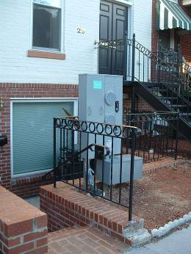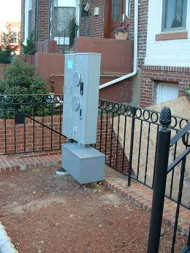
ANC 6A Transportation and Public Space Committee 2007-2008 Goals

- Provide a forum for the ANC 6A community to discuss and recommend solutions to transportation and public space-related issues impacting ANC 6A.

- Provide the ANC 6A Commission with timely, well-informed recommendations regarding transportation and public space-related issues so that it may weigh in on city decisions affecting ANC 6A including, but not limited to, streetscape improvements for the H Street corridor, the proposed streetcar line serving the H Street/Benning Road corridor, proposed uses for public spaces and implementation of the Capitol Hill Transportation Study.

- Track progress of streetscape improvements for the H Street corridor, creation of a streetcar line serving the H Street/Benning Road corridor and implementation of the Capitol Hill Transportation Study, and report to the ANC 6A Commission on these matters.

- Work with the District Department of Transportation, Deputy Mayor for Planning and Urban Development and/or other city agencies to implement the proposals contained in the H Street Corridor and Capitol Hill Transportation Studies, including upcoming studies and initiatives aimed at making the city more bicycle rider and pedestrian friendly.

- Review and report to the ANC 6A Commission all significant transportation and public space-related activities conducted by the District Department of Transportation, Washington Metropolitan Area Transit Authority, Deputy Mayor for Planning and Urban Development, Office of Planning, National Capital Planning Commission, and other agencies that directly or indirectly impact ANC 6A.

- Expand relationships and coordinate efforts with other city ANCs and community groups having a stake in transportation and public space matters impacting ANC 6A.

- Assist the District Department of Transportation with development of a transportation management plan (parking, public transit, car sharing, etc.) for areas in ANC 6A facing increased demands on transportation infrastructure, such as the H Street/Benning Road corridor and the surrounding neighborhoods.

- Help educate the ANC 6A community on transportation and public space-related concepts.

- Work with other ANC 6A committees to address committee crossover issues including, but not limited to, zoning and public safety concerns.

ANC ____
A Resolution Supporting Passage of H.R. 328

WHEREAS, the each Commissioner on every Advisory Neighborhood Commission (ANC) in the District of Columbia is a publicly elected official of the District of Columbia government; and

WHEREAS, the United States government recognized the importance of local representation of citizens of the District of Columbia by creating the ANCs in Pub. L. 93-198, title VII, § 738, as amended; and

WHEREAS, pursuant to DC ST § 1-309.10(f), “each Commission may present its views to any federal or District agency”; and

WHEREAS, at a duly noticed public meeting of Advisory Neighborhood Commission (ANC) ____ held on ____________ ___, 2007 the Commissioners considered the matter of H.R. 328, introduced in the United States House of Representatives during the 110th Congress on January 9, 2007 by the Honorable Eleanor Holmes-Norton (DC) and the Honorable Tom Davis (VA); and

WHEREAS, over half a million people living in the District of Columbia, the capital of our democratic Nation, lack direct voting representation in the United States Senate and House of Representatives; and

WHEREAS, District of Columbia residents have fought and died to defend our democracy in every war since the War of Independence; and

WHEREAS, District of Columbia residents pay billions of dollars in Federal taxes each year; and

WHEREAS, our Nation is founded on the principles of `one person, one vote' and `government by the consent of the governed'; and

WHEREAS, a Bill identical to H.R. 328 was passed by the United States House of Representatives during the 109th Congress, but the Senate failed to take up consideration of that Bill prior to dissolution of the 109th Congress; and

WHEREAS, the citizens of the District of Columbia have for too long been denied many of the rights, responsibilities and privileges enjoyed by the citizens of each of the United States, including representation in the Congress.

NOW THEREFORE, BE IT RESOLVED:

- ANC ____ urges the Judiciary Committee of the United States House of Representatives to promptly consider and vote to recommend passage of H.R. 328 by the full United States House of Representatives.

- ANC ____ urges each Congressperson in the United States House of Representatives and each Senator the United States Senate to promptly consider and pass H.R. 328, and forward the Bill to the President of the United States for his signature.

- ANC ____ urges the President of the United States to promptly sign H.R. 328 into law after the Bill is presented for his signature.

This Resolution was duly considered and passed by ANC ____ at its public meeting held on _____________ ___, 2007 by a vote of ___ - ___ - ___.

________________________________ Attest: ________________________________
Chair Secretary

