7:00 pm Call to order, adopt agenda and approve previous meeting’s minutes – starts on page 3
7:05 Community Comments (2 minutes each)
7:10 Officer Reports:
Chair (2 minutes)
Vice-Chair (2 minutes)
Secretary (2 minutes)
Treasurer (2 minutes) - starts on page 14
- Approve treasurer’s report and previous month’s disbursements.
- Approve monthly photocopying expenses.
- Approve 1st Quarter Financial Report
8:40 Single Member District reports (2 minutes each)
Standing Committee Reports:
8:50 Alcohol Beverage Licensing – starts on page 20
- Next meeting – 7:00 p.m., February 19, 2008 (third Tuesday)
9:00 Economic Development and Zoning – starts on page 21
- Recommendation: Send letter to DCRA stating the proposed use of 820 8th St, NE meets the definition of an adult rehabilitation home and that a Certificate of Occupancy should not be granted until the owner obtains zoning relief for the facility.
- Recommendation: Support the plans for rear-addition and patio area for 225 9th St., NE (HPA #08-123) if Mr. Fiore can produce letters of support from his adjacent neighbors.
- Recommendation: Oppose application for 2 story addition for 1131 D St., NE (HPA #07-337) for lack of information.
- Recommendation: Send letter to Director Argo at DCRA stating that calls to 727-6161 on the weekends were not resulting in investigation of illegal construction complaints.
- Next meeting – 7:00 p.m., January 15, 2008 (third Tuesday)
9:00 Community Outreach – starts on page 24
- Recommendation: Approve a grant not to exceed $4,230 to the Rosedale Citizen Alliance and Rosedale Youth Institute for purchase of 2 sets of football uniforms.
- Recommendation: Approve a grant not to exceed $4,000 to the Capitol Hill Restoration Society to fund a Historic Survey along H Street.
- Recommendation: Approve use of a moderated listserv for official announcements of ANC6A business to replace current word based e-mail list.
- Recommendation: Approve language for the moderated listserv for official announcements of ANC6A business.
- Next meeting – 7:00 p.m., January 21, 2008 (third Monday)
9:00 Public Safety – starts on page 32
- Next meeting – 7:00 p.m., January 15, 2008 (third Wednesday)
9:00 Transportation and Public Space Committee – starts on page 34
- Recommendation: Send letter of support for the National Marathon.
- Recommendation: Send letter of support for H Street Shuttle Bus Service to Council Member Wells.
- Recommendation: Send letter to DDOT requesting an elimination of vacant property curb cuts on the 1400 block of MD Avenue and the 600 block of 14th Street, NE and to change the location of a bus stop, to expand the curbside parking supply.
- Recommendation: Send letter of support of car sharing program to DDOT with ANC6A recommendations for improving the car sharing program.
- Recommendation: Send letter to DDOT requesting removal of parking restriction signs on the east side of the 400 block of 13th Street, NE
- Next meeting – 7:00 p.m., January 23, 2008 (third Monday)
9:00 Unfinished Business
9:00 New Business – starts on page 2

Advisory Neighborhood Commission 6A
Miner Elementary School
January 10, 2007
Minutes

The meeting began at 7:00 PM.

Present: Commissioners Alberti, Beatty, Fengler, Holmes, Mack, Marshall, Nixon, and Schultheiss

- Agenda
Ms. Beatty asked that a proposed allocation for an increase in the cost of liquor store stickers be added to the ABL discussion. The addition was accepted by consensus, and the agenda, as amended, was approved without objection.
- Minutes
The November minutes were adopted without objection
- H Street Update
Emeka Moneme, Director of DDOT, along with Karina Ricks, who has worked on the H Street project for five years, presented the current status of the H Street Streetscape project:
Bids were opened during the first week in January, and a decision on contractors will be reached by the third week in January. He said that the new sidewalks would be aggregate, and the project will include new lighting, storm water management, bus shelter, which will be installed by Spring 2008. He expects the project to take 20-30 months, depending on the weather. In order to mitigate the impact of the project on H Street, it will be broken up into sizeable chunks, there will be regular coffees with the affected businesses to discuss any changes in the scope of work, etc., and there will be a storefront office to provide access. He said DDOT is working on the potential disruption, and is working with Metro on the route of the X2 bus, as well as working on a better traffic plan. He is also working with Councilmember Wells on shuttle service along the corridor. He reiterated that the streetcar tracks are included in the RFP and said that he and the Mayor would make an announcement in the near future.
He reported that DDOT is finalizing the streetcar network, including the Anacostia leg as well as H Street, but said that the streetcar, which will run from 3rd to 14th Street, will not be shuttle service and connections with Benning Road and Union Station will have to be developed. He said that the streetcars will be ready by the end of construction, and money has been set aside for five cars.
Joe Englert asked about how the construction will be staged to allow vehicles to be moved out of the front of businesses at night. Ms. Ricks said that the construction will occur three blocks at a time, beginning at the west end, and moving up to 16th Street, and back down the south side of the street from 14th Street to 3rd. There will be Jersey barriers in the work zone, and all parking will be eliminated. There will be meters on blocks off of H Street, which people with residential stickers can use without paying. They will maintain 5’ of the 10’ wide sidewalk. The sections will be, on the south side, 3rd –6th Street, 7th-11th Streets, 12th to 16th Street, and reversed on the North side. Frank Hankins stated that a year and half with that plan will put him out of business. Ms. Ricks said that there are incentives in the plan for the contractors to make it go more quickly, and there is an advertising scheme in place to promote the H Street corridor during construction. She said that DDOT is aware of the heavy burden it will place on business owners, but there is a willingness to work to mitigate it. One of the reasons, she said for the staging is that the lighting is on a single conduit.
Mr. Fengler suggested that there has to be a meeting with the business owners and the engineers and others working on the project, and the meeting should be set up sooner rather than later.
Aaron Hirsch, a business owner asked whether there was any benefit for owners, and whether a parking plan has been included in the plans. Mr. Monome responded that no federal transportation dollars can be used for local businesses. He also said that DDOT is working on citywide valet parking regulations.
Steve Hessler said his wife is opening a business-an art gallery-on the north side of H Street at 13th Street and asked whether there is any tax credit or tax moratorium available for real estate owners. Councilmember Kwame Brown responded that there is a micro-loan fund that has $2 million in it, that Ben’s Chili Bowl was able to take advantage of it when the Metro was being built on U Street, and that they are working out how to administer the funds.
Mr. Schultheiss asked about a response to a letter he wrote in May asking about the possibility of parking on Florida Avenue. He also asked about the nighttime enforcement of steel plate sealing. Mr. Monome said that there is capacity for parking in the 1200, 1300 and 1400 blocks of Florida Ave. during the day, but that at night it was being used for valet parking. As for the steel plates, he said that DDOT is only one agency involved and there is “no consensus on the leadership level” of PEPCO and WASA that have to be involved in these decisions.
Derek Woody, Great Streets Program Manager, addressed the program, which has $25 million set aside for H Street to diversify the retail mix on the street and create a lively destination street to enhance the community. He said that there has been public notice that funds are available for unique retail, that $500,000 has been set aside for façade improvement, and that $6 million is targeted for H Street capital improvements. They are working on developing a mixed-use program for 13th and H Street that will incorporate the Christian Library, and something should be available by the end of January.
Drew Ronneberg asked whether business owners at the eastern end of the corridor have access to the funds, and Mr. Woody replied that individual owners did not, but that it would be possible for groups to band together to apply for them. Joe Englert said he had spoken with the owner of Mark and Orlando’s, a restaurant on P Street NW, who said that business went down 70%, which he said would be devastating to his business. Mr. Fengler responded that the plan has been public for five years, and these issues haven’t been raised. Bobby Pittman asked whether thought was being given to the tax impact of the development to residential property owners on and off H Street. Mr. Woody responded that there is nothing can be done about those increases.
Anwar Saleem, Director of H Street Main Street, began with a history of the Clean and Safe program that is being implemented on H Street to pick up trash and provide Ambassadors for visitors needing assistance. They are currently raising seed money, and have $320,000 from various sources including DDOT and Dreyfus. They are contracting, like other BIDS, with Ready, Willing and Able, a project of the Gospel Ministry homeless program, and they have enough money to start the program. Mr. Alberti said that the success of other BIDs has been their ability to tax the businesses in their areas, and that this program was voluntary and how did he expect it to succeed. Mr. Saleem responded that H Street does not yet have the tax base, but as retail increases, they will reach a critical mass and be able to institutionalize the fees. He said that property tax increases mean that there will be more available funds, and that the business owners needed to be educated as to the value of a BID.
Patrick Lally said that they had tried their own version of a BID once before, and it failed, and asked how he could guarantee that the same thing didn’t happen this time. Mr. Saleem responded that the goal is to raise the funds to guarantee stability, and the important thing was to educate business owners. He said that the program should be ready to go in March or by April 1st.
Mr. Saleem reported that Dreyfus has released some money for some façade projects which will begin on twelve buildings as soon as the architects complete their drawings. The buildings are 410, 417, 519, 654, 1017, 1125, 1236, 1255, 1338, 1360, 1366 and 1411 H Street. The buildings were selected by a committee and the focus will be on easier things like painting. There has been an average of $15,000 allocated for each building.
Gary Rapaport, CEO, Rapaport Companies, along with Chip Glasgow of Holland & Knight, presented a history of the site of the H Street Connection, which was constructed in 1987. He said he always builds and manages his projects for the long term, and plans to do the same thing with this project. He said he wants to build something special for the long term, and not sell for its short-term value.
Mr. Glasgow said they would build a 90’ building at the rear of the site, which will have an FAR of about 5. It will be about 430,000 square feet, with a total of 50,000 sq. ft. of retail. There will be about 400 residential units, with parking and loading off of 8th and 10th Streets.
Mr. Fengler said how pleased he was that Mr. Rapaport is starting early on his plan, and there was a long time for discussion. Mr. Rapaport said he is looking at starting four years, because he has tenants with leases, and has to go through the zoning process. He said he has management relationships with lots of retail establishment and restaurants and plans to have a good mix of stores for the development.
Councilmember Tommy Wells complimented the ANC as one of the best in the city. He said that the streetcars are in the budget, and there are three cars waiting in Prague earmarked for H Street. He said he is frustrated with the delays on H Street, but he and the Mayor will be having a news conference soon to recommit to the project. He has asked for funding for a shuttle to go from Union Station to Benning Road. On vacant buildings, he said he has his list of buildings and is trying to stop the speculation and flipping of buildings. He concluded by saying that there is a huge public investment in H Street and it is a challenge to try to bring order out of chaos. He reported that his vacant property legislation, closing a loophole in the tax law, will be put in with the next round of tax bills.
Councilmember Kwame Brown said that businesses on P Street are suffering because of their street project, and it would have died if local residents did not keep going back to the restaurants week after week. He said that H Street will benefit from lessons learned from P Street. He reiterated that small businesses will not survive without local patronage. He also said that the Committee of the Whole will have oversight over the redevelopment, and that after the streetscape there will be incentives for retail and restaurants with 50 seats of more—for example, Napa will be able to take advantage of them.
A member of the community said that parking at Union Station is expensive -- $14—and rates will have to come down if it’s going to be used to mitigate conditions on H Street.
- Special Orders
Mr. Fengler suggested that the by-laws changed be adopted en bloc. Mr. Holmes seconded the motion. The following changes to the bylaws were presented:
- The current bylaws incorrectly contain two sections listed as “Section 2” within Article VIII. Technical correction: Article VIII, Section 2 is renamed Section 3 – Committee Membership.
- Bylaw changes regarding committee membership. Proposed standards for committee membership:
1. Committee members may be nominated by a commissioner or committee chair to serve for a term of one year. (In Article VIII, Section 3, add subsection d).
2. If a committee member misses three consecutive meetings, the committee chair may request that the ANC, by simple majority vote, remove thee member from the committee. (In Article XI, Section 3, insert a new subsection c and renumber existing c to d, d to e, and e to f).
3. Committee membership is open to all residents of ANC 6A. Residency is defined as a person who is registered to vote or files their District or federal taxes (as a primary residence at an address within ANC 6A. A person shall not be considered a resident of ANC 6A if they claim a homestead exemption on an address located outside the boundaries of ANC 6A (In Article VII, Section 3, add subsection e).
4. If item number 2 is approved, the following technical correction for Article XI, Section 3, subsection (b) is proposed as follows: A vote to remove a committee chairperson (delete or committee member) shall be called if at least one-half of the elected Commissioners request in writing that the ANC Chairperson take such action. After the request is made, the ANC Chairperson will ensure that the action is included on the next regularly scheduled meeting agenda.
The motion to accept the by-law changes passed 8-0.
- Election of Officers
Motion: Mr. Fengler proposed electing the new officers as a slate. The motion passed without objection.
Motion: Ms. Beatty moved/Mr. Holmes seconded a motion to elect the current officers—Chair: Joe Fengler; Vice Chair – David Holmes; Secretary – Bill Schultheiss; Treasurer- Nick Alberti—for 2008. The motion passed unanimously.
Motion: Mr. Fengler moved/Ms. Beatty seconded a motion to elect the current committee chairs—Alcoholic Beverage and Licensing – Mary Beatty; Economic Development and Zoning – Drew Ronneberg; Public Safety – Stephanie Nixon; Community Outreach – Elizabeth Nelson; and Transportation and Public Space – Omar Mahmud. The motion passed unanimously.
Motion: Ms. Beatty moved/Ms. Nixon seconded a motion to elect the current members of committees for 2008—Alcoholic Beverage and Licensing – Trish Olshefski, Michael Herman, Mary Kosinski, Jeremy Marcus, Derrick Figures, Richard Sundberg; Economic Development and Zoning – Annie Swingen, Rich Luna, Linda Whitted, Jeff Fletcher, Barbara Halleck; Public Safety – Annie Swingen, Joe Bellino, Dan Wolff; Community Outreach – Louis Barbash, Sylvie Lee, Kenneth Wicks, Rosetta Williams, Mark Roy; Transportation and Public Space – Lance Brown, Marion Smoker, Delanie Hardy, Diane Hoover, Sean Lovett, Warner Sterling. The motion passed unanimously,
- Community Comment
Patti Shea asked about the status of Lincoln Park, and was told by Mr. Alberti that the projection is that Phase 1 of the renovation will be completed by February 12, and he will have a more definite answer shortly.
Annie Swingen announced a meeting of H Street Heritage Trail project on February 6th at the Atlas Theater.
Herbert Jones, consumer advocate from the Office of the People’s Counsel announced a hearing by Councilmember Mary Cheh on the quality of service by PEPCO and WASA on February 9th.
- Officer Reports

Treasurer
Mr. Alberti presented the Treasurer’s Report. The opening balance of the checking account was $27,991,96. The savings account had an opening balance of $4,175.74, and there was an interest payment of $1.03, for a balance of $4,176.77. The following disbursements were approved: $1000 to the School Libraries Project for a grant for Ludlow Taylor School (Check #1343); $3000 to Capitol Community News for monthly Hill Rag ads (Check #1344); $127.50 to Roberta Weiner for transcribing minutes (Check #1345); $338.50 to Catalogue Marketplace3 Inc. for a grant to Eastern High School PSTA (Check # 1346); $703.05 to On-Line Dance Wear for a grant to Eastern High School PSTA (Check #1347)); $500 to Liberts for a grant to Eastern High School PSTA (Check #1348); $274.99 to the Band Shoppe for a grant to Eastern High School PSTA (Check #1349); $1,536.76 to Weissman Designs for Dance for a grant to Eastern High School PSTA (Check #1350); and $584.49 for a grant to Trees for Capitol Hill (Check #1351). The closing balance was $19,136.97.

Motion: Commissioner Alberti moved/Mr. Fengler seconded a motion to approve the Treasurer’s Report. It was approved without objection.
Motion: Mr. Alberti moved/Mr. Fengler seconded a motion that $600 be approved for copying for ANC materials, and that up to $60 be approved for copying for each Committee’s materials and each SMD’s materials for the next month. The motion was accepted without objection.
Motion: Mr. Alberti moved/Mr. Holmes seconded a motion to disburse $25 to the ANC Security Fund. The motion passed without objection.
Motion: Mr. Alberti moved/Mr. Fengler seconded a motion to allocate $25 to the petty cash fund. The motion passed without objection.
Motion: Mr. Alberti moved/Mr. Fengler seconded a motion to allocate up to $250 for the yearly post office box rental.
- Single Member District Reports
Mr. Alberti reported that he as entered an appeal to the AppleTree permit for a public school at 138 12th St NE, citing that required environmental assessments have not been made on the site, which is a former oil company site. An environmental impact assessment is required for projects of this size. The assessment would presumably have been required by DCRA, had AppleTree not under reported the cost of the project on it's permit application. He also said there had been a meeting on parking at Brown AME Church with Councilmember Wells, and no progress was made. Another meeting was scheduled for January 19th.
Mr. Marshall reported that Jimmy’s Tires had collapsed, and an oil tank was submerged. He said, however, that HAZMAT did an assessment and the site is okay. He said that New Year’s Eve in his SMD had been the quietest New Year’s ever, and he was sending a letter to Chief Lanier to commend her officers. Finally, he reported he had called Reverend Jones in regard to his plans for the halfway house at Pilgrim Baptist Church, but his calls have not been returned.
- Committee Reports
Alcoholic Beverage and Licensing
Motion: Ms. Beatty moved/Mr. Alberti made a motion to support the committee recommendation to approve a stipulated license for SOVA. The motion passed without objection.

Motion: Ms. Beatty moved/Mr. Fengler seconded a motion to increase the allocation of $300 for a sticker for establishments that have voluntary agreements with the ANC to place in their windows to $318. The motion passed without objection.
There were no other committee reports.

The meeting was adjourned at 9:10 pm.

January 16, 2008

Mr. David Maloney
State Historic Preservation Officer
Historic Preservation Office
810 North Capitol Street, NE
Washington, DC 20002

Dear Mr. Maloney:

Advisory Neighborhood Commission 6A has voted unanimously endorse a survey of all the potentially historic resources within our boundaries. To that end, we are working in partnership with CHRS on a survey effort of the Rosedale and Capitol Hill North (extended) area over the next year and a half. We are asking for your assistance through a federal historic preservation fund grant.

CHRS will be submitting the proposal and listed as grant sponsor, as they will be administering the grant and supplying a 50% cash match. But this is a full partnership between ANC 6A and CHRS. The original cost of the contract to undertake this project was $67,850. Together with CHRS, we have reduced the price by $20,800 by supplying volunteer on-site surveyors.

In tandem with the Rosedale project, we are also embarking upon a survey of H Street within our boundaries (from 8th to 15th Street), in partnership with CHRS.

As you can see, we are very engaged and committed to the historic survey of our neighborhood. We hope that you will assist us in our efforts by granting us the requested $23,525.

On behalf of the Commission,

David Holmes
Vice Chair, Advisory Neighborhood Commission 6A

cc: Richard Wolf, CHRS
Donna Hanousek, CHRS
Joseph Fengler, Chair, ANC 6A

January 11, 2008

Mr. David Maloney
Historic Preservation Review Board
801 North Capitol Street, NE
Suite 3000
Washington, DC 20002

RE: Request for hearing postponement for HPA# 07-337 (1131 D Street, NE)

Mr. Maloney:

We formally request a postponement in hearing HPA #07-337 regarding 1131 D Street, NE as our Commission has not had the opportunity to discuss potential concerns with the applicant. After reviewing the plans, we believe the following issues must be addressed before our Commission makes an informed recommendation on the application:

- This free-standing building is on an R4 designated square. The existing structure is over the maximum 40 % lot occupancy (DCMR 403.2). The owner and developer of the property, Mr. Barry Johnson, are seeking to put an addition onto the west side of the existing structure. The proposed addition will be built into a side yard which is currently vacant. There are questions as to where his property lined ends and if the side yard is indeed part of the lot. Based on the drawings, it appears that Mr. Johnson plans to connect his building, via the addition, to his neighbor’s (lot 836) through the creation of a party wall. However, no letters of notice and approval from neighbors have been presented to CHRS or the ANC. Thus, we are concerned both about the zoning implications of this addition (as he is already over the maximum lot occupancy allowed) and the lack of proper notice given to his neighbors.

- We are also unclear as to his actual property lines and design of the building. Based on his survey and drawings, it appears the applicant may be planning to use public space in the rear for parking. Thus, we would like the opportunity to speak with Mr. Johnson and clarify these issues. Additionally, we have a few design questions (e.g., placement and number of doors, bay projecting into public space) that should be addressed.

- The existing structure has two curb cuts; on D Street, NE and the other on 11th Street, NE. We have not received any site plans that include the curb cuts or driveway/alley and would like to review the plans for these areas with Mr. Johnson

Mr. Johnson has agreed to present and discuss his plans at the scheduled ED&Z committee meeting on January 15, 2008.

On behalf of the Commission,

Joseph Fengler, Chair

Cc: Jonathan Mellon, HPO
Nancy Metzger, CHRS
Gary Peterson, CHRS
Barry Johnson
January 11, 2008

Mr. David Maloney
Historic Preservation Review Board
801 North Capitol Street, NE
Suite 3000
Washington, DC 20002

RE: Request for hearing postponement for HPA # 08-123 (225 9th Street, NE)

Dear Mr. Maloney:

We formally request a postponement in hearing HPA #08-123 regarding 225 9th Street, NE as our Commission has not had the opportunity to discuss potential concerns with the applicant. After reviewing the plans, we believe the following issues must be addressed before our Commission makes an informed recommendation on the application:

- We have not been unable to review any site plans that include adjacent properties nor have we received any letters of support from neighbors directly affected by this addition.

- We have concerns regarding the ambiguity of material to be used in the rear.

- We would like to see current photos of the property itself as well as neighboring properties to gain a better understanding of the scope of the project.

We have requested that the owner or representative of the property attend our scheduled January 15, 2008 ED&Z meeting to answer the above questions.

On behalf of the Commission,

Joseph Fengler
Chair

Cc: Jonathan Mellon, HPO
Nancy Metzger, CHRS
Gary Peterson, CHRS
Lou Fiore

December 18, 2007

Peter Feather, Chairman
Alcohol Beverage Regulatory Administration
941 North Capitol, NE
Washington, DC 20002

Dear Chairman Feather:

At our regularly scheduled meeting on December 13, 2007, with a quorum present, our Commission voted unanimously to support the issuance of a stipulated or temporary liquor Class Tavern license to Naby’s Island Restaurant located at 1128 H Street NE.

The owner of Naby’s Island Restaurant has appeared before our Commission to explain his plans for the restaurant and we have signed a voluntary agreement with him. We forwarded that voluntary agreement to your office. It is our understanding that after a review of the documents that Naby’s Island Restaurant had originally filed, the Alcohol Beverage Regulatory Administration informed them that the documents were incomplete. Since this will slow down the issuance of the Class Tavern license, our Commission supports the issuance of the stipulated license until they can provide the required information for a permanent license.

On Behalf of the Commission,

Joseph Fengler
Chair, Advisory Neighborhood Commission 6A

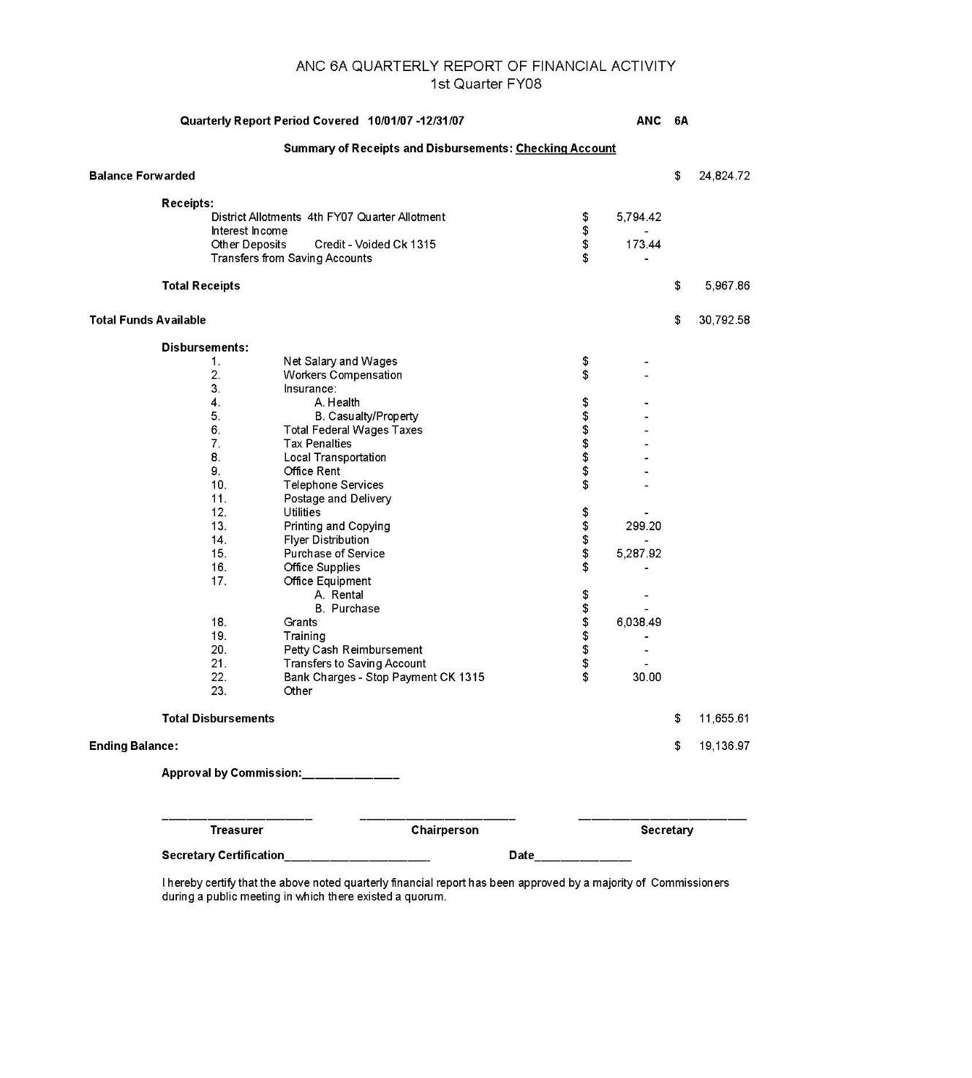
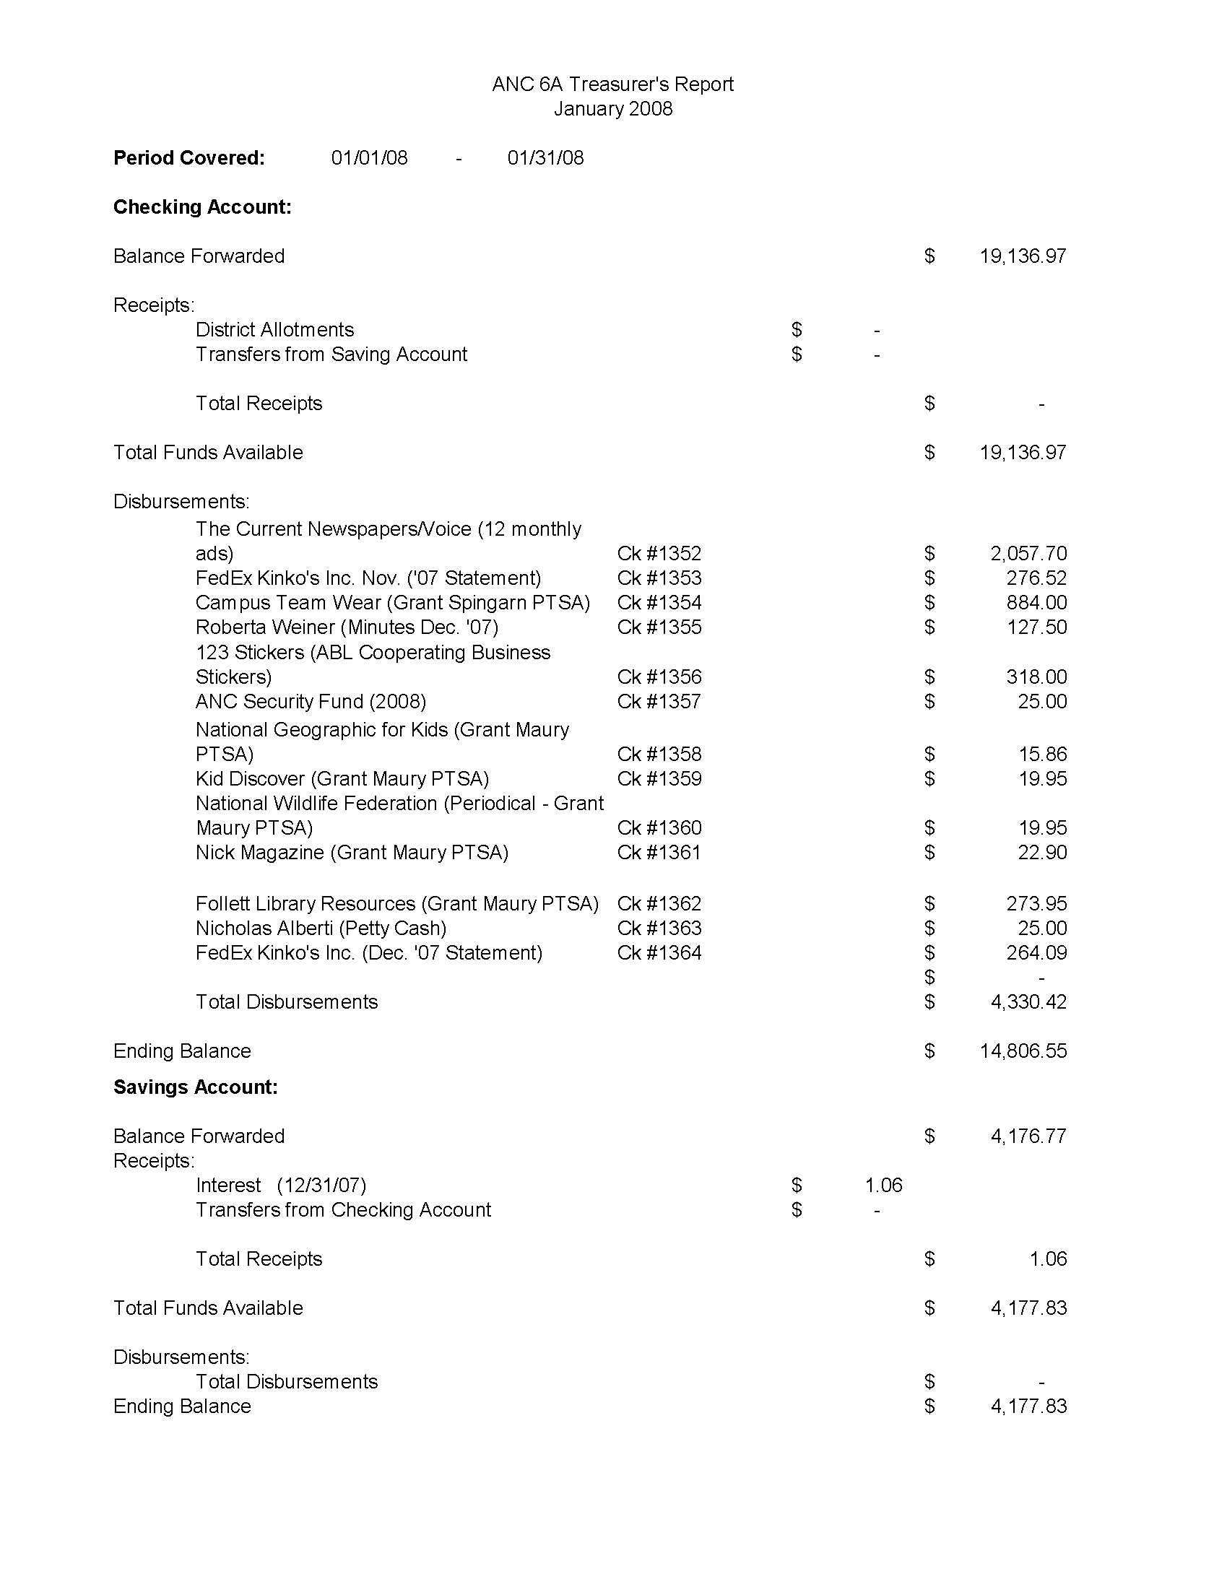
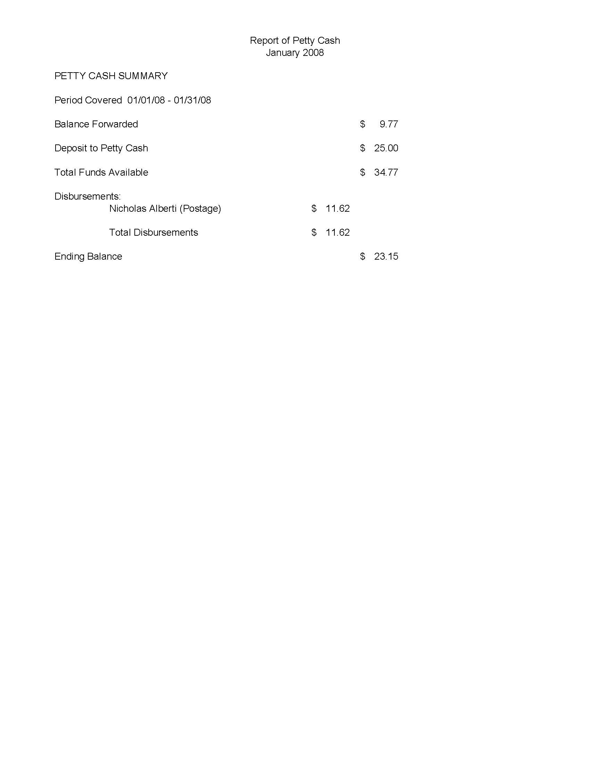
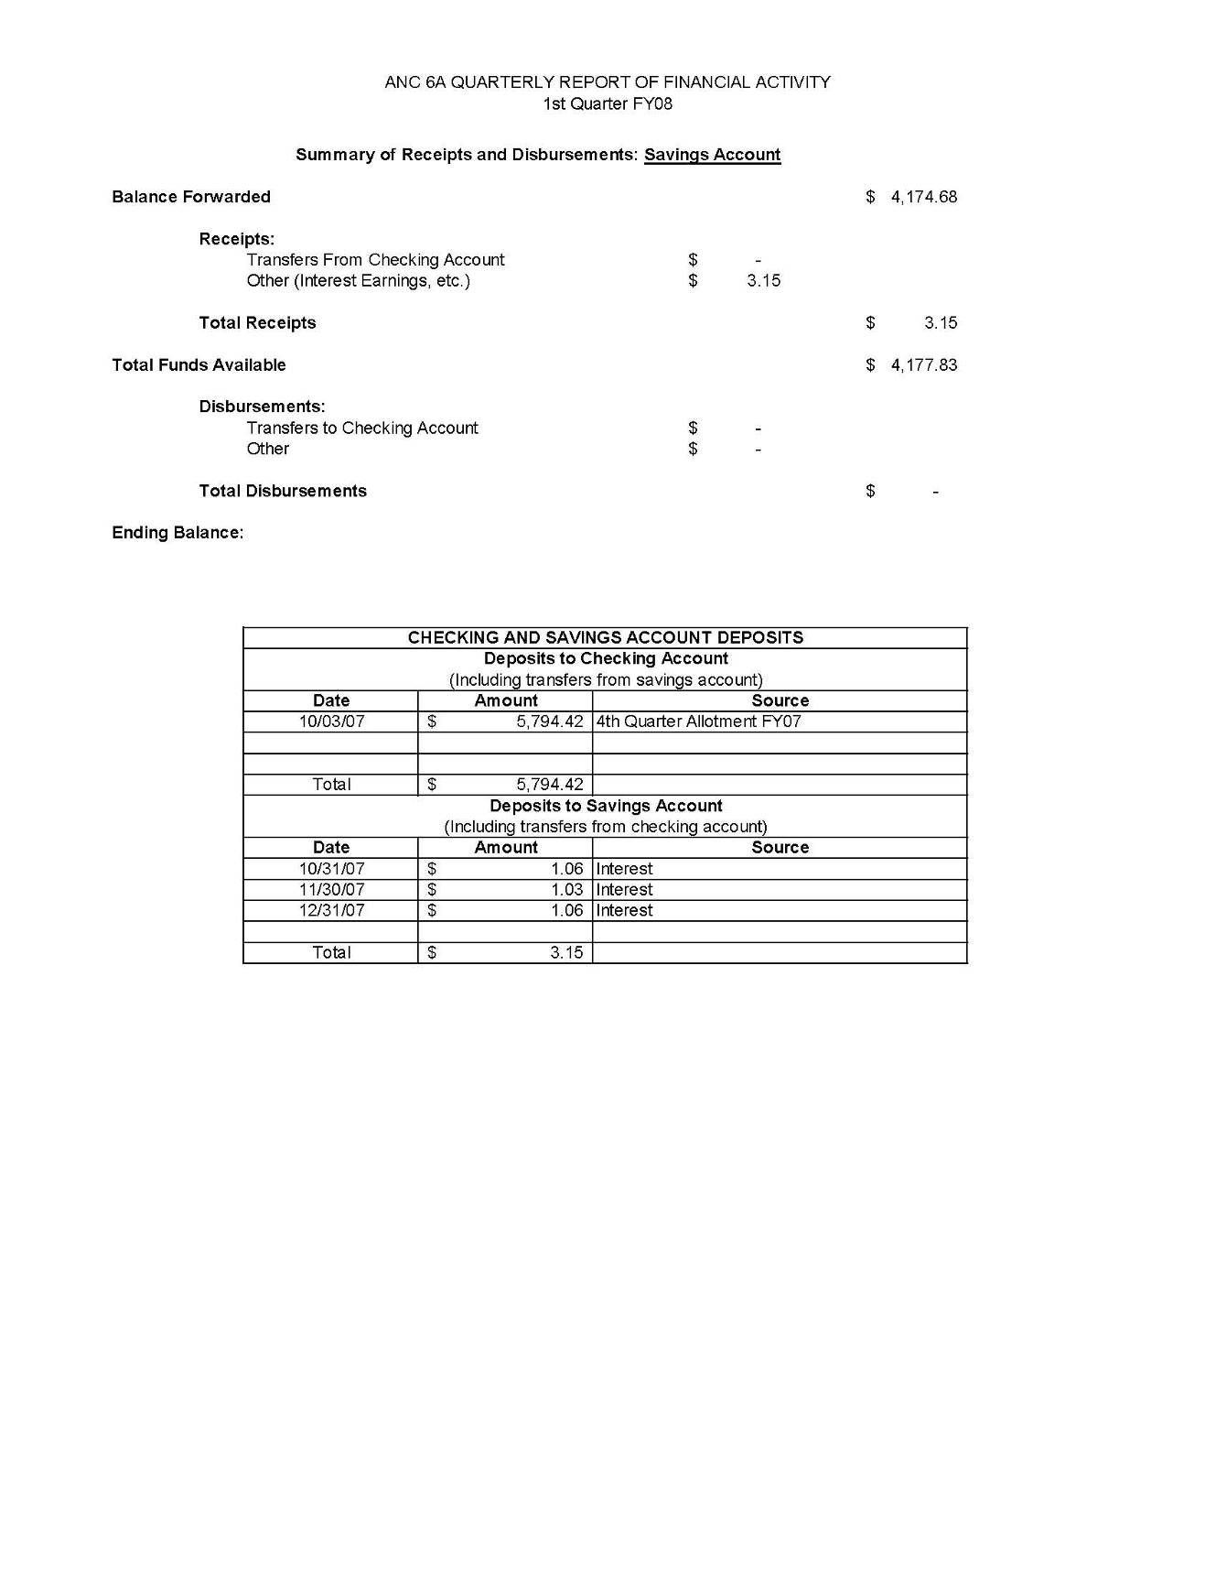
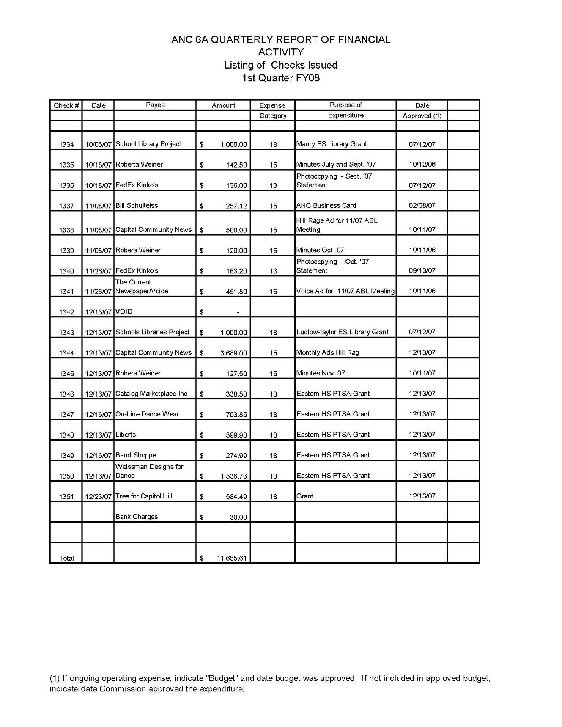
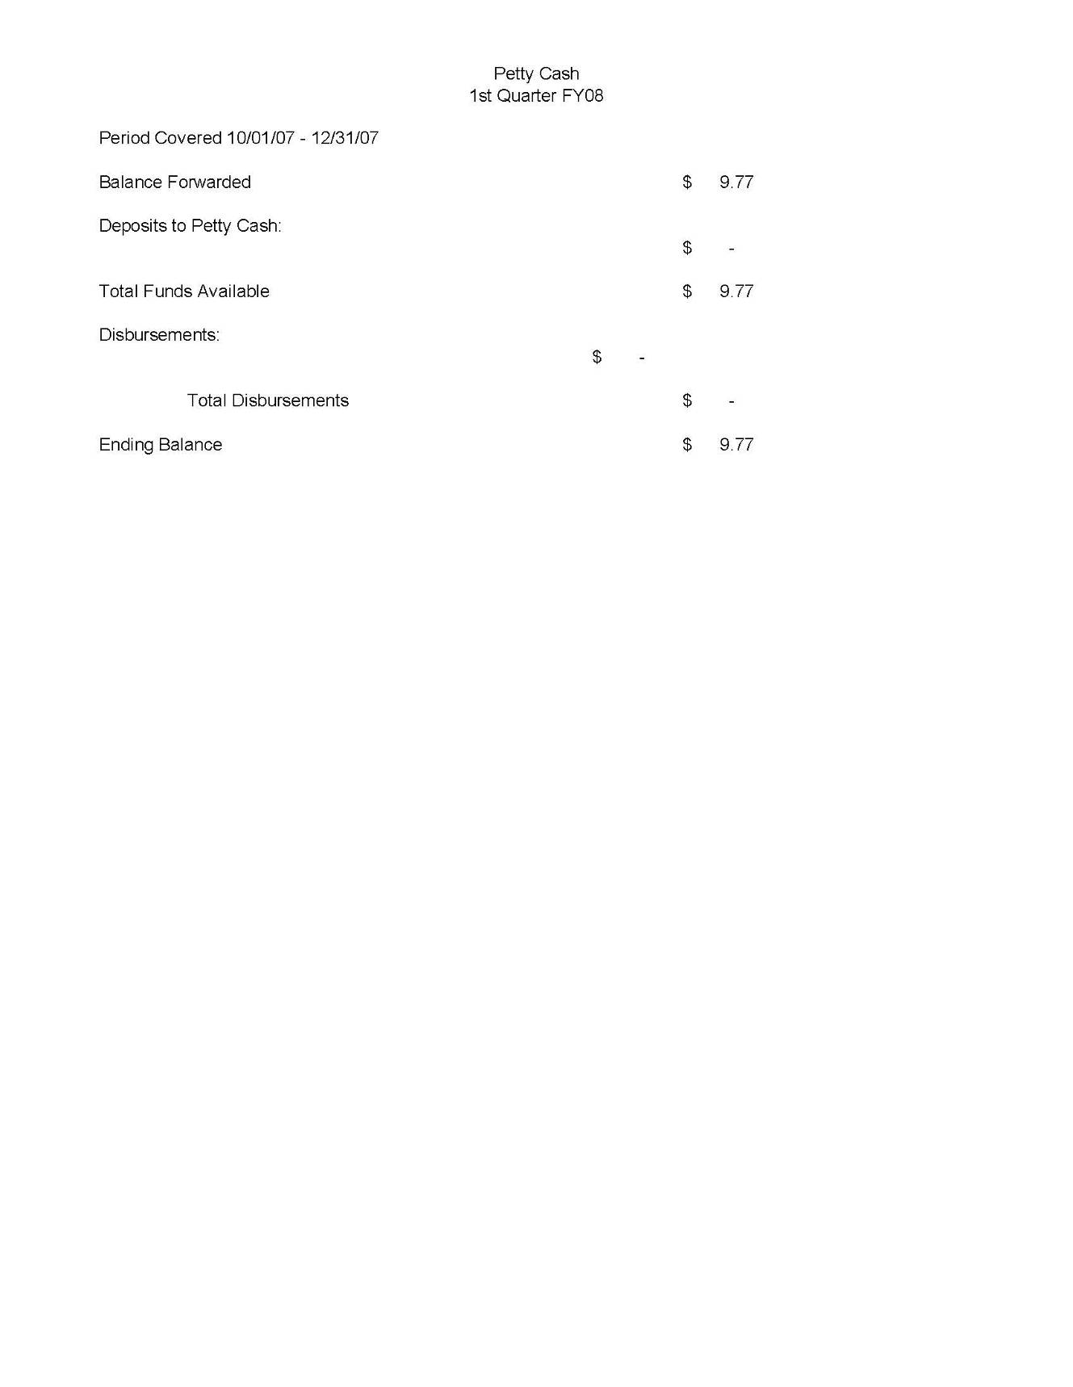
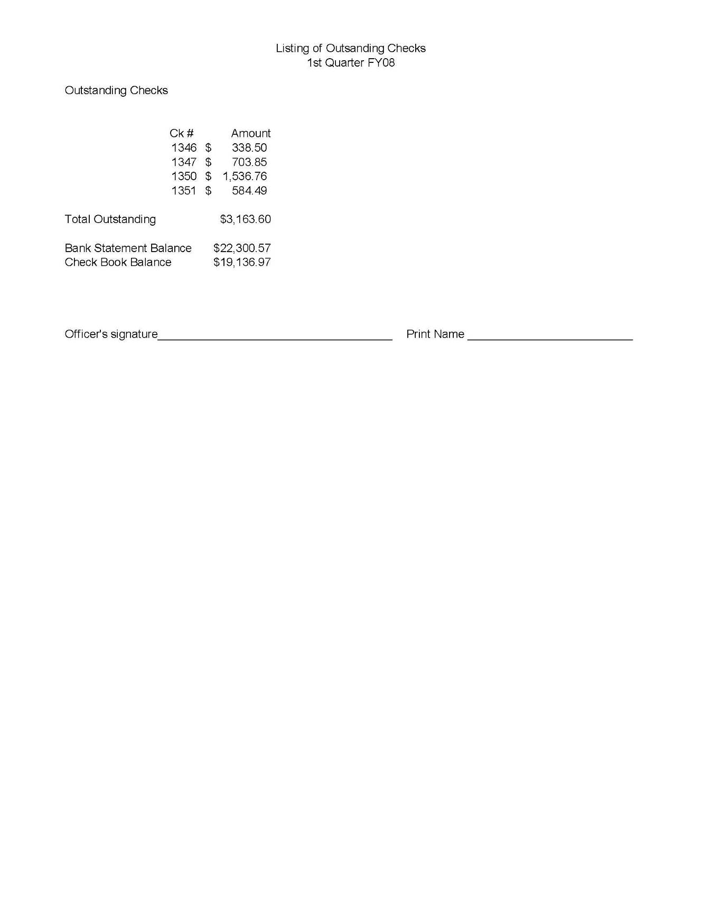
No Meeting in January

REPORT OF THE ECONOMIC DEVELOPMENT AND ZONING
COMMITTEE OF ANC 6A
January 15, 2008

Present: Commissioners: Raphael Marshall
Resident Members: Drew Ronneberg, Annie Swingen, Linda Whitted, Barbara Halleck
Drew Ronneberg chaired the meeting.

Community Comments
None

Status Reports

Vacant Properties. Drew Ronneberg reported that the committee will need a new point of contact for vacant properties because of Heather Scott’s resignation

Historic District Expansion/Creation. Annie Swingen reported that the ANC has conditionally supported a $4000.00 grant to be applied toward the surveying of H Street between 8th and 14th Street, NE. Additionally, CHRS has agreed to match the ANC grant for survey work. The surveying process of the Rosedale and Barney Circle neighborhoods is scheduled to be completed by March 1, 2008.

1383-1835 H St NE. Drew Ronneberg reported that the BZA granted the requested relief (2 variances & 2 specials exceptions) and that Mr. Robbins was planning on commissioning detailed drawings and applying for building permits.

1113-1117 H St NE. Drew Ronneberg reported that the group lead by Mr. Stan Wall won the NCRC RFP. Mr. Wall, who was in attendance at the meeting, pledged to work with the ANC on the design of the new structure. He also said that there would be 10 residential units in the new structure with 2 meeting the District’s standard for affordability.

Condo Conversion and Warranties. No updates.

Old Business
None

2008 ED&Z Committee Goals

The Committed adopted the following goals on a unanimous vote:

- Provide a regular public forum for Commissioners and residents to obtain information and discuss land use issues in the ANC 6A area or that affect the ANC 6A area.

- Review and report to the ANC on all significant activities by the Board of Zoning Adjustment, Zoning Commission, Historic Preservation Review Board, Office of Planning, National Capital Planning Commission, and other agencies that affect land use in the ANC 6A area.

- Make timely recommendations to the ANC that permit informed participation in city decisions on zoning, historic preservation, economic development, and other topics related to land use in the ANC 6A area.

- Monitor public and private development activities on H Street NE for consistency with the Strategic Development Plan and Neighborhood Commercial Overlay.

- As needed, schedule speakers from city or federal agencies who can address the interests or concerns of residents related to land use in the ANC 6A area.

- Work with the Transportation and Public Space Committee to systematically collect and report all
  - vacant and nuisance properties,
  - building permit violations and
  - public space violations.

- Major topical focus areas will be:
  - Historic District creation/expansion
  - Insuring that of the redevelopment of the H Street Connection site (800-1000 H St NE) consistent with Commission guidance
  - Insuring that ANC 6A vacant properties are on the DCRA vacant property list and that occupied properties are removed from the list.
  - Developing condo warrantee legislative proposals that close loopholes in the current system.
  - Participating in the process of rewriting the DC Zoning Code
  - Making sure DCRA applies the provisions of the H Street NE NC Overlay district to all properties on H Street,
  - Working with other groups to pass legislation to insure that City-funded social services are spread fairly and evenly across DC.

820 8th St NE

Commissioner Marshall requested the ED&Z committee look into whether the proposed ex-offender rehabilitation home at 820 8th St NE was permitted under the zoning regulations. The committee first examined whether Pastor Jones’ description of the facility at the December ANC meeting was covered by the definition of a Community Based Residential Facility (CBRF). The committee thought that the facility would fall under the definition of an Adult Rehabilitation home, which the zoning code defines as “a facility providing residential care for one (1) or more individuals sixteen (16) years of age or older who are charged by the United States Attorney with a felony offense, or any individual twenty-one (21) years of age or older, under pre-trial detention or sentenced court orders” While Pastor Jones claimed that the facility would not house felons, it was likely that individuals housed at the facility would be under court orders for probation, which would qualify the facility as a adult rehabilitation home. The committee also noted that Section 335.1 did not permit an adult rehabilitation home as a matter of right in an R-4 area, but only as a special exception. The committee also thought that the facility would likely fail several of the tests required to grant a special exception, and that the facility would then require a variance in order to operate.

Recommendation: The committee unanimously recommends that the ANC send a letter to DCRA pointing out that the proposed use of 820 8th St NE meets the definition of an adult rehabilitation home and that a Certificate of Occupancy should not be granted until the owner obtains zoning relief for the facility.

HPA #08-123 (225 9th Street, NE)

The applicant, Louis Fiore, presented plans to excavate his rear year and build a rear-addition and patio area. His architect clarified outstanding questions regarding materials and design. Given its “sunken” nature, the addition will be minimally visible from the rear and will neither adversely affect the air or light of the neighboring properties. Additionally, it falls within the design guidelines set forth by HPRB.

Recommendation: The Committee unanimously recommends that the Commission support Mr. Fiore’s application if he obtains letters of support from his adjacent neighbors.

HPA #07-337 (1131 D Street, NE)

The applicant, Barry Johnson, was not present at the ED&Z meeting to discuss a number of outstanding issues concerning his proposed construction. Based on Ms. Swingen’s phone conversations with Mr. Johnson, as well as plans supplied to the committee, it appears Mr. Johnson would like to put a two-story addition onto the western wall of his property, thus creating a new party wall with the neighboring property. Mr. Johnson has provided neither the ANC nor CHRS with letters of support from his neighbor. The existing plans show ambiguous property lines, do not provide adequate information about the types of materials that will be used in the addition and need clarifications on a number of design issues. Lastly, the committee is concerned about the use of the existing curb cuts on both 12th and D streets and the likelihood that setting back the addition will encourage parking on public space on D St.

Recommendation: The committee unanimously recommends that the ANC oppose HPA #07-337.

Reporting of After-hour Construction to DCRA

When Ms. Linda Argo, the director of DCRA, attended ANC 6A’s September meeting she told a number of stories about the difficulty of reporting illegal construction on the weekends. Ms. Argo replied that residents who wanted to report illegal construction on the weekends should call 727-6161. Drew Ronneberg reported that when he called that number on the weekend, the DCRA dispatcher said that MPD handled weekend illegal construction calls. Stephanie Nixon and David Holmes had reported similar experiences at a prior ANC meeting.

Recommendation: The committee unanimously recommends sending a letter to Ms. Argot stating that calling 727-6161 on the weekends was not causing the investigation of illegal construction complaints.
Next Scheduled ED&Z Committee Meeting:
Wednesday, Feburary 20, 2008
7-9 PM
640 10th Street, NE
2nd Floor - Sherwood Recreation Center
ADVISORY NEIGHBORHOOD COMMISSION 6A
Community Outreach Committee (COC)
Report for January 21, 2008

The Committee convened at 7:30 PM, at the Church of the Lord Jesus Christ of the Apostolic Faith annex, 1235 C St. NE.

Attending COC members: (quorum)
• Rose Williams
• Sylvie Lee
• Kenneth Wicks
• Louis Barbash
• Mark Roy
• Elizabeth Nelson (chair)

Community members:
• Annisteen Wicks
• Michelle Cohen, Capitol Hill Arts Workshop (CHAW)
• Jill Strachen, CHAW
• Rick Uzes, Rosedale Citizen Alliance (RCA)
• John Cotten, Rosedale Youth Institute (RYI)

I. Membership:
1. At the January 10 meeting of ANC 6A, the commissioners confirmed the nomination of Mark Roy as a member of the COC. His fellow committee members are very pleased to welcome him.

II. Grant application from Rosedale Citizen Alliance (RCA) & Rosedale Youth Institute (RYI)
1. Rick Uzes of the RCA and John Cotten of the RYI submitted their joint grant application for purchase of football uniforms for the teams associated with the Rosedale Recreation Center. These teams use the facilities at Rosedale but the program is operated and funded entirely by community volunteers. Football games are heavily attended and enjoyed by spectators from the community as well as the players. It is a successful community building program. By working closely with youth over a period of 30 years, they have been able to keep them out of trouble and reduce crime. Also, adults in the community have been motivated to make the surrounding safer for the benefit of children participating in the program.
2. Ms. Lee stated that she is personally familiar with the program and that it is indeed a good program.
3. Mr. Cotten said that his organization, RYI, is interested in getting involved with ANC activities and that the youth could help with tasks such as future distribution of the ANC 6A flyer.
4. There was some discussion as to whether or not there are funds available in the current ANC 6A budget. Ms. Nelson said that she asked, at the November ANC meeting, whether the Commissioners would be willing to consider grants once the budget had been exhausted, because she anticipated that additional grant applications would be received and she did not want to waste applicants’ time in applying, if there was no hope of funding. At that time, she was told that the Commissioners would be willing to consider funding grants beyond what had been budgeted.
5. With that in mind, the committee agreed, unanimously, to recommend approval of the grant application for at least one set of uniforms, preferably two.

Committee recommendation (unanimous): that ANC 6A
Approve a grant of $4,230 (jointly) to the Rosedale Citizen Alliance and Rosedale Youth Institute for the purchase of two sets of football uniforms, if funds are available. If the entire amount cannot be funded, we recommend approving $2,115 for one set of uniforms.

III. Grant application from Capitol Hill Arts Workshop (CHAW)
1. Jill Strachan and Michelle Cohen presented a grant application from CHAW to purchase the additional equipment necessary to add a “garage band” component to their existing music instruction program.
2. Mr. Barbash and Ms. Williams are personally familiar with CHAW, both having had children enrolled in arts programs run by the organization. They attested to the important role CHAW has played in the lives of neighborhood children.
3. After some discussion, it became apparent that the grant application was not ready for consideration and the CHAW representatives withdrew it. They expect to resubmit at a later date.

IV. Grant application from Capitol Hill Restoration Society (CHRS)
1. At the November ANC 6A meeting, the commissioners voted to fund a survey of the buildings fronting H Street N.E. in the Squares that are within the jurisdiction of ANC 6A. However, the funds cannot be disbursed without a grant application to support the expenditure.
2. With the purpose already approved by the commissioners, the only action required by the COC was to review the grant application submitted by CHRS, to ensure that it meets the statutory guidelines. It does.
3. The committee recommends acceptance of the grant application as the mechanism for funding the H Street NE survey.

Committee recommendation (unanimous): that ANC 6A
Accept the grant application in the amount of $4,000 from the Capitol Hill Restoration Society (CHRS) as the appropriate means of funding survey of the buildings fronting H Street N.E.

V. National Marathon
1. No representatives of the National Marathon appeared at the COC meeting. It is unknown whether they forgot or decided that it wasn’t necessary because most of their issues were dealt with by the Transportation and Public Space Committee.
2. In any case, Ms. Nelson will contact them for information that can be posted on the website, especially the route. This information will be useful to residents concerned about parking and traffic issues associated with the event.

VI. Moderated listserv for official ANC 6A business
1. Since the origination of the website, users have been able to submit a form providing their contact information and requesting e-mail notification of ANC 6A activities. These requests are received by the webmaster (Ms. Nelson) and organized into a Word document. This document includes a string of addresses that can be pasted into the “to” line of an e-mail message. As the list has grown, it has become increasingly impractical to use. Due to limitations of many service providers, the list must be broken into several chunks and the sending of messages must be spaced out because there is a limit on how many addresses can be contacted within a fixed time frame. As a result, the list is not used as often as the subscribers might have expected when they signed up.
2. Notices are posted on the listserv, anc-6a@yahoogroups.com. However, this listserv has no affiliation with ANC 6A and is widely used for non-ANC business. Many people prefer not to join. Others cannot join; many government e-mail accounts (which may be their only e-mail account) are blocked from joining a yahoo group.
3. Ms. Nelson has been discussing this with Jon Mitchiner, our contact at Gallaudet, the host of the website. He has created a moderated listserv anc6a-announce@yahoogroups.com. He and Ms. Nelson have conducted testing and have found that it will work for users with government accounts. Mr. Roy who works for the Treasury Department, in the area of e-mail abuse, thinks the plan will be acceptable from that perspective.
4. Committee members have developed suggested language for the ‘boilerplate’ of the website, .and notices and invitations both for the current subscribers and future subscribers. (see attached)
5. If the commissioners approve, Ms. Nelson will update the ‘boiler plate’ on the website, and send an explanatory e-mail to the current subscribers (using the cut and paste method from the Word document). Existing subscribers may decide that they no longer wish to get e-mail, under the new conditions. If they do wish to get e-mail, Ms. Nelson will begin adding their names to the new yahoo group. This can be done at a rate of 10 per day so it will take some time to register everyone. When they are added, yahoo automatically sends an invitation which they must accept in order to complete the subscription process. They can “opt out” at this point if they wish to do so. As they are added to the new service, their addresses will be removed from the string in the Word document. In future, subscribers will be added on a flow basis.
6. Once a significant number of addresses has been loaded, the service will go into production and will operate in tandem with the existing system until all addresses have been migrated. Commissioners and Committee Chairs wishing to contact the subscribers will send a message to the listserv and the moderator will release the message to all subscribers. This will ensure that only items of official ANC business will be sent/received. It is suggested that postings continue to anc-6a@yahoogroups.com so that persons wishing to comment on them may do so, as they do now. Initially, Ms. Nelson and Mr. Mitchiner will serve as moderators. That can be changed, in future, if the Commissioners so decide.

Committee recommendation (unanimous): that ANC 6A
Approve the use of a moderated e-mail service (listserv) for official announcements of ANC 6A business, to replace the current Word-based e-mail list and to accept the language, proposed by the COC, for informing the public about this service.

VII. Plan for link-testing of the ANC 6A website
- Ms. Nelson asked for volunteers to help test all the links on the website, a task that is done annually. All the committee members plus Ms. Wicks, offered to help. Each person will receive a list of pages to be tested within the next few weeks.
- The Other Documents page still needs to have some links moved to the Archive pages because the lists have grown so long. A request was sent to the Committee Chairs, asking that they provide recommendations as to what is and is not current. However, most Chairs have not responded. Of particular concern is the Land Use section. If a recommendation is not received, Ms. Nelson will make her best guess. If items need to be moved back out of archive, that can be done. Suggestions from the Commissioners and Committee Chairs as to sub-categories for this section would be most welcome.

The meeting adjourned at 9 pm.
Next meeting is February 18, 2008.
Respectfully submitted,
Elizabeth Nelson
Boilerplate for website:

Join Our Email List
Most ANC 6A communication is handled by e-mail. Please use this form to join our e-mail service and receive announcements of meetings and cancellations.

Text of acknowledgement email

Currently: Your contact information has been forwarded to the individual commissioners. Thank you for your interest in ANC 6A.

In future: Your contact information has been forwarded to the individual commissioners. Your e-mail address will be added to the anc6a-announce, the official ANC 6A yahoogroup, so that you can receive announcements of ANC 6A events, including meetings and cancellations. It is moderated and only used for ANC 6A business. If you do not wish to receive e-mail, please reply or refuse the service invitation when it arrives. Thank you for your interest in ANC 6A.

Text of mass e-mail message to be sent to individuals already on the list

To provide better service and more timely announcements of ANC 6A meetings and cancellations, an official ANC 6A e-mail service has been established. This is necessary because the list of e-mail addresses has grown so large that it is not possible to paste all of them into a single message. There will be a gradual "roll out" of the new service over the course of the next few months. You will be receiving an invitation from anc6a-announce@yahoogroups.com. If you accept the invitation, you will continue to get messages via e-mail from ANC 6A. The service is moderated and only used for official business of ANC 6A. You do not have to go through a listserv subscription process; this makes it possible for government employees to receive messages at their work accounts.

Text of anc6a-announce message
Welcome to anc6a-announce, the official e-mail service of ANC 6A. If you accept this invitation, you will receive announcements of ANC 6A events, including meetings and cancellations. If you do not wish to receive e-mail from ANC 6A, simply delete this message.

1. Date of Application 2. Date of Project or Activity
12/13/2007 May – December 2008

3. Applicant Organization Name and Address
Rosedale Youth Institute (RYI) and the Rosedale Citizens Alliance (RCA)
1720 E. Street NE Washington, DC 20002 and P.O. Box 75987 Washington, DC 20013

4. Contact Name 5. Title
John F. Cotten Community Outreach Coordinator, RYI
Rick Uzes President, RCA

6. Address (if different from above)

7. Telephone 8. Fax
(202) 388-9680(Cotten)

9. E-mail Address
jfcotten87@yahoo.com and yfuzes@gmail.com

10. Brief Description of Proposed Project/Activity
The RYI and the RCA request a grant not to exceed $5,000 to purchase two sets of uniforms for the Rosedale Tigers Football Program.

11. Projected Total Cost 12. Amount Requested
$$4,230 $4,230

13. Other Sources of Funding (be specific, provide names)
The Rosedale Youth Institute hosts a variety of fundraising events such as fruit sales and concessions during home games through the year to raise money to provide the children of the ANC6A and the Rosedale community with academic, mentoring and athletic programs. Being a Non-profit organization, direct funding for the program from year to year is hard to predict, but we are applying for grants from the Capitol Hill Foundation and others as well. DCPR helps with equipment request sparingly.

14. Statement of Benefit (detailed description of project or activity, who will benefit and in what way)
The Rosedale Tigers Football Program is one facet of the RYI. The Football Program supports RYI’s mission by developing the social, discipline and teamwork skills of the children in ANC6A through teaching and playing the sport of football. The football program is eligible for children between the ages of 5 and 15. Rosedale is a member of the District of Columbia Pop Warner Football League. ANC6A benefits from having team sports. First and foremost it brings a sense of pride to the community by having something positive to root for. Next, it develops the social skills in the children who participate, by forcing them to work together in spite of their differences. It also teaches them that you have to have discipline and teamwork in order to achieve desired results. These traits can be useful throughout their lives. Finally, it has been proven that children who participate in team sports are likely to pursue post secondary education and are better at being team players in any environment that they are in.

The Rosedale Youth Institute (RYI) has been a part of the ANC6A and Rosedale community for 17 years. Its mission is to provide the children of the Rosedale community with academic, mentoring, and athletic programs. The RYI has partnered with the Rosedale Recreation Center to promote and support the programs that are supported but not funded by the District of Columbia Parks and Recreation Department. Over the past 17 years, the RYI has provided the Rosedale Recreation Center with thousands of man hours of volunteering and numerous fundraising dollars in support and development of their programs.

The RYI does not discriminate based on race, color or creed and routinely provides programming to over 250 children between the ages of 5 and 15, in which 95% of the participants live in the ANC6A community. Some of the award winning programs that the RYI provides to the children are Tutoring and Mentoring, Football, Cheerleading, Pom-Pom, Basketball, Baseball, T-Ball and Teen Club. The Football Program has long been known as the flagship youth football program, not only in the Rosedale Community, but in the Washington DC area. With six different weight and age groups, the program has won over 30 City Wide Championships including the 2007 DC Pop Warner Mighty Mite (6-9 year old) division First Place team and the 2007 Capital Beltway Youth Football League Tiny Mite (5-7 year old) Tournament Runner-Up. The Capital Beltway Tournament featured teams from DC, Montgomery, and Prince Georges Counties. This is not to take away from the numerous City Championships that the Cheerleading, Pom-Pom and other teams have won. The Rosedale Youth Institute has also hosted a number of free community day events to promote the strength and pride that togetherness in a neighbor can bring.

Always looking to evolve, the RYI has again partnered with the RCA in the rallying and successful bid to get a new recreation and community center in ANC6A. The RYI supports the RCA mission to promote public safety, community service and neighborhood beautification projects while honoring and maintaining its rich history and diversity, and the RCA supports the RYI mission. Now we are reaching out to the ANC6A to help us both in our missions to bring together, instill pride and promote safety and awareness in this great community.

Finally, at Rosedale we field six football teams every season. Due to budget constraints we try to replace the worn out uniforms and equipment for two teams per year. We try to attain resources from a variety of sources as not to put much of a strain on anyone and will appreciate partial funding, if ANC 6A cannot pay the entire cost.

BUDGET for one team*:

Uniform Package: Units Unit Cost Total
Each unit consist of a Jersey, Pants and socks 30 $68 $2,040

Estimated shipping cost (From Game Wear) $ 75

Total Cost of Uniforms plus Shipping and Handling $2,115

* We hope to purchase enough uniforms for two teams at a projected total cost of $4,230

1. Date of Application 2. Date of Project or Activity
1/13/2008 2/1/08-7/31/08
3. Applicant Organization Name and Address
Capitol Hill Restoration Society
420 10th Street, S.E.
Washington, DC 20003
4. Contact Name 5. Title
Donna Hanousek At-large Member, Board of Directors; Chair, “Beyond the Boundaries”
6. Address (if different from above)
909 C Street SE, Washington, D.C. 20003

7. Telephone 8. Fax
CHRS - 543-0425; D.Hanousek – 547-8065 ( ) -

9. E-mail Address
hanousek@earthlink.net
10. Brief Description of Proposed Project/Activity

The project is a survey of the buildings fronting H Street N.E. in the Squares that are within the jurisdiction of ANC 6A. That area is approximately from 8th Street N.E. to 15th Street, N.E. and contains approximately 15 square: the south side of Square numbers 889, 911, 933, 958, 981, 1003, 1026, 1049N, and the north side of Square numbers 1049, 1027, 1004, 982, 959, 934, and 912. The survey activity will consist of two parts: archival and on-site survey. The archival survey will involved pulling all building permits: the permit to build, which gives the construction date and information on the original construction; and permits for repair or alternation, which will provide information on changes to the building. The on-site survey will involve photographing and surveying each building. The survey form will provide details about the buildings construction and current condition. Volunteers will perform the on site survey work; professional architectural historians will check the on-site forms, assemble the archival materials, and prepare a property database containing all information.

11. Projected Total Cost 12. Amount Requested
$ 8,078* (+$4,290 in volunteer labor) $4,000

13. Other Sources of Funding (be specific, provide names)
$4,000 CHRS Board funds; CHRS and ANC 6A will each contribute to the volunteer labor effort.

14. Statement of Benefit (detailed description of project or activity, who will benefit and in what way)
The ANC 6A community will have a complete record of the buildings on H Street, which can help inform future restoration projects; add to the historic record for preparation of brochures, tours, and heritage trails; and possibly serve as a basis for a future nomination of any individual building, or block of buildings, to the D.C. Inventory of Historic Sites.

Budget: $8,078 ($7,748 professional services fee to Traceries plus $330 expenses (paper, copyiing, CD Discs, and printing ink)
*The total estimate for surveying H Street from 2nd to 15th Street is $18,240, less $6,500 for the volunteer on –site survey work, for a total of $12,750. It is estimated that approximately 2/3rds of the buildings are in ANC 6A, so the project price is calculated at 66%, or $8,078 for the survey within ANC 6A boundaries.
ANC6a Public Safety Committee
NOTES
Sherwood Recreation Center
January 16, 2008

Committee members present: Stephanie Nixon (Chair, Commissioner ANC6A08), Annie
Earley, Joe Bellino
Committee members absent: Daniel Wolff (excused absence)
Police officers: Inspector George Kucik, Lt. Caldwell 202-698-0066, george.kucik@dc.gov
Government representative(s) present: Michael Bonds, Community Relations Specialist, CSOSA
202-220-5438 – michael.bonds@csosa.gov

A quorum was not achieved

Dr. Nixon called the meeting to order at 7:05 PM.

Letters to be submitted:

Action Items:
- Obtain existing rules and procedures for routing calls through Office of Unified Communications
- Compare OUC’s list of 311/911 calls made at corner of 15th and A with that kept by neighbors to check consistency of coding and proper routing of calls.
- Invite the Director of OUC to a Public Safety Committee meeting within 2008

Adoption of 2008 Mission Statement and Goals:

ANC6A Public Safety Committee
2008 Mission Statement and Goals

Mission:

Engage residents, community groups, the District of Columbia Government and all other public and private institutions in an effort to prevent criminal activity affecting our quality of life and promote the public safety and health of our community.

Goals:

- Act as a convenient and useful forum for residents and local businesses to discuss public safety issues and solutions.

  - Hold monthly meetings with a quorum present.
  - Increase attendance of residents, businesses, community groups at meetings.
  - Improve outreach to and participation of residents from all parts of ANC 6A.

- Provide the Advisory Neighborhood Commissioner with well-informed recommendations for changes in Federal and District legislation, and regulations and operating procedures of relevant government agencies, based on input from community members.

  - Identify procedures and/or DC legislation that should be changed or improved

- Maintain collaboration among law enforcement agencies in our community including, Park Police, FEMS, WMATA Police, Capitol Police, MPD, and all others to address community issues at the levels of procedure, policy, and legislation.

- Collaborate with the other ANC committees on the following issues:

  - Economic Development and Zoning – Abandoned/Vacant properties that are a safety hazard; illegal construction; H St NE – need for security at new properties
  - Transportation and Public Space Committee – Need for speed control in areas affected by crime; safe development of H Street, NE

- Investigate Office of Unified Communications (OUC) polices and regulations to ensure efficiency and proper documentation of service calls as well as recommend improvements to the existing system.

Discussion of OUC

Dr. Nixon addressed the inconsistent categorization of non emergency and emergency calls made to MPD. This is not only disconcerting for those calling in various activities, but inconsistent criteria and categorization of calls prevents police from being adequately prepared for potentially dangerous situations.

Major issues addressed include lack of accountability and ability to follow-up as callers are not provided tracking numbers for their calls. Other questions the committee would like considered include:

- Training of the OUC operators
- Establishment of an online reporting system (assist those who are disabled in making reports as well as allow people to track calls much like they do for 727-100 (now 311).
  - It was noted that Boston has enacted a system that allows citizens to text message 311/911 calls to the police via their mobile phones
- Validity and reliability testing of calls communicated to officers

Additionally members of the committee voiced concern about the recent switch of DC’s 727-1000 to 311 and 311 to 911 and lack of an existing district-wide educational campaign communicating the switch to citizens.

The meeting adjoined at 8:10 PM

ANC 6A Transportation & Public Space Commission Meeting
Capitol Hill Towers (900 G Street NE)
January 23, 2008

I. Call to Order
Chairman Mahmud called meeting to order at 7:10 PM.

II. Introductions

ANC 6A Transportation & Public Space Commission Members:
Chairman Omar Mahmud
ANC Commissioner Bill Schulteiss
Lance Brown
Diane Hoover
DeLania Hardy

Speakers/Guest/Public:
Diane Thomas, Greater Washington Sports Alliance (GWSA)
Chris Browne, Greater Washington Sports Alliance (GWSA)

III. Community Comment
None present.

IV. Old Business

A. National Marathon
Chris Browne thanked the committee. ANC Commissioner Nick Alberti followed up right after the last meeting with GWSA. First time noted on the revised course (distributed to group) is a 5 min miler second number is 14-15 miler first when it open/second when it stops with clean up. “Clean-up” rounds up the slow runners not at pace. With regard to East Capitol- just over a 3-hour closure, opening about 10 AM, with egress for north traffic flow (7:10-8:10 estimated). GWSA have met with funeral homes, churches. VMS signs will be used along with various media.

GWSA will be meeting with DDOT next week on related issues and will meet with WMATA next week.

Mr. Browne raised the issue that marathons in other cities have designated route identification (some permanent, some semi-permanent). Mr. Browne asked if the committee had ideas. Commissioner Schulteiss asked about it being longer term (reference to Boston’s brick path). The group had discussion on flags and campaign signs. Chairman Mahmud asked about volunteers for clean up and, Ms. Thomas responded that GWSA have been working with fraternities and sports groups from colleges, noting a good relationship with Howard University, for clean-up volunteers.

Lance Brown asked if chalk was a possibility, stating that long-term signage is premature at this point. Mr. Browne said that GWSA is more focused on the shorter term. Mr. Brown spoke to the overwhelming street signage in DC, and that adding to it may just make it more confusing.

The group had general discussion on circulation and publications that will discuss the event.

Ms. Thomas spoke to the Junior Monumental Milers program for youth who will run 26 miles in 17 weeks. GWSA is working with the DC recreation centers for this program element of the marathon.

ACTION:
Chairman Mahmud recommends letter of support. Lance Brown seconded the motion. The motion passed.

B. Bus Shuttle Service

Chairman Mahmud reported that Councilmember Wells identified funds to support a shuttle service. The supplemental budget has identified a $250000 million to support this. This comes from the DC budget surplus with possible additional funds next budget. This would be similar to that in Adams Morgan. The route would be from Union Station to Benning Road, targeting the H street merchants as an express service. Chairman Mahmud noted that the plan involved an initial 6 buses. DeLania Hardy raised concerns about available buses in the event of breakdown to ensure dependable service.

ACTION:
Chairman Mahmud moved to write a letter applauding the effort to identify funding for H Street Shuttle service. Lance Brown seconded the motion.

Additional discussion:
DeLania Hardy offered to look through WMATA contacts to confer earlier tactics used Adams Morgan for that area’s shuttle service. Mr. Brown stated that ANC 6A’s Transportation and Public Space Committee could offer to be neighborhood sounding board. Commissioner Schultheiss volunteered to work with business owners. The group discussed the level of service, route and service hours. Diane Hover noted that the X2 does not go to Union Station and that some may wish the shuttle service to run in the morning.

The motion passed.

V. New Business

A. 2008 Committee Goals
Chairman Mahmud opened general discussion on the goals from 2007. The group felt that they were broad and still apply. Some minor edits may be needed to reflect that ANC6c has a transportation group now and that there should be outreach to ANC 5. Lance Brown noted that it would be wise to have a joint meeting with adjacent ANCs when we have informational speakers (reps from DDOT, etc). Commissioner Schulteiss noted that some of the issues in ANC 5 are very different than our issues, sighting high-density condos and related traffic. He also noted that ANC6c was interested in expanding park space. Chairman Mahmud suggested that the group include the shuttle bus service in bullets numbered 2 and 3.

ACTION:
Chairman Mahmud moved adoption of the Goals as presented previously with addition of shuttle bus creation in items 2 and 3. Diane Hoover seconded the motion.

Additional discussion:
Lance Brown asked if we had to be so specific on the “who” as it relates to various city agencies. Chairman Mahmud felt some guidance was needed.

The motion passed.

- Bulb out curbs at 10th and Constitution
Removed from agenda at the request of the presenter, Commissioner Holmes.
Chairman Mahmud motioned. Diane Hover seconded. Motion passed.

C. H Street Connection
Chairman Mahmud stated that there were ongoing discussions to remove the strip mall called, “H Street Connection.” Lance Brown attended a recent zoning meeting and stated that there are initiatives for lot coverage of 100%. Additionally, he noted that there are discussions of trade offs between density for amenities.

Chairman Mahmud noted that Commissioner Schultheiss had been representing this committee’s interested at meetings with developers. Other interested persons should contact Chairman Mahmud directly.

D. Discuss Increase in Parking and Elimination of Curb Cuts at 14th and Maryland Ave

Commissioner Schultheiss referred the group to an aerial map. The commission discussed increases in parking and elimination of curb cuts around 1400 Maryland Ave. By retaining the curb cuts, it has a direct impact on public space. Chairman Mahmud stated having problems with public space for a “for profit” use. Commissioner Schultheiss referenced a map outlining the area and noted an issue with 14th street parking, curb cuts would not be allowed (safety/with intersection and turning radius). He suggested a few options and there was general discussion on the following:

- Move bus stop X8 stop in dead space to church
- Move from “pork chop” to the front of Checkers restaurant

Alternately:
Include corner in H Streetscape project and look at possible curb extension.

ACTION:
Commissioner Schultheiss moved to request DDOT eliminate the rush hour parking on 14th Street, add parking to 14th (west and east), move westbound X8 bus stop in front of Checkers/eastbound in front of church, close curbs adjacent at 1400 Maryland Ave (former residence). Chairman Mahmud seconded the motion (see attached map). The motion passed
Lance Brown volunteered to draft this letter.

E. Car sharing
Chairman Mahmud reviewed some of the key issues noting that Ms. Hardy’s work on enforcement of car illegal parked in car share spots showed in the DDOT release. Chairman Mahmud also stated that the release was strongly supportive of car sharing and that it sited high usage rates in the District. The group discussed the following items:

- Towing: should fees associate with towing be used for enforcement?
Lance Brown noted that our recommendation should not be so tied to one activity. DeLania Hardy agreed that funds should also be available for maintenance of the spot (downed sign, etc).

- Charging Zip Car to use public space for parking
Lance Brown suggested a reasonable recovery fee. DeLania Hardy said that she would follow up with her contacts to see what other jurisdiction charge.

- Allowing for a reduced fee for renting a public space spot in areas that are underserved by transit or have other economic considerations that may limit mobility or mode choice
Commissioner Schultheiss suggested a reduced fee for underserved areas. DeLania Hardy said that she would follow up with her contacts to see what other jurisdiction do.
- Using Residential Parking Permitted (RPP) spots for car share
Commissioner Schultheiss noted that with performance parking demand on residential parking would go up. Lance Brown felt that DDOT should look at allowing car share in RPP should the community wish.

- Requiring developers to include a car share spot as a community amenity in new development.

Commissioner Schultheiss suggested that new development should require car-sharing spots as community amity.

ACTION:
Chairman Mahmud motioned that the commission send a letter of support, including the key items discussed. Lance Brown seconded the motion. The motion passed.

F. NE corner at 13th and D
Commissioner Schultheiss raised a concern that it appears that although a new condominium, Lincoln Park Terrace, is now open that the parking signage no longer matches the use along that property. At the northeast corner of 13th and D, parking restriction need to be removed so that residents could leave their vehicles. Previously, this was a commercial site.

ACTION:
Commissioner Schultheiss moved to remove the parking restrictions. Diane Hover seconded the motion. The motion passed.

Review of Assignments:
Chairman Mahmud: letters on marathon, shuttle, goals, and car sharing
Lance Brown: 14th and Maryland letter
DeLania Hardy: calls on Adams Morgan shuttle and car share spots pricing
Commissioner Schultheiss: NE corner at 13th and D letter

- Adjournment

Chairman Mahmud adjourned the meeting at 8:50 PM.

