7:00 pm Call to order, adopt agenda and approve previous meeting’s minutes – starts on page 3
7:05 Community Comments (2 minutes each)
7:10 Community Presentation
Polly Thibodeau – Joy of Motion, 5 minutes
7:15 Officer Reports:
Chair (2 minutes)
Vice-Chair (2 minutes)
Secretary (2 minutes)

Treasurer (2 minutes) - starts on page 22
- Approve treasurer’s report and previous month’s disbursements.
- Approve monthly photocopying expenses.
7:20 Single Member District reports (2 minutes each)
Standing Committee Reports:
7:20 Alcohol Beverage Licensing – starts on page 24
- Recommendation: The Committee, with a quorum, recommends the ANC amend the Red and Black VA to include language that will address mitigation of noise on the "summer garden".
- Next meeting – 7:00 p.m., June 17, 2008 (3rd Tuesday)
7:25 Economic Development and Zoning – starts on page 27
- Recommendation: The Committee, without quorum, recommends the ANC send a letter of support, with encouragement to move the garage back out of the alley, to the historic preservation review board for the garage project at 225 9th St. NE.
- Recommendation: The Committee, without quorum, recommends the ANC send a letter of support to the Mayor recommending selection of the Argos Group to develop the fire station (1341 MD Avenue) and police station (529 9th Street) properties.
{Attached comments from Single Member District 6A06 begin on pg. 47}
- Next meeting – 7:00 p.m., June 18, 2008 (3rd Wednesday) (Combined Meeting with TPS)
8:00 Community Outreach – starts on page 32
- Recommendation: The Committee, with a quorum, recommends the ANC approve a grant of $1,000 for KidPower DC to purchase books and supplies for their summer program
- Next meeting – 7:00 p.m., June 16, 2008 (3rd Monday)
8:10 Public Safety – starts on page 40
- Next meeting – 7:00 p.m., Jul 15, 2008 (Quarterly)
8:15 Transportation and Public Space Committee – starts on page 41
- Recommendation: The Committee, with a quorum, unanimously recommends the ANC send a letter to DDOT requesting improved pedestrian crosswalk markings and signs for the intersection of 10th and Maryland Avenue, NE.
- Next meeting – 7:00 p.m., June 18, 2008 (Combined Meeting with EDZ - Wednesday)
8:15 Unfinished Business
8:15 New Business – starts on page 46
- Motion: Authorize Nick Alberti, David Holmes or any other officer of ANC6A to represent the ANC in opposition to the establishment of a school at 138 12th Street as authority for an expansion campus goes before the Public Charter School Board, including a letter expressing that opposition.
- Discussion: review of draft request for proposal to contract services for coordinating, developing, editing, and distributing the ANC6A Agenda Package on an annual basis.

Advisory Neighborhood Commission 6A
Miner Elementary School
May 8, 2008
Minutes

The meeting convened at 7:05 PM.

Present: Commissioners Alberti, Fengler, Holmes, Mack, Marshall
Absent: Commissioner Beatty, Nixon, Schultheiss

- Community Presentation – AppleTree Institute Building Permit
Linda Argo, Director of the Department of Consumer and Regulatory Affairs (DCRA), and Matt Le Grant, Zoning Administrator, presented a detailed chronology of their perspective on the matter of granting permits to AppleTree Institute to renovate a building at 138 12th Street NE for a pre-school. Ms. Argo said, “the saga is over” and that a permit had been granted to AppleTree after a settlement was negotiated between the Institute and DCRA. She apologized for mistakes that DCRA had made, and said that DCRA had undertaken a “careful, extended” process along with the District Department of the Environment (DDOE) to check for hazards. She said she had checked out the authority of the Charter School Board and found it had no jurisdiction over AppleTree Institute. She said she wanted to look out for the community, without being “over the top” in case of litigation.
She said she had called the Applicants back after the Zoning Commission order, and said they had to look at the plans again after the September 14th Zoning Commission decision. She said she knew within an hour of the permit being granted that it was wrongfully issued because the review was not complete. But the permit did not come back. The plans were sent back to DDOE for continued review, and they were returned in March, when DCRA was still in conversation with AppleTree about returning the permit.
She called on Mr. Le Grant to explain how the two conflicting zoning rulings apply. Mr. Le Grant said that it is a complex case, with the Zoning Commission ruling appealed to the BZA. A thorough review had to be undertaken. The central point is that after the Zoning Commission revised the zoning regulations, DCRA placed another hold on the permit to see which regulations applied. A concurrent review was undertaken with DDOE. The question is, when does the permit vest, and which rules apply at the time. The Zoning Commission decision was September 14th and the BZA date, August 19th, preceding it. making the BZA ruling the effective ruling. He said the decision was not reached lightly, and it was reached by looking at what is the rule of law.
Mr. Fengler asked what the result of the DDOE investigation was, and was told that on March 28th the head of the hazardous materials division gave the site clearance. He then gave the ANC’s perspective, which is that it appears to have been a race between the Zoning Commission and the BZA, and that David Holmes, who is the ANC’s volunteer representative and negotiator in this matter, should not have been left out of consultations and negotiations. The ANC can argue, he said, that the permit process was up for review because of the DDOE report. It seems everyone was included in the decision-making process except the community. Two parties have settled, but the third has not.
Mr. Holmes read from an order issued by the Office of Administrative Hearings, which said that because the ANC has objected to the Order to Dismiss filed by DCRA and AppleTree, it has until May 14th to file its objections, and the other parties have until May 21th to respond.
Mr. Fengler said that the issue of fairness has to be considered and have to be able to say that all perspectives were included in the decision-making process. Mr. Le Grant said that the “public input process” is a bit mechanical, and Ms. Argo said that she didn’t have an answer for the ANC, but that there are a number of lawyers on staff that advise DCRA that work for the Office of the Attorney General making decisions, and it all turns on the rule of law. Mr. Fengler said he was deeply disappointed to hear that. Ms. Argo said she believes that the attorneys may “have made a conscious decision to restrict ANC access given DCRA’s exposure to District taxpayers.” Mr. Fengler said that would be even more alarming, because issues of governance and exclusion are involved.
Mr. Alberti thanked Ms. Argo for being so detailed, but the bottom line is that left out was the piece of the law that says that the BZA ruling is conditional and that certain things have to be in effect on the date of the ruling, and that “plans and information are sufficiently complete,” and that DCRA knew that the plans were not sufficiently complete because the DDOE report was not complete. Mr. Le Grant said that the issue with the DDOE report was soil contamination, and did not bear on the plans for the layout of the school. It is a separate issue not related to zoning. Mr. Alberti pointed out that it is a 9,000 sq. ft. project, budgeted at $250 a square foot, which is well over the threshold for an environmental review, which is required prior to zoning permits are issued. Mr. Le Grant said he didn’t require an environmental review, and Ms. Argo said that DCRA had said it was not necessary on the basis of information provided by the applicant. Mr. Alberti said that the applicant’s estimate of the project costing only $1.25 million was a low-ball figure, and that any layperson could see that it was a lot more expensive. He asked whether DCRA requires contractors to assess self-certification.
Mr. Holmes said he, on behalf of the ANC, had a right to be included in the negotiations. He also asserted that Mr. Bergstein of the Office of the Attorney General pointed out a contrary regulation, and there was a contrary reading of the law within OAG. He asked whether there had been any investigation as to whether there was any corruption involved in the granting of the permits. Ms. Argo responded that the Office of Public Integrity and DCRA’s internal investigation team and permit expeditors did a full investigation to see if there was any problem with the granting of the permit. All the documents, she said, are in the permit file and are available through FOIA. She was told that ANCs are not required to go through the FOIA process.
Margaret Holwill pointed out that AppleTree’s website claims the project will cost $2.3 million. The project will cost at least that much. She asked why can’t DCRA can prosecute AppleTree for filing false information. Ms. Argo said it was difficult to prosecute without having hard information in hand. Mr. Le Grant added that if the information is fraudulent and the permit applications were submitted erroneously, if not fraudulently, they would certainly take a hard look at it.
Mr. Fengler asked what drove DCRA to reach a settlement at this point. Ms. Argo said that it would have been premature prior to this point, and DCRA determined it was a valid permit. She said she can’t think of another case that took as long or was as detailed as this one to resolve.
Richard Sundberg pointed out that the ANC is the voice of the local community, and agencies are required to consult with it. Shauna Holmes asked how a settlement could have been negotiated without the participation of the intervener, or knowing the intervener had been excluded. Mr. Alberti added that at the least DCRA should have informed the ANC that it was in negotiation with AppleTree.
Ms. Argo concluded by saying that a balance has to be struck between the community and applicants, and a safe and healthy environment has to be created for citizens. She said that she hopes that DCRA is a better place since she’s been there, and that if you do something for someone, you end up pissing someone else off. She said she wants things to be transparent, and she is deeply apologetic for the problems that have been created with this issue.
- Agenda
The April agenda was adopted without objection.
- Minutes
Ms. Mack asked that her SMD report be changed to read “…that a child was shot in her SMD on March 28th”. The minutes were adopted as amended.
- Officers’ Reports
Chair
Mr. Fengler reported that the City Paper, in an issue on the Best of Washington, said that ANC 6A was listed as the Best ANC in the District.
Vice Chair
Mr. Holmes reported that he and Mr. Alberti had testified at the City Council about the ANC. He also reported that the proposals for the renovation of the police and fire stations have been issued, with comments due by the end of May. The proposals are on the ANC’s website. He also said that the package of modifications to the ANC law that the ANC had approved was moving forward at the City Council.
Treasurer

Treasurer’s Report
Mr. Alberti presented the Treasurer’s Report. The opening balance of the checking account was $9,964.04. There was an allotment from the District government in the amount of $6,019.50. The savings account had an opening balance of $4,179.80, and there was an interest payment of $1.06, for a balance of $4,180.94. The following disbursements were approved: $36.15 to FedEx/Kinkos for copying expenses (Check #1374); and $127.50 to Roberta Weiner for the transcription of minutes (Check #1375). The closing balance was $15,819.89. The report was adopted without objection
Motion: Mr. Alberti moved/Mr. Holmes seconded a motion to approve the Quarterly Report for the second quarter of FY08. The motion was adopted without objection.
Motion: Mr. Alberti moved/Mr. Holmes seconded a motion that $600 be approved for copying for ANC materials, and that up to $60 be approved for copying for each Committee’s materials and each SMD’s materials for the next month. The motion was adopted without objection
- Single Member District Reports
Mr. Mack reported that a community outing was planned for May 31.
Mr. Holmes reported that the Ward 6 Arborist reports that there are not sufficient funds for tree removal.
Mr. Alberti reported that there will be a silent auction and talent show for the benefit of Maury School. He also reported that he has been dealing with the Department of Health and Animal Control about a vicious dog that has been guilty of at least five attacks on other, leashed dogs, and a mother with a child, resulting in serious injuries in at least two instances. He has been dealing with DOH, unsuccessfully, for at least a month, and can’t get them to investigate and get the owner’s information.
Mr. Marshall reported that residents of the his SMD are having problems finding parking spaces near H Street because of the RPP, and reported that one constituent had fallen asleep in her car waiting for a space. He also reported that he has received a lot of email about the green triangle at 12th St., and West Virginia and Florida Avenues NE, which is too heavily trafficked for a dog park or a playground. He is establishing a committee to develop a plan for keeping the area green.
- Committees
Alcohol Beverage Licensing
In the absence of Ms. Beatty, the Committee report was presented by Mary Kozinski.
Little Miss Whiskey’s Golden Dollar
This is a new establishment planned for 1103 H Street that will have two floors, limited food and DJ music. There is not yet an application, but ABRA may approve the application and placard before the next ANC meeting.
Motion: Mr. Fengler moved/Mr. Holmes seconded a motion to accept the Committee’s recommendation that after the Committee has the opportunity to review the application for Little Miss Whiskey’s Golden Dollar that the Committee will begin pursuing a voluntary agreement with the establishment. The motion passed without objection.
Red and Black Summer Garden
The Red and Black has applied to open a summer garden with 12 seats. Information was received by the Committee only one day before its meeting. The Committee will have time to discuss the matter, but the ABRA deadline is prior to the next meeting of the ANC.
Motion: Mr. Holmes moved/Mr. Fengler seconded a motion to accept the Committee’s recommendation that, due to the timing of the petition date (May 27), after the ABL Committee has had an opportunity to review the application for a summer garden at Red and Black that the ANC Chair will be able to act on the Committee’s recommendation prior to the next ANC meeting. The motion passed without objection.
Motion: Mr. Fengler moved/Mr. Holmes seconded a motion to nominate Seth Haring to be a member of the committee. The motion passed without objection
The Committee’s report was accepted without objection.
Economic Development and Zoning
The Committee had no recommendations
The Committee’s report was accepted without objection.
Community Outreach
There were no recommendations from the Committee.
The Committee’s report was accepted without objection.
Public Safety
There were no recommendations from the Committee.
The Committee’s report was accepted without objection.
Transportation
Pilgrim Baptist Church Elevator
Motion: Mr. Fengler moved/Mr. Alberti seconded a motion to accept the Committee’s recommendation that the ANC send a letter of support for a public space permit for Pilgrim Baptist Church for the construction of an elevator outside the church. The motion passed without objection.
Kingsman Field Dog Park
Motion: Mr. Fengler moved/Mr. Holmes seconded a motion to accept the Committee’s recommendation to send a letter of support for the Hill Hounds dog park proposal for Kingman Field to the proper city officials at the Department of Parks and Recreation. Mr. Alberti asked that a request be included in the letter that the ANC be allowed to see the final plans before the park is implemented. The motion passed without objection.
H Street Curb Cuts
Motion: Mr. Fengler moved/Mr. Marshall seconded a motion to accept the Committee’s recommendation that the ANC send a letter to DDOT requesting that curb cuts serving vacant properties in ANC 6A be removed during streetscape construction, allowing for curb cuts to be re-installed that are legally obtained through the proper process. The motion passed without objection.
1900 Constitution Avenue NE Curb Cut
Motion: Mr. Fengler moved/Mr. Holmes seconded a motion to accept the Committee’s recommendation that the ANC send a second letter of support for the revised curb cut and public space application for 1900 Constitution Avenue NE. The motion passed 4-0-1, with Commissioner Alberti abstaining.
Rosedale Avenue Traffic Calming Petition
Motion: Mr. Fengler moved/Ms. Mack seconded a motion to accept the Committee’s recommendation that the ANC send a letter of support for the already-filed 1600 Rosedale Avenue NE traffic calming petition and request a formal response within 30 days. The motion passed without objection.
The Committee’s report was accepted without objection.
- New Business
Singles Moratorium Legislation

Legislation is now pending in the City Council to prohibit single sales of alcoholic beverages in Wards 7, 8 and 4. Councilmember Wells has asked Ward 6 ANCs whether parts of the Ward should be included in the legislation.

Motion: Commissioner Fengler moved/Commissioner Alberti seconded a motion to refer the issue to the ABL committee for its recommendation. The motion passed without objection.

Appointment of Don Dinan in AppleTree Matter

Motion: Mr. Holmes moved/Mr. Alberti seconded a motion to approve the appointment of Don Dinan to represent ANC 6A before the Office of Administrative Hearings in the AppleTree matter. The motion passed without objection,

Maintenance at Lovejoy Park

Mr. Alberti presented a letter prepared by Ms. Beatty to be sent to the Department of Parks and Recreation on the issue of shoddy maintenance at Lovejoy Park, including a lack of lighting, no water faucets for drinking or watering the community garden, re-sodding and grass cutting, and an absence of “Keep Dogs on Leash” signs.

Motion: Mr. Alberti moved/Mr. Holmes seconded a motion to approve the sending of the letter on Lovejoy Park to the Department of Parks and Recreation. The motion passed without objection.

The meeting was adjourned at 9:10 p.m.

May 16, 2008
Karina Ricks
District Department of Transportation
2000 14th Street NW, 7th Floor
Washington, DC 20009
Re: H Street NE Streetscape and Curb Cuts

Ms. Ricks:

At our regularly scheduled public meeting on May 8, 2008, Advisory Neighborhood Commission 6A voted unanimously to request District Department of Transportation (DDOT) action regarding curb cuts on H Street, NE.

We consider it of the utmost importance for H Street, NE to have a pedestrian-friendly character. Curb cuts disrupt that character and should therefore be minimized. In that interest, our Commission requests the following for H Street Streetscape work within ANC6A, both on H Street and in the adjacent numbered streets, to the extent that their curbs are affected:

- Eliminate curb cuts serving vacant properties.
- For other existing curb cuts, verify that the taking of public space was permitted by DDOT; if not, provide the owners an opportunity to reapply for their respective curb cuts.
- Promptly notify ANC6A of any new curb cut applications between now and the completion of the streetscape project so that we may weigh in on them.

It is not our intent that all existing curb cuts be closed. Rather, we would prefer DDOT’s default position be closure unless there is a demonstrated need for the curb cut. Should you have any questions regarding this matter, please contact Omar Mahmud of our ANC’s Transportation and Public Space Committee at (202) 546-1520 or familymahmud@yahoo.com.

On behalf of the Commission,

Joseph Fengler, Chair
Advisory Neighborhood Commission 6A

Cc: Tommy Wells, Councilmember Ward 6
Anwar Saleem, H Street Main Street
June 2, 2008

Mr. Ray Clark
Director, Department of Parks and Recreation
3149 16th Street, NW
Washington, DC 20010

Director Clark:

At our regularly scheduled meeting on May 8, 2008, having a quorum present, our Commission voted to join the Friends of Lovejoy Park and the single member district representative, Commissioner Mary Beatty, in seeking a resolution to several problems at Lovejoy Park. The following issues have been identified that require the immediate attention of Department of Parks and Recreation:

- Park Lighting- The lights were not turned on for over six months after the park was open, have been on inconsistently since then, and are currently off. This creates an unsafe and hazardous environment for the families that use this park.
- The water faucets run continually, or not at all. Following numerous resident complaints that the water faucets were wasting water by being on continuously, DPR sent a representative who, rather than fixing the problem, shut off the water completely.
- As the water was completely shut off, the faucet does not function, and the water supply to the community garden is also dysfunctional. Therefore, children have no source for drinking water and nothing can be grown in the community garden.
- Areas where the grass has died need to be re-sodded,
- Grassy areas need regular cutting so that the grass does not go to seed and die,
- Signs that dogs must be kept on a leash should be posted.

Lovejoy Park is a relatively new park in DC, having been open a little over a year. It is a shame that it has been left to fall into disrepair so soon. We look forward to your speedy resolution of these issues to maintain this community resource.

On behalf of the Commission,

Joseph Fengler, Chair
Advisory Neighborhood Commission 6A

Cc: Tommy Wells, Councilmember Ward 6

May 16, 2008
Said Cherifi, Team 3 Leader
District Department of Transportation
64 New York Avenue, NE
Washington, DC 20002
Re: Request for Traffic Calming Study – 1600 Block of Rosedale Street NE

Mr. Cherifi:

At our regularly scheduled public meeting on May 8, 2008, our Commission voted to support Ms. Sylvia Smith’s completed Request for Transportation Audit, submitted previously on October 4, 2007 (see attached). Given that some time has passed since Ms. Smith’s petition was first submitted, we request a formal response regarding the status of this request by June 16, 2008.

If there are any questions regarding this matter, please contact Mr. Omar Mahmud, ANC 6A Transportation and Public Space Committee Chair at (202) 546-1520 or familymahmud@yahoo.com.

On behalf of the Commission,

Joseph Fengler, Chair
Advisory Neighborhood Commission 6A

Cc: Tommy Wells, Councilmember Ward 6
Sylvia Smith, 1651 Rosedale Street NE
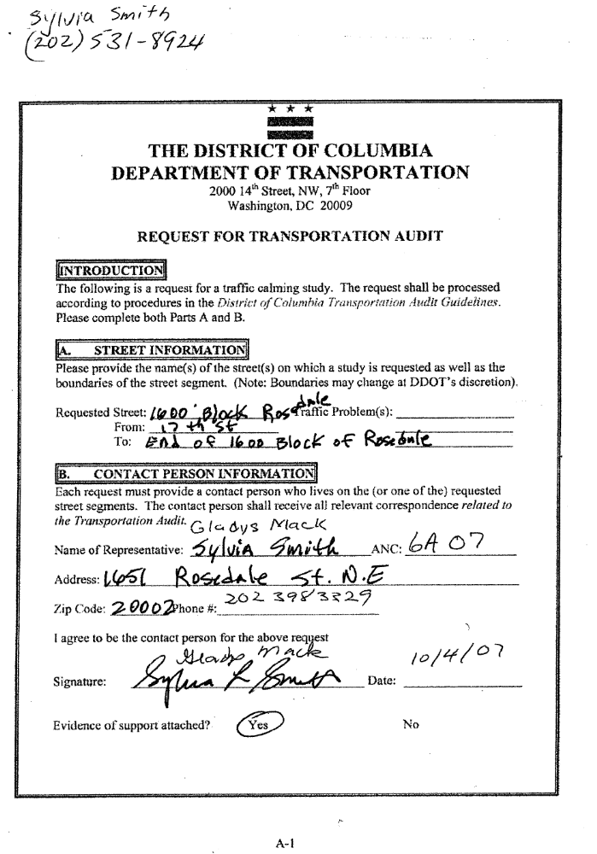
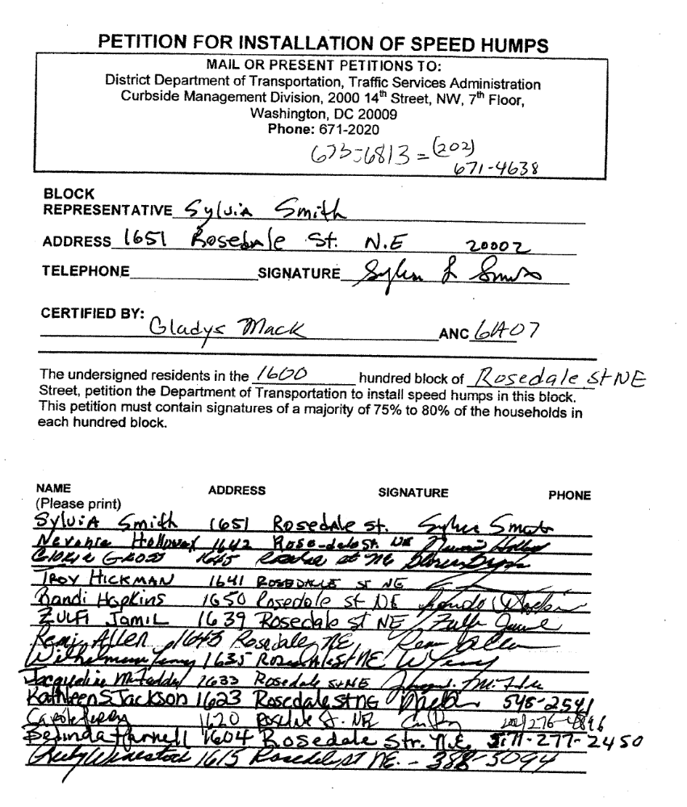
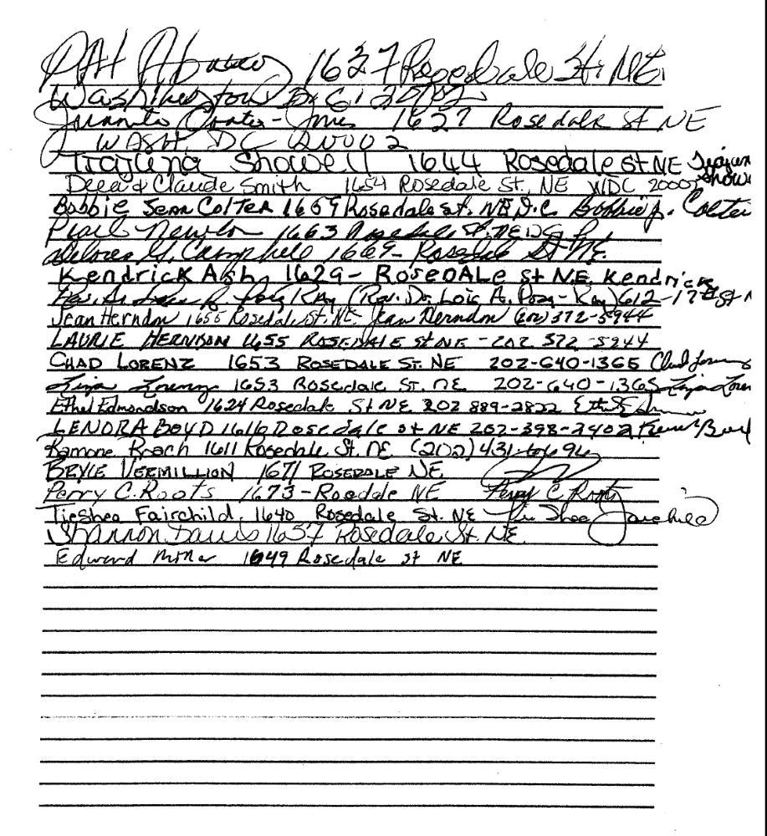
May 16, 2008

Mr. Bill Schoon
Public Space Administration Engineer Technician
District Department of Transportation
941 N. Capitol Street NE
Washington, DC 20002
Email: bill.schoon@dc.gov

Re: 1900 Constitution Avenue NE Public Space Application for Curb Cut and Driveway

Mr. Schoon:

At our regularly scheduled public meeting on May 8, 2008, our Commission voted to support Mr. Alex Cumbay’s revised plans for a proposed curb cut and driveway on public space at 1900 Constitution Avenue NE.

Our Commission’s previous letter of support for this application was conditional on Mr. Cumbay’s agreement to narrow the driveway and curb cut in his proposed plans to no more than ten feet. Mr. Cumbay has presented plans demonstrating this condition had been satisfied. Accordingly, we support Mr. Cumbay’s public space request.

Should you have any questions regarding this matter, please contact Mr. Omar Mahmud of our ANC’s Transportation and Public Space Committee at (202) 546-1520 or familymahmud@yahoo.com.

On behalf of the Commission,

Joseph Fengler
Chair, Advisory Neighborhood Commission 6A

Cc: Alex Cumbay (acumbay@gmail.com)

May 16, 2008

Mr. Matthew Marcou
Acting Public Space Manager
District Department of Transportation
941 North Capitol Street, NE
Washington, DC 20002
Email: Matthew.Marcou@dc.gov

Re: Pilgrim Baptist Church Public Space Application

Mr. Marcou:

At our regularly scheduled public meeting on May 8, 2008, our Commission voted unanimously to support Pilgrim Baptist Church’s application before the District Department of Transportation (DDOT) Public Space Committee to install an elevator on public space.

Should you have any questions regarding this matter, please contact Omar Mahmud, the chair of our ANC 6A Transportation and Public Space Committee at (202) 546-1520 or familymahmud@yahoo.com.

On behalf of the Commission,

Joseph Fengler, Chair
Advisory Neighborhood Commission 6A

Cc: Tommy Wells, Councilmember Ward 6

May 16, 2008
Clark Ray, Director
Department of Parks and Recreation
3149 16th Street, NW
Washington, DC 20010
Re: Proposed Dog Park at Kingsman Field

Mr. Ray:

At our regularly scheduled public meeting on May 8, 2008, our Commission voted unanimously to support the Hill Hounds application for a dog park on Kingsman Field.

Hill Hounds representatives stated that their application meets Department of Parks and Recreation (DPW) requirements and that they are providing multiple configuration options. Accordingly, our Commission supports any of those options as DPW deems appropriate.

Should you have any questions regarding this matter, please contact Mr. Omar Mahmud of our ANC’s Transportation and Public Space Committee at (202) 546-1520 or familymahmud@yahoo.com.

On behalf of the Commission,

Joseph Fengler, Chair
Advisory Neighborhood Commission 6A

Cc: Tommy Wells, Councilmember Ward 6

June 2, 2008

Peter B. Feather, Chairperson
Alcoholic Beverage Control Board, Suite 700
941 North Capitol Street, NE
Washington, DC 20002

Reference: Red and Black Addendum to Voluntary Agreement (1212 H Street, NE)

Mr. Feather:

On May 8, 2008, with a quorum present, ANC6A voted to seek a Voluntary Agreement with Red and Black, located at 1212 H Street, regarding the addition of a summer garden. The attached agreement between Mr. Joe Englert of the Red and Black and ANC 6A seeks to address potential issues related to noise. Because of the proximity between ANC 6A residents and this outdoor venue, we wish to mitigate noise concerns and therefore, we request that this Voluntary Agreement be made a part of the license and included in the Board Order

On behalf of the Commission,

Joseph Fengler
Chair, Advisory Neighborhood Commission 6A

e-mail: fengler6a02@yahoo.com
202-423-8868

cc: Commissioner Raphael Marshall
Commissioner Mary Beatty
Mr. Joe Englert, owner of Red and Black

Addendum to Voluntary Agreement

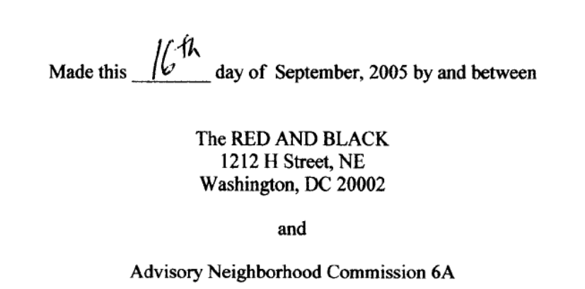

Whereas Joe Englert, owner of The Red and Black, has applied for a Summer Garden (16 seats) at the Red and Black located at 1212 H Street, NE, and
Whereas Mr. Englert and ANC6A agree that measures should be taken to mitigate noise emanating from the Summer Garden, the parties agree that:

- The patio will be used for dining:
- There will be no amplified music on the patio:
- Wooden walls with sound baffling will be constructed to buffer noise to neighbors behind the establishment;
- Patio will closed for seating at 10:00 PM weekday evenings and 11 PM on weekend evenings;
- Placards or signs will be posted on walls to notify patrons of the hours;
- Placard will be posted on walls requesting patrons to respect the neighboring residents;
- Licensee will respond quickly to potential noise complaints, and if complaint is legitimate, will take action to mitigate the problem;

If residents have no noise complaints for a three month period following opening of the Summer Garden and the licensee has a record of good conduct during this time period, the hours for service on the patio may be extended to 11PM on weekdays and 12PM on weeknights.

Agreed to this 28 day of May, 2008.

________________________________
Joe Englert, on behalf of Red and Black

______________________________________
Joe Fenger, Chair ANC6A, on behalf of ANC6A

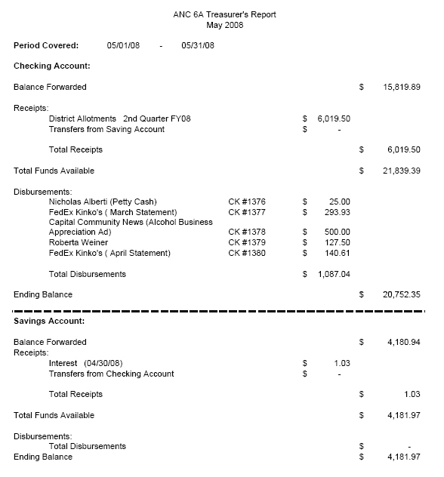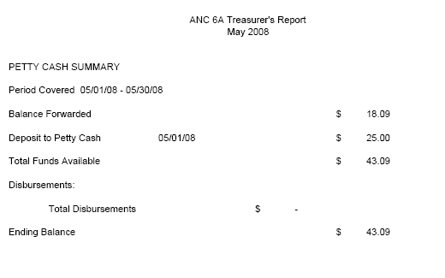
ANC 6A ABL Committee
May 20, 2008
Minutes

Meeting called to order at 7:07 pm.
Committee members present: Mary Beatty, Derrick Figures, Michael Herman, Tish Olshefski, Richard Sundberg
Community members absent: Mary Kozinski, Jeremy Marcus
Community Members Present: Coralie Farlee/ANC6D ABC Committee Chair; Chris Homon; Kelly Sheeran/Little Miss Whiskey’s; Mark Thorp/Little Miss Whiskey’s; Joe Englert/Red & Black; E. Zeleke; Bernard Gibson/Twelve
ANC Commissioners Present: Raphael Marshall (ANC6A01)

- Housekeeping
  - Welcome/Introductions - Committee members introduced themselves.
  - Agenda – Motion to accept agenda (clarified that we are talking about the VA language for Little Miss Whiskey’s). No objections. Motion to accept minutes of last meeting as amended. No objections.

- Community Comment
  - Raphael Marshall praised Mary and the committee for great work.
  - Coralie Farlee is chair of the ANC6D Liquor committee. Raised issue of ward-wide moratorium effort.

- Discussion-Updates
  - ABL Recognition Program Ads
The ads were in the Hill Rag and the Voice of the Hill the previous week. The committee plans to distribute the stickers on the weekend along with a letter recognizing willingness to work with our community. Committee will be splitting up the distribution of the stickers. Friday from 4:00 to 7:00 pm we’ll deliver to CTs & CRs. On Saturday morning we’ll deliver to A’s and B’s. Mary will send a schedule. Mary is trying to generate some press around this. We will take photos with owners at all presentations and the photos will be posted on the Web site.
  - Little Miss Whiskey’s Golden Dollar CT Application – VA Language
The establishment got their CT application filed but they do not have placards yet. The ANC wants to put in additional language to the standard VA regarding the outdoor patio. Commissioner Raphael Marshall went to residents in the area and consensus is they don’t want any more outdoor noise. Issues clarified in the discussion: there will be a 16 foot rear wall and no music. The owner would prefer to have the opportunity to show they can be good neighbors and put language in the VA that forces them to correct any problems or else shut down the outdoor area. An additional way to minimize noise is to use the area only for dining up to a certain hour.

Mary Beatty and Raphael Marshall will get together about language for the VA. Mark Thorp will provide a description (to be included in the VA) of all sound proofing plans. (Owner suggests that community members visit his other establishment -- Jimmy Valentine’s Lonely Hearts Club on Bladensburg Road -- to see soundproofing efforts there).

- New Business
  - Joe Englert – Application for Summer Garden/Red and Black, Petition Day May 27 (1212 H Street NE)
The original application for Red & Black included a summer garden. The area will seat 16. Fencing is already present as well as baffling between 7 foot high posts. Most of the area has overhangs or coverings. There will not be music. Owner is also willing to provide plans for soundproofing in writing. Hours for food outdoors are until 11PM and until midnight on weekends.

Raphael Marshall wants the hours to be 10 PM on weekdays and 11PM on weekends. Negotiations began in the meeting which Mary Beatty asked be moved to the more formal process outside the Committee meeting.

The ANC won’t protest this license change if we get the matter settled by May 27.

Motion: Mary Beatty moved to amend the VA to include language which will address mitigation of noise on the patio. Second: Derrick Figures. Unanimous.

  - M&M Kerschbaumer – Jiggs Restaurant & Bar, 735 8th St NE, Class CR, Petition date June 16
Have no details and the owners are not here. Richard: consider filing a protest to force them to respond.
Mary Beatty moved that we take no action until we determine if the address is correct (could be NW). Second: Michael Herman. Unanimous.
(Note to Minutes: Mary Beatty learned after the meeting that Jiggs will be located at 735 8th SE, so is not is our ANC.)
  - Potential Violations of ANC6A VAs
    - XII (Twelve)– Bernard Gibson, owner
      - A neighbor shared that on the 9th of May he could hear music inside his house in the 1200 block of G Street, NE. The noise was pounding bass and it sounded like a loud band with windows open but that wasn’t the case on observation. Neighbor does agree that the next weekend was better.
      - Mr. Gibson is looking to purchase a noise meter. He has installed triple paned windows to reduce noise. Will look at additional sound proofing and install a door where there may be sound escaping. Also will look at carpet.
      - Mary Beatty pointed out that the noise meter can determine whether he exceeds noise levels under DC law, but the VA is more restrictive than DC law. She warned that this could potentially be a violation of our VA if the problem is not resolved, and that a complaint would be filed by the ANC.
    - Viggy’s – owner not present.
      - Mary will be following up with Viggy’s as she has heard a constituent say that they are selling singles.
    - H Street Martini Bar – owner not present.
      - Pending violation filed by resident over noise. Nothing this committee can do except be informed of the pending action.
  - Ward 6 participation in Moratorium Legislation
This issue was turned back to our committee to recommend how to proceed on the Ward 6 participation in the moratorium legislation. After discussion, consensus reached that we are in favor of signing onto this legislation which currently includes Wards 4, 7 and 8. We should maintain our current position on a moratorium on the sale of singles.
  - Discussion of Pub/Bar Crawl/ANC6A VA
Follow-up to discussion started at our last meeting and the request to consider including language in the standard VA for exceptions to the pub crawl language for charity events. The committee did not find a lot of enthusiasm from the committee or the audience. Business owners in the audience said that they view pub/bar crawls as a way to promote cheap liquor or beer and excessive drinking. One stated he doesn’t ever want to be attached to anything called a pub crawl and doesn’t want to be shanghaied into reducing prices. Raphael stated his concern that this idea would come from a member of our committee. Mary Beatty stated that Jeremy says that he doesn’t want to promote drinking but was thinking of ways to promote H Street.
Mary Beatty moves that we not amend the VA to exempt charity events from pub crawls. Seconded: Richard Sundberg. Unanimous.

V. Adjourn. Move to adjourn 7:58 pm. Next meeting: June 17, 2008.

REPORT OF THE ECONOMIC DEVELOPMENT AND ZONING
COMMITTEE OF ANC 6A
May 16, 2008

Present: Commissioners: David Holmes

Resident Members: Drew Ronneberg, Jeff Fletcher, Barbara Halleck

Drew Ronneberg chaired the meeting.

Community Comments
The ANC 6A Economic Development and Zoning Committee is recruiting members to work with vacant property issues.

Status Reports

None

Old Business
None

New Business

- 225 9th St. NE – HPA #08-239. Demolition of a garage, construction of a new garage.

Presenter
Derrick Siever of Precision Contracting
Lou Fiore, owner of 225 9th St. NE

Committee questions/concerns
- Is the current garage on Mr. Fiore’s property legal; e.g., does he truly own the property that extends into the alley past the back of the other garages on the alley?
- If he does not own the property that extends back into the alley, will the garage’s footprint exceed lot occupancy rules?

Motion(s) made
The ED&Z Committee, without quorum, passed a motion to support the historic preservation aspect of Mr. Fiore’s garage project with encouragement to move the garage back out of the alley.

Notes
- Had submitted plans to the DCRA for a new garage at 225 9th St. NE that was 26’ long.
- Based on the meeting, anticipated a BZA hearing for exceeding lot coverage regulations and cut the garage size to 20’ long. Current plans are for 16’ x 20’ x 15’ high.
- Mr. Fiore is now applying for less than originally requested.
- There is an existing small garage (16’ x 10’) that Mr. Fiore currently uses for storage, as it is too small to accommodate his vehicle.
- Mr. Fiore proposes tearing down the old garage, building 10’ deeper into his property. The proposed design includes an angled entryway instead of a back door facing directly into the alley. This design is favored by Mr. Fiore as it will make it easier for him to access the garage with his vehicle. Mr. Siever also stated that he believes it will make it easier for other drivers to maneuver through the alley.
- Mr. Fiore stated that he is legally disabled and needs a large garage for his current vehicle and looking forward to changes in his condition, he will likely need to park a handicapped accessible vehicle in the garage.
- The back of the current garage now extends out into the alley some feet further than other garages on the same alley. Derrick Siever’s drawings seem to indicate that the property belongs to Mr. Fiore but the Committee believes that issue is still in question due to the placement of the other garages.
- The DC regulations state that the garage must be 12’ from the center of the alley. The Committee is concerned that the original garage is not legal.
- Neighbors attending the ED&Z meeting stated that
  - The alley is very narrow
  - People bump into (her) fence because they cannot pass cleanly through
  - They are concerned that Mr. Siever’s crews not use the alley as staging, work space as many neighbors have garages that the need access to.
- Mr. Fiore and Mr. Siever stated that they would not use the alley as a staging space; that the current garage space and yard would be used for staging and that they would not block the alley.
- Mr. Fiore also stated that the alley is narrow all the way through and that it would be very difficult to get the whole alley fully cleared.
- The ED&Z Committee encouraged Mr. Fiore to move the garage back to align with other garages on the alley. Mr. Fiore said he thought this would increase his lot occupancy percentage; ED&Z Committee stated that it would not, as he would still own the space in the alley.

- 1131 D St. NE – HPA #07-337. Mr. Barry Johnson will be presenting plans for the renovation of 1131 D St. NE

Presenter/Speaker
Mr. Barry Johnson, owner of the property
Ms. Pip Gilmore, neighbor, speaking in opposition to the project

Committee questions/concerns
- The committee is concerned that the overall design of the project does not blend with the surrounding area; the extension is set back from the street to allow additional parking.
- The committee would like to have seen Mr. Johnson return one curb cut to the community.

Motion(s) made
None.

Notes

- Mr. Johnson purchased 1131 D St. NE in 2002 and decided to redevelop the building, which had been neglected for some time.
- Mr. Johnson expressed his efforts to reach out to the appropriate governing bodies—DCRA, HPRB, CHRS, and the ANC; he said that it was very important that he proceeded by the book on this project.
- The original plan for the site was to be four units; he has now changed his plans:
  - The plans call for a “two unit flat” with space for a single family and a supporting apartment
  - Includes an extension to the side of the building that will butt up against the neighboring building.
  - Maintenance of the curb cut in front to allow for parking; with an ornamental fence obscuring the parking space
  - Covering two of the existing four openings of the adjacent building
  - Re-establishing the bay on the front of the structure
  - The drawings also indicate a second parking space would be available
- The two-unit flat allows for 60% lot occupancy by matter of right.
- There was some discussion about past invitations to Mr. Johnson and confusion regarding communication between the ANC 6A ED&Z Committee and Mr. Johnson.
- In Mr. Johnson’s discussions with DCRA, he stated that DCRA had asked him to move the addition back from the street.
- Mr. Johnson stated that he sees the curb cut as an economic benefit as it makes the space easier to rent. When asked, he stated that under no circumstances would he return the curb space to the community.
- Mr. Johnson also stated that the windows on the neighboring building were illegal based on zoning regulations—it is illegal to have openings on space that you do not control. In his plans, however, he stated that he would only close two of the openings with his addition.
- Mr. Johnson provided a “list of supporting neighbors” for the renovation of 1133 D. St. NE but the list does not indicate what the users were signing; in other words, it’s a list of supporters but we cannot determine what they are supporting. However, the committee also received seven signed letters from other neighbors who directly oppose Mr. Johnson’s proposed addition.
- Ms. Pip Gilmore spoke in opposition to this project.
  - The two properties used to work as a single property
  - The modern design of the addition would negatively impact the historic nature and design of the neighborhood
  - Mr. Johnson proposes to close up more open areas which benefit the neighborhood
  - She does not want to have her windows closed up and does not want to sit on her roof deck and see Mr. Johnson’s wall.
- Mr. Johnson replied that he is following historic guidelines in materials and style.
- The committee agreed that while they are not in favor of this project, it appears to be within his rights to build the addition. No recommendation is passed forward to ANC6A.

- Recommendation to the ANC for preferred proposals for 1343 Maryland Ave. NE and 525 9th St. NE

Presenter/Speaker
Mr. Julian Hunt, Hunt Laudi Studio
Mr. David Holmes, ANC 6A Commissioner

Committee questions/concerns
None

Motion(s) made
The ED&Z Committee, without quorum, passed a motion to support the proposal presented by the Argos Group.

Committee questions/concerns
- David Holmes stated that the committee and the ANC are grateful for the time and energy that the presenters put into developing their proposals and sharing them with us.
- All proposals came in at about the same price so that the decision regarding which proposal to accept would be based on design and service to the community.
- The projects incorporated several different ideas, including an art center and day care center.
- However, the ED&Z committee felt that a simpler project would be more in keeping with each of the locations.
- When questioned specifically about the external glass stairwell, Mr. Hunt stated that he felt that they had been very respectful of the buildings and that it is important for people to see that a neighborhood can change.
- Without quorum, the committee passed a motion to accept the Argos proposal.

Next Scheduled ED&Z Committee Meeting:
Wednesday, June 18, 2008
7-9 PM
640 10th Street, NE
2nd Floor - Sherwood Recreation Center

ADVISORY NEIGHBORHOOD COMMISSION 6A
Community Outreach Committee (COC)
Report for May 19, 2008

The Committee convened at 7:30 PM, at the Church of the Lord Jesus Christ of the Apostolic Faith annex, 1235 C St. NE.

Attending COC members: (quorum)
• Sylvie Lee
• Rose Williams
• Kenneth Wicks
• Elizabeth Nelson (chair)

Absent COC members:
• Louis Barbash
• Mark Roy

Community members:
• Maya Mimms, Assistant Program Director, KidPower DC

I. Grant application from KidPower DC:
1. A grant application was received from KidPower DC requesting funding for books, supplies and equipment for a summer program. Examples of supplies include art supplies for art camp, science and technology equipment for science camp, math books for math camp, baking equipment for cooking and nutrition camp. Initial comments were provided by committee members and an updated application was received timely. However, additional questions arose during the COC meeting, as might be expected, and the representative provided by the organization did not have any knowledge of the grant application and could not address any of them. She did ask that a replacement be sent to the meeting and, after a very brief delay, Maya Mimms arrived. Ms. Mimms was able to answer most questions and a call to Kim Singer (the author of the application) supplied the rest of the information. .
2. The program will include 30 children who are currently enrolled at Miner ES, plus several alumni from that school. These children reside in ANC 6A and constitute at least a third of all participants. The ANCs in which the other children reside are also being asked to provide support for the program. Although the activities are not taking place in ANC 6A, the children who live there will have free transportation provided from Miner ES
3. There is a modest enrollment fee of $15 but the COC members felt that this would be manageable for most families, considering that it is an all-day program that lasts for several weeks and includes meals and field trips – there are no other expenses to participants. Also, this amount is consistent with other similar programs. The program offers a wide range of activities, including academics, physical education, life skills and the arts. Having such a program during the summer months is clearly beneficial to both the children and their families. It will keep the children occupied with safe, productive activities and encourage learning during school vacation. Having youth engaged in such pursuits is also beneficial to their home community.
4. The COC is familiar with KidPower, having recommended funding for past projects. These projects have been well-run and a good use of ANC resources. The importance of having receipts for items consistent with the purpose of the grant application was emphasized. If the grant is approved by the commissioners, such receipts will be presented for reimbursement with the grant acknowledgement letter.
5. The COC is convinced that the organization and the specific project are worthy of funding and that there is significant benefit to ANC 6A. But the budget provided with the grant application contained a few minor errors and was very difficult to understand. Rather than recommending non-funding of the application, the COC voted, unanimously, to recommend funding – conditional on receipt of a corrected application within two business days. Note: the corrected application was received, timely.
6. Subsequent to the meeting Ms. Nelson contacted Ms. Singer to ensure that she was aware of the need to provide a corrected application within two business days.

Committee recommendation (unanimous): that ANC 6A
Approve a grant of $1,000 for KidPower DC to purchase books and supplies for their summer program (which could include art, science and technology equipment, and baking equipment).

II. Recording of ANC meetings
1. Ms. Lee asked if the COC/ANC were still interested in recording ANC meetings. There ensued some discussion of the taping of the May ANC meeting. Omar Mahmoud, Chair of the Transportation and Public Space Committee, has a copy of the file on his computer and is investigating the possibility of processing it and posting it with a link running from the ANC website. Lind Argos presentation would be of the greatest interest to the public and possibly that portion, alone, could be posted.

The meeting adjourned at 8:40 pm.
Next meeting is June 16, 2008.
Respectfully submitted,
Elizabeth Nelson

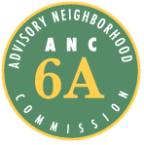
Advisory Neighborhood Commission (ANC) 6A
Grant Request Application Form

1. Date of Application 2. Date of Project or Activity
4/21/08 6/30/08 - 8/01/08

3. Applicant Organization Name and Address
Kid Power-DC Inc., 755 8th St. NW, Washington, DC 20001
operating at Miner Elementary (601 15th St. NE, Washington, DC 20002)

4. Contact Name 5. Title
Kim Singer Development Director

6. Address (if different from above)

7. Telephone 8. Fax
(202) 554 -6070 (202) 347-6360

9. E-mail Address
kim@kidpowerdc.org

10. Brief Description of Proposed Project/Activity
Kid Power-DC will be operating a full-service summer camp to serve youth from under-served communities in the District of Columbia. One-third of the participants reside in 6A and some of the summer camp activities will operate in 6A.

11. Projected Total Cost 12. Amount Requested
$ 43, 760 $ 1,000

13. Other Sources of Funding (be specific, provide names)
Children’s Youth Investment Trust Corporation, $40,000
ANC Districts 1A, 2A, 6D, $3,000 (pending)

14. Statement of Benefit (detailed description of project or activity, who will benefit and in what way)
Please see attached

KID POWER-DC GRANT REQUEST

- Organizational Information

Mission Statement: Kid Power-DC is a civics-based organization that provides academic, artistic, and service-learning opportunities for youth in under-served neighborhoods in the District of Columbia. Kid Power-DC empowers youth to become informed and engaged advocates for change in their own lives and in their communities.

History and Previous Year’s Accomplishments:
Kid Power-DC (KPDC) was incorporated in March 2002, received its tax-exempt status in July 2003, and initiated direct educational programs in October 2003. Currently, KPDC provides educational programming for nearly 200 students at the following sites: Miner E.S. since 2003, Tubman E.S. since 2004, Ross E.S. since 2006, Amidon E.S. since 2007, Sousa M.S. in Fort Dupont SE since 2007, Marie Reed E.S. since 2008, and the Calvary Baptist Church middle school program since 2006. Organizational accomplishments in the past year include: In June 2007, students completed the 2nd year of the Citizenship Project with significant academic improvements (1.3 grade levels for reading and 23.1% improvement in civic assessment scores). In the summer of 2007, eleven middle school students organized a major service and cultural trip to the Dominican Republic. In DC, the students formed the CookieTime! bakery with CakeLove. Students staged a poetry slam at Busboys & Poets and winter and spring talent shows at the Calvary Baptist Church, including a presentation of the Greek tragedy “Antigone.” In October 2007, students helped organize a rally with other youth-serving organizations at the Wilson Building around the issue of funding for summer programs. This Council of the District of Columbia eventually voted to allocate $5 million for these programs. In 2007, KPDC was featured in the 5th anniversary edition of the Catalogue of Philanthropy, was the sole beneficiary of the Federal Communication Bar Association charity auction, and received the Lehrman Foundation Impact Award. In 2008, KPDC completed the Fair Chance capacity-building program, where it focused on board development, long-term planning, fundraising strategies, and leadership development.

Current programs and activities: The Citizenship Project: Using a literacy-building and civic engagement curriculum, elementary school students and their high school mentors from the Edmund Burke, Georgetown Day, and Sidwell Friends schools investigate the fundamental building blocks of citizenship, produce visual and performing art works, and implement youth-led community action projects. CookieTime!: With the assistance of CakeLove bakery, middle school students operate a small baking business and use the profits to fund local community projects and service trips outside the District of Columbia. Extra-Curricular Program: In the Explorers Club, students participate in advanced weekly workshops with area professionals. Classes include boxing, yoga, cooking, acting, hip-hop dancing, poetry, fashion design, chess, and visual arts. KPDC also operates a full-service day and overnight summer camp.

- Program Description

Program Proposal: This summer, KPDC will offer a camp for 90 public elementary and middle school students from under-served communities in the District of Columbia. The camp will operate from June 23, 2008 to August 11, 2008, five days a week, seven hours a day. There is no charge to camp participants. Students reside in the Columbia Heights, Adams Morgan, Rosedale Northeast, Southwest Waterfront, Dupont Circle, and Fort Dupont SE communities (Wards 1, 2, 6, and 7). KPDC, acting as the lead agency, will partner with Linking Communities for Educational Success (LINK) to organize six distinct camps of approximately 12-15 students each.
The four younger youth camps will have the following themes: Theater & Arts, Science & Technology, Nutrition and Cooking, and Sports and Mathematics. The older youth campers will be divided into a Documentary Film camp and the CookieTime! bakery project. Twice a week, all youth will participate in the academic and educational enrichment activities related to their camp theme. These will include intensive literacy-building and critical-thinking components embedded in the different curricula. Each camp will also include significant service-learning opportunities to benefit local communities and beyond.
All camps will take part in bi-weekly swimming and recreational sessions at the East Potomac Park in Hains Point. Recreational activities will include an organized Olympics and other competitive sports. Once a week, the campers will participate in a large group field trip. Possible destinations include the Maryland beach, the Fort Dupont Ice Skating Arena, Six Flags, the Baltimore Aquarium, and a local water park. Full meals from the Capital Area Food Bank will be provided daily for all students. Toward the end of the summer, campers will have the opportunity to join a week-long overnight camp at Camp Frasier in rural Virginia. Youth will engage in team-building exercises on a full ropes course, arts and crafts sessions, swimming lessons, and other outdoor activities.

Public Benefit:
Kid Power-DC’s summer camp will achieve three significant community benefits. First, KPDC will directly serve youth who live in the ANC 6A neighborhood. Currently, programs at Miner Elementary School serve thirty students. These students will represent one-third of the students enrolled in camp. Because all of Kid Power’s camp activities revolve around the spirit of service and teach students how to become good citizens, students will ultimately give back to the 6A community and become role models for their neighbors. Second, the students plan to host a large showcase night at the end of the summer camp, which will feature the accomplishments from each of the six camps. For instance, the cooking camp will provide dinner and dessert, the theatre and arts camp will provide entertainment and perform a show, CookieTime! will sell cookies, etc. Students’ families and friends from the 6A community will be invited to attend the festivities. Other summer camp activities will also occur within the 6A community, including a parent night at Miner E.S. and CookieTime! bake sales. Finally, youth will connect their academic knowledge and artistic expression to substantive civic action in their local communities. They will fully integrate their summer learning into tangible and long-lasting service opportunities.

Specific Grant Request:
Kid Power-DC requests $1,000 from ANC 6A to purchase educational books and supplies for summer camp, which cost $2,400 total. Examples of supplies include art supplies for art camp, science and technology equipment for science camp, math books for math camp, baking equipment for cooking and nutrition camp, etc.

SUMMER CAMP 2008 BUDGET
 |  |  |  |  | Jul - Aug 2008
Program Expenses
 | Field Trip Admissions |  |  |  | $ 3,500.00
 | Program Food |  |  |  | $ 2,000.00
 | Program Books/Supplies |  |  |  | $ 2,400.00
 | Transportation |  |  |  | $ 8,000.00
Total Program Expenses |  |  |  |  | $ 15,900.00
Rent |  |  |  |  | $ 1,000.00
Salaries and Wages
 | Benefits |  |  |  | $ 560.00
 | Payroll Expenses |  |  |  | $ 100.00
 | Payroll taxes |  |  |  | $ 3,000.00
 | Program Salaries
 |  | Total Assistant Program Directors |  |  | $ 5,200.00
 |  | Instructors/Counselors |  |  | $ 6,000.00
 |  | Program Director |  |  | $ 8,000.00
 |  | Site Coordinators |  |  | $ 4,000.00
 | Total Program Salaries |  |  |  | $ 23,200.00
Total Salaries and Wages |  |  |  |  | $ 26,860.00
GRAND TOTAL |  |  |  |  | $ 43,760.00


Kid Power-DC, Inc.
www.kidpowerdc.org
501(c)(3) registered

May 7, 2008

Advisory Neighborhood Commission 6A
Community Outreach Community

To Whom It May Concern:

Kid Power provides academic, artistic, and service-learning programs to nearly 200 students throughout the District of Columbia. It currently works with six public schools, one neighborhood site, and four independent school partners. Kid Power empowers youth to become informed and engaged advocates for change in their own lives and in their communities. This summer, Kid Power is organizing a full-service day and overnight camp for 90 students; more than double the size of last year's summer camp.

Kid Power-DC is seeking $1,000 to assist this project. This funding will go towards the purchases of educational and art supplies. We greatly appreciate any aid that ANC 6A can provide. We look forward to your response.

Respectfully,



Max Skolnik
Executive Director, Founder
Kid Power-DC, Inc.

________________________________________________________________________

Kid Power-DC, Inc., 755 8th St. NW, Washington DC, 20001, 202.554.6070, info@kidpowerdc.org

No Meeting in May
ANC 6A Transportation & Public Space Committee Meeting Minutes
Capitol Hill Towers (900 G Street NE)
May 19, 2008 at 7:00 pm

- Meeting called to order at 7:05 pm
  - Committee members present: Shane Artim, Lance Brown, Sean Lovitt, Marlon Smoker and Omar Mahmud (Chair)
  - Committee members absent: DeLania Hardy, Diane Hoover and Warner Sterling
- Community Comment
  - Mr. Brown informed the committee that the curb cuts along the 1400 block of Maryland Avenue we asked DDOT about removing have been removed.
  - Mr. Mahmud informed the committee Commissioner Bill Schultheiss has invited the owners of the former car lot site at 1400 Maryland Avenue to give a presentation to our committee in June. The ANC will consider holding a joint meeting with the Economic Development & Zoning Committee (ED&Z) for this presentation since there are crossover issues.
  - Mr. Lovitt asked the committee about potential zoning violations at a house renovation site at 14th and G Streets. There was some confusion over exactly which house Mr. Lovitt was referring to, but Mr. Brown believes he investigated the zoning issue and thought it was OK. The committee agreed it was best for any zoning problem at this site to be referred to ED&Z.
- New Business
  - Parking Enforcement on H Street
    - Mr. Mahmud briefed the committee on an email correspondence between Commissioners Joe Fengler and Bill Schultheiss, and a resident of our ANC regarding parking for H Street merchants. The resident asked if anything could be done by the city to allow merchants parking permits, something similar to the Residential Parking Permit program.
    - Mr. Mahmud informed the committee there probably isn’t anything DDOT can do for the merchants in this regard.
    - Mr. Brown agreed that we are probably not going to find a solution for the merchants. He encouraged the businesses to seek cooperation with other businesses like Hechinger, Autozone, etc. where parking is more available.
- Old Business
  - Routing of Nationals Parking Lot Busses
    - Mr. Mahmud briefed the committee on his conversation with Ms. Francine Waters, Director of Transportation and Planning for the Washington Nationals:
      - Ms. Waters is sensitive to the community’s concern over the routing of Nats Express parking lot buses on “conflict days” (the eight game days when both the Nationals and DC United hold home games). On conflict days, Nationals fans must park in lot seven, instead of lot eight. On non-conflict days, Nationals fans can park in lot eight, from which buses can exit and leave the parking lot using the RFK access road (runs along the Potomac River and avoids most residential streets).
      - The conflict days are as follows:
        - Wednesday, April 09, 2008
        - Saturday, April 26, 2008
        - Saturday, May 10, 2008
        - Saturday, May 24, 2008
        - Wednesday, June 4, 2008
        - Sunday, June 22, 2008
        - Sunday, June 29, 2008
        - Saturday, July 12, 2008
        - Saturday, August 2, 2008
        - Saturday, August 30, 2008
      - On conflict days, Nationals fans parking in lot seven must be bussed to the stadium using the following route:
        - Left out of the lot onto Oklahoma Ave NE
        - Right on C Street NE
        - Left on 17th Street NE
        - Right on Potomac Avenue SE
        - Right on I Street SE
        - Left on 8th Street SE
        - Right on M Street SE and on to the stadium
      - Mr. Mahmud explained that some of the citizens living along this route have complained about large busses using these streets to transport fans to and from the game. Citizens have cited noise and safety issues, as well as general unease about the impact of these large busses on small residential streets.
      - Ms. Waters pointed out that some of these roads are also traveled by Metro busses, which was a key consideration in establishing the current route. She also pointed out that her staff worked with DDOT, MPD and Councilmember Wells’ office to establish the best route possible for the busses on conflict days, and that given all the concerns that needed to be addressed (adequate space for turning, public safety, etc.) this was the best route they could come up with. Ms. Waters also expressed regret for not including local ANCs in the discussion (she genuinely thought all concerned parties had been included in the discussions), but promised to do so going forward. She has also discussed this issue with representatives of ANC 6B
      - Mr. Mahmud asked Ms. Waters why her office could not find a way to route busses to Nationals Stadium using the RFK Stadium access road on conflict days, even though this would require sharing the road with DC United fans traffic. Ms. Waters explained that MPD ruled that option out since the access road must be kept one way on game days. Changing that policy would result in additional safety and traffic flow concerns.
      - Mr. Mahmud also informed Ms. Waters that Nats Express busses have been seen traveling through Hill East neighborhood streets even on non-conflict days. In addition, he expressed doubt as to whether the busses are indeed sticking to the route she described.
      - Ms. Waters asked that any resident noticing a bus either going off route or using this route on non-conflict days or speeding or doing anything else impacting the safety and well being of residents, should contact her immediately at 202-640-7131 or francine.waters@nationals.com. Residents should be sure to provide the Martz bus number if possible and date/time of the incident. Armed with that information, Ms. Waters promised to follow up with Martz bus officials. Ms. Waters made a point of saying she wanted to work with the community and be responsive.
      - Mr. Mahmud promised to follow up with her should he hear any more complaints about busses failing to follow the guidelines she explained.
    - Mr. Lovitt pointed out that the committee should be concerned about greater traffic coming through local neighborhoods in general. We need to work on this issue with Councilmember Wells’ office. He agrees that our ANC and the community should have been consulted on this decision.
    - The committee decided to follow up on other concerns raised by community members with Ms. Waters, but to otherwise recommend no action be taken by the ANC at this time.
  - Crosswalk at 10th Street and Maryland Avenue
    - Mr. Mahmud explained that residents have complained about the lack of proper signage and street markings like “zebra striping” for pedestrian crossing at this intersection. Last month, per the suggestion of Karina Ricks at DDOT, Mr. Mahmud submitted a city services request regarding this issue.
    - Given that the city service request Mr. Mahmud submitted contains no inspection date or due date for completion of the work, the committee discussed sending a follow up letter to Ms. Ricks to ensure the request is addressed in a timely manner.
    - Mr. Brown asked that we also request infrastructure improvements, including extending the median, reconfiguring the Maryland Avenue to 10th Street turn off, and bulb outs to increase pedestrian safety. The committee discussed and agreed it may be best to ask for the easier, less expensive fixes now.
    - Mr. Mahmud made a motion to recommend the ANC send a letter to Karina Ricks of DDOT, copying Councilmember Wells, asking for better pedestrian signage and street markings like zebra striping at the corner of 10th Street NE and Maryland Avenue NE. Mr. Brown seconded the motion, which passed without objection. Mr. Artim volunteered to prepare a draft of the letter.
- Meeting adjourned at 7:43 pm.

- ANC Agenda Package Request for Proposal Detailed Scope of Work
- Motion for David Holmes and Nick Alberti to represent the ANC in opposition to the establishment of a school at 138 12th Street as authority for an expansion campus goes before the Public Charter School Board, including a letter expressing that opposition.
Re: [anc-6a06] Fire Station Redevelopment

Hi Bill,
I am not interested in a community center, especially if Rosedale is going to be turned into a state-of-the-art facility as you describe in your last email. i'd rather the see the current community centers be improved before we build another one.
that said, there's some interesting, new ideas i've read about (but don't remember where) in community development and would be pleased to see some ideas along those lines. where commercial and social are combined in ways to draw in many age groups and backgrounds.
it will be quite difficult, i would think, to get people to move into a building with a day care center on the first floor. i also don't understand where the first developer thinks there's room for six cars in the alley. the last thing i don't like about the day care idea is that the housing appeals mostly to young singles because the housing would be studios and one-bedrooms. they will be the least committed to the neighborhood and to the community.
however, i see so many new toddlers on the hill and that is an exciting development and therefore, maybe a day care center (18 is a nice number) with additional commercial and social use.
i'd like to see some of the condos selling in the 'hood before a bunch more are built.
so i guess my top choice is none of the ones that have been suggested to date. i'm for mixed use, i.e., social and commercial, that will appeal to the diverse nature of our community. let's not become another adams morgan or another U Street.
thanks, Bill, and thanks to everyone else for having some really interesting ideas.
best,
patricia

Re: [anc-6a06] Fire Station Redevelopment

Whatever goes in there I hope they plan for off street parking on the left side of the building. With the bars and entertainment on H Street, it is nearly impossible to find a place to park on Friday and Saturday nights.
Tony

Re: [anc-6a06] Re: Fire Station Redevelopment

There's a two year wait list for daycare on Capitol Hill and it is especially difficult to find a place for children under two. We have to drive 20 minutes each way to get to the closest daycare in DC with availability (there's plenty of availability in DC and VA if you're into crossing a bridge at rush hour). There is a critical need for a good local daycare. We support any option that includes daycare.
Lauren V. Kabler
Re: [anc-6a06] Fire Station Redevelopment

Hi all,
I really like the childcare idea. I know that there is not enough good childcare here on the Hill, and that it would fill up in a heartbeat, if parents could be assured of its quality. (I can only imagine the buzz this would generate on the MOTH listserv....)
I also like the idea of artists' studios. I know that these are mutually exclusive, but I'm just throwing that out there as my #2 choice.
Also, as far as things to do on H Street besides going to bars, everyone should go visit the H Street Playhouse! All of the Theatre Alliance productions there are FREE to neighbors. My husband and I have been a couple of times and really enjoyed ourselves.

I'm glad the old fire station will be put to good use! Thanks!
Beth Neal

Re: [anc-6a06] Fire Station Redevelopment

We should not always be guided by revenue. We have income being generated by the clubs, the coffee houses and all other commercial development in the area. When the street cars and the 5-Points project are completed there will be more than enough revenue for the area.
More condos means more people, yes an increase in DC residential tax base, but little else. However, with the price of housing residents
will be forced to stay in their community and therefore need facilities to address recreational needs. If necessary residents can pay a fee
for utilization of facilities. There are many grants out there to be had to abate asbestos. If the building is gutted there will be no asbestos.
Funds were created to rehab Atlas and funds are available for the firehouse.
La Vita

Re: [anc-6a06] Fire Station Redevelopment

I'm late to the conversation and do apologize. My first question is, really, developers are really just thinking more residential property is what will be best in the designated area?! It seems we've got nothing but residential property development. I agree with La Vita Grigsby 1000%. It would great to actually see our community develop and INCLUDE things that benefit those that already live here. A learning center, day care, recreation center for community members of all ages all seem to be great options. I'd love to see a book store, food co-op, or something along these lines in our community. Is the process still open? Is it possible to find a developer who could compromise or at least attempt to meet more of our needs?!
Meryl Heyliger
1426 F Street NE
Re: [anc-6a06] Fire Station Redevelopment

Good morning Bill. I like Developer 3's (Argos Team's) plans for the fire station on MD Avenue. Enjoy your day --
Darlene
Re: [anc-6a06] Fire Station Redevelopment

I like the DB Lee plan.

I like the deasigns/ projects that change the street curb of the Firehouse.
I do not like the current curb...
mary Bakota

Re: [anc-6a06] Fire Station Redevelopment

I agree when it comes to parking. I have wondered if the zone 6 only parking would work in our neighborhood (much like what one experiences as they get closer to the ballpark in SE).
I like the idea of affordable housing for seniors or artists. Artists can offer shows and maybe classes in the studio space. And, well, I like the idea of affordable senior housing because I selfishly want my parents to move to DC, but I know it is not an economically smart move given they are ready to retire!
Kyra
REPORT OF THE ECONOMIC DEVELOPMENT AND ZONING
COMMITTEE OF ANC 6A
April 30, 2008
Resident Members: Barbara Halleck, Jeff Fletcher, Rich Luna
Present: Commissioners David Holmes and Bill Schultheiss
Also Present: Joseph Wolfe, Project Manager, District of Columbia Office of the Deputy Mayor for Planning and Economic Development
David Holmes chaired the meeting.
Community Comments
None
Status Reports
None
Old Business
None
New Business
The evening’s agenda focused exclusively on three presentations for the renovation of two buildings. The city owns both buildings and has requested proposals for redevelopment. The locations are:

- Engine House 10, located at 1341 Maryland Ave. NE
- Precinct 9 Police Station, located at 525 9th St. NE

The criteria for ANC 6A’s evaluation of the proposals are as follows:
- Appropriateness to the historic district community
- Design and use of the buildings
- Maximum benefit to the community

Joseph Wolfe, Project Manager, District of Columbia Office of the Deputy Mayor for Planning and Economic Development outlined the city’s basic evaluation criteria:
- Feasibility of the proposals
- Affordability of the units
- Certified Business Enterprises (CBE)
- Qualification and experience of the team
- The amount of the offer to the City for the properties

Each group was given 25 minutes for their presentation; questions and answers followed each presentation

Summary of the Presentations (edits in yellow are corrections by Century June 10th, 2008)

Developer | Argos Group  Gilberto Cardenos, President | Century Associates  Joel Kelty | DBLee Development  Dennis B. Lee, President
Architect | Architrave PC  Judith Capen | Century Associates  Joel Kelty | Hunt Laudi Studio  Julian Hunt, Lucrecia Laudi
Builder | Hamel Builders  Thomas Wahl | BDS Construction | CDG Construction  David Bishop
Special contributor | Hasson’s Education and Cultural Services  Bill Hassan | EHT Traceries, Laura Hughes  Specialists in architectural history and historic preservation  Sustainable design consultant Sustainable Design Consulting, Sandra Leibowitz, | LMH Architecture and Consulting  Lisa McCabe Hobbs, AIA, LEED ® AP
Green construction | Gilberto Cardenos is LEED certified. Determination regarding which green standard (LEED or Green Communities) will be made once the design is complete.  Judith Capen is committed to green construction. | Green Communities requirements or LEED will be met | LMH Architecture & Consulting, Lisa McCabe Hobbs; pursuing LEED certification for both projects.
Community involvement | Hasson’s Education and Cultural Services: educates groups of DC public school students in the design and development process.  Design/development process involves the community residents directly as well. | Periodic updates to ANC ED&Z committee  Project website that tracks progress on the project including drawings, photos  Also web page for community feedback  Community Construction Watch Tours
Historic preservation goals | Architrave PC Architects/ Judith Capon is a 30-year Hill resident; specializes in historic preservation. Member of CHRS. | EHT Traceries  Specialists in architectural history and historic preservation  Project will apply comply with requirements for Federal Historic Preservation Tax Credit and meet Standards of Secretary of the Interior | n/a
Condominium or rental? | Condominium | Rental | Rental
 |  | Century Associates developed three different proposals for each site. The summary information below corresponds to the proposals that offer alternative uses for the buildings. Other proposals are described below this chart.
Engine House 10 |  | Option 3
# Units | 4 | 6 | 6
# Market Units | 2 x 3 br., 1900 sf each, private patio | 3 total:  1 x 1 br., 714 sf  1 x 1 br., 627 sf  1 x 1 br. loft, 1022 sf, roof deck | 1 x 2 br., 1634 sf; 510 sf deck  1 x 1 br., 1030 sf; 280 sf deck
# Affordable | 1 x 2 br., 810 sf  1 x 3 br., 1100 sf | 3 total:  2 x studio, 413 sf  1 x studio, 465 sf | 1 x 1 br., 810 sf; 100 sf deck  1 x 1 br., 940 sf; 120 sf deck
# Accessible | n/a | TBD per codes | 2 efficiencies, 544 sf each
Other space | n/a | 1 x day care space, 1520 sf. | 6 x art studios, 156 sf each
# Parking spaces | 5 | 6 legal parking spaces for apartments (1 per unit) + transient parking for daycare | 2 + 1 space dedicated to ZipCar
Matter of right or zoning relief needed | Matter of right | Matter of right | Matter of right
Rooftop access | None | Yes—for loft apartment only | Yes—4 roof decks
Footprint change | None | None | Relocating stairwell outside the body of the building  Upper levels rise to from 36’ 6” to 40’; set back from parapet so as not to be visible from street
Green space | Eliminate concrete areas in front and on side of building; landscape | Retains concrete front apron for transient parking for day care  Day care play space, 1086 sf  Apartment rec space, 590 sf  Landscape design to be determined during design phase after project award | Key to the project; functional landscaping captures runoff, uses native/adapted species that need no irrigation.
Precinct 9 Police Station |  | Option 1
# Units | 4 | 6 | 6
# Market Units | 2 x 3 br., 1900-2000 sf each, private patio | 1 x 1BR @ 452 SF  1 X 1 BR @ 576 SF | 2 x 1 br., 1224 sf each; includes basement as bedroom area  1 x 1 br., 1 office, 1188 sf  1 x 2 br., 1440 sf
# Affordable | 2 x 2 br., 850-860 sf each | 1 X 2BR @ 795 SF  1 x 2 br. loft, 982 sf; roof deck  1 x 2 br. loft, 941 sf; roof deck  1 x 2 br. loft, 778 sf | 1 x 1 br., 1008 sf
# Accessible | n/a | TBD – per code requirements | 1 x 2 br., 1440 sf
# Parking spaces | 4  Curb cut will be abandoned | 6 legal parking spaces (1 per dwelling unit) | 2 + 1 space dedicated to ZipCar
Matter of right or zoning relief needed | Matter of right | Zoning relief needed  - Matter of right – 3 stories & 40 feet | Matter of right
Rooftop access | None | Two units will have roof decks  One unit will have small balcony  Remainder of roof will be green roof | Yes; individual decks and common roof terrace area
Footprint change | None | None | Upper levels rise to from 36’ 6” to 40’; set back from parapet so as not to be visible from street  “build out to 60% lot occupancy as an addition to enclose a courtyard garden in the old parking area”
Façade changes | n/a | None | Changes to side elevation to improve light and air circulation
Green space | Eliminate concrete areas in front and on side of building; landscape | Drive aisle will be restored as patio or landscaped for outdoor rec area for residents  (landscape to be designed during design phase of project) | Eliminate concrete areas in front and on side of building; functional landscaping to capture runoff. Native/adaptive species that require no irrigation.

Presentation 1: Argos Group, Gilberto Cardenas
- All stakeholders are long term residents of the Capitol Hill community
- Argos is located in Ward 6
- Architrave is located on Capitol Hill
- They have a clear understanding of the historical aspect of the projects and the value of historic preservation to the community
- They believe in involving the community

General project vision
- Low density development; 4 units at each location rather than the 6 that are allowed by matter-of-right.
- Incorporating 5 parking spaces per building, higher than the required number
- Both buildings sit in a “sea of paving”; adding green is paramount
- Two loft-like units will be at the front of each building
- Two affordable 2 or 3 bedroom units will be located at the back of each building
- Parking will be accessed from the rear of the buildings
- All units will have access directly to/from the outside, adding to the “housiness” feeling
- Affordable housing deserves to have great architecture
- Façade not changing
- Footprint not changing

Judith Capen, Architrave PC Architects was selected to be the architect for these projects.
- 30 year resident of Capitol Hill
- Her firm has been on Capitol Hill for 13 years
- Architrave specializes in historic preservation
- Has a commitment to green construction
- Judith is a member Capitol Hill Restoration Society

Bill Hasson, Hasson’s Educational and Cultural Services
- Site Visit Project
- Work with public school students
- Class goes through the entire process of the project
  - Meets the team
  - Learns green concepts
  - Prepare and present their own projects
- Unique educational opportunity--“Profound impact on students when they are involved”
- Allows students to be come knowledgeable about construction trades and crafts; financing; architecture, design, planning.

Tom Wahl, Hamel Builders
  - Primarily multi-family builder
  - Half of the projects are in Washington, DC
  - Opened an office in Washington, DC in order to stay in be in close proximity with contractors
  - Experienced in adaptive re-use projects

Presentation 2: Century Associates, Joel Kelty
- Real estate development firm located on Capitol Hill
- Lives near one of the two sites
- Also an architect
- Adaptive redevelopment projects include auto show rooms in NW DC; turned them into condominiums
- Company’s focus is workforce housing
  - 60% - 120% of the area’s median income
  - Keep the units affordable
- Experienced with adaptive re-use/redevelopment

General project vision
- Mixed income rental housing
- Stressed the team’s flexibility and willingness to work with any of several plans to make the projects work for the neighborhood

Engine House 10
- Believes that some public commercial space would be consistent with the neighborhood’s character; eg, day care center
- R-4 zoning allows day care for up to 16 children.
- Jenkins Hill Day Care is looking for new space; if they could find temporary space this could be developed as a permanent space for them.
- No affordability requirement for day care center.
- Also suggested that 8 units could be built; zoning relief would be required for this.
- Three plans offered
  - Option 1: six units, 6 parking spaces, common roof deck; no zoning relieve required
  - Option 2: eight units, 6 parking spaces, shared patio, private roof deck; zoning relief required
  - Option 3: 6 units, 6 parking spaces, private patio, private roof deck, day care center; zoning relief required

Precinct 9 Police Station
- Two plans offered
Option 1: 6 units, 6 parking spaces, private roof deck for two units
Option 2: 7 units, 2 parking spaces, rebuild carriage house; zoning relief required for this

Presentation 3: DB Lee Development, Dennis Lee
General project vision
- Retain historic character of the buildings
- Incorporate excellent design
- Condominiums
- No zoning relief required, all matter of right
- Maximized for R-4 zoning
- Gut the interiors, preserve the exteriors
- High emphasis on green construction

Dennis Lee, DB Lee Development
- 95% of their projects are in Washington, DC
- LSDBE certified

Hunt Laudi Studio, Architects
- Design architects; “design drives the thinking”

LMH Architecture and Consulting, Lisa McCabe Hobbs
- LEED certified
- Pursuing LEED certification for both projects
- Selecting building strategies based on energy and water conservation
- Landscaping is key to the project.
- Functional landscaping—capturing runoff, use of native and adaptive species that need no irrigation. This helps cool the building’s microclimate.
- Rainwater catchment system will provide water to be used by residents for car washing, etc.

Engine House 10
- Wanted to link the project to the H Street NE Arts and Entertainment district; to do this, HLS proposed incorporating artist studios into the Engine House 10 project
- Moved the stairs outside the main building into a glass tower “as a modern feature…that will be lit up at night to show that the building has come back to life”

Web sites:
- Architrave P.C., Architects: http://www.archiplanet.org/wiki/Architrave_PC_Architects,_Washington,_District_Of_Columbia,_USA
- CDG Construction: http://www.capitaldesigngroup.com/sections/about/about.htm
- EHT Traceries: http://www.traceries.com/
- Hamel Builders: http://www.hamelbuilders.com/
- Hunt Laudi Studios: http://www.huntlaudistudio.com/
- US Green Building Council, LEED certification: http://www.usgbc.org/DisplayPage.aspx?CategoryID=19
- Washington D.C., Certified Business Enterprises: http://dslbd.dc.gov/olbd/cwp/view,a,1403,q,634728,olbdNav_GID,1747,olbdNav,%7C34049%7C.asp
Ladies and Gentlemen,

In preparation for our meeting tomorrow evening, we reviewed the meeting minutes provided from the EDZ Committee presentation. I noticed a couple of minor items regarding our proposals that I either did not make clear during the presentation or otherwise failed to appropriately convey. Attached is a copy of the minutes in which I have made some adjustments and annotations regarding our proposals for both sites. My purpose in providing this information in advance of the meeting is to ensure that the committee has the best information available before rendering a decision in support of one of the development teams.

Changes to the Century portion of the chart are highlighted and underlined in the attached MS Word document. Following is a summary of our comments:

Special Contributors: In addition to a historic preservation consultant, we have a sustainable design consultant, SDC. Our team also includes a tax credit investor (Tax Credit Capital) and a lender (NorthMarq Capital). We have assembled a great team and are ready to move forward with the projects.

Community Involvement: As indicated on our handout, we also propose to offer community construction watch tours to expose residents to the rigors and excitement of an adaptive reuse project and to keep the community apprised of our progress. We are open to any other ideas you have about community involvement.

Historic Preservation Goals: We intend to finance the project through the procurement and sale of Federal Historic Tax Credits. As such, our project will be required to adhere to rigorous preservation standards issued by the Secretary of the Department of the Interior. I should also point out that we are the only respondent who proposes substantial preservation of the interiors of these historic properties, particularly the largely salvageable stair halls and corridors, and in the case of 1341 Maryland Avenue, the engine room.

Market Rate and Affordable Unit mix: We propose to exceed the required number of affordable units in 1341 Maryland Avenue and meet the requirement for affordable units in 525 9th Street. We offer more affordable units in total than any other proposal. Furthermore, our units are rental units and will remain affordable for a minimum of 50 years. Century Associates is actively engaged in the business of providing "workforce housing." We develop affordable accommodations for working people who would otherwise be forced to live far from their jobs and incur the environmental, lifestyle and economic costs associated with long commutes.

We are not in the business of "welfare housing." We are not active in the Section 8 program or similar subsidized housing programs - our typical tenants are teachers, government workers, legal assistants, workers for non-profit organizations, graduate students and service workers in the retail, healthcare and restaurant industries. While our tenants earn a fraction of the area median income of $99,500 per year, they must still meet reasonable employment, credit and background standards including criminal background and eviction checks.

We have offered the Deputy Mayor's office the option to modify the affordable unit mix (i.e. designate different unit types - for example an additional 2 BR unit as affordable) at their option.

Accessibility: Our units will comply with current codes including those regulating accessibility.

Parking: We will provide 6 LEGAL parking spaces for each property (i.e. one per dwelling unit). Our plans show spaces that conform to current DC parking regulations for width and depth. Many of our spaces are standard spaces as defined by the zoning regulations. We have some spaces that will meet the requirement for compact spaces. In the event we develop a child care center in the ground floor of the fire station, the parking apron would be used to provide transient parking during pickup and drop off. We will encourage neighborhood residents to use the facility and to walk to and from the center to reduce transient parking further. It is our hope that a portion of the affordable units above the day care center will be occupied by child care workers, reducing or eliminating the need for staff parking and providing the environmental benefits of a true live-work arrangement for moderate wage earners.

Green Space: All of our plans indicate designated green space, both at ground level and on roof tops. Our conceptual designs designate areas for green space, though the actual landscape has not been designed yet. These areas will be designed to maximize resident enjoyment, provide compatibility with the surrounding neighborhood and achieve our sustainable design objectives. The exterior elements of our drawings are conceptual and the selected proposal will undergo considerable refinement, including in the area of landscape design.

Zoning Relief for Precinct 9: At the EDZ meeting we heard a strong preference for Option 1 at Precinct 9. We have therefore elected to revise the chart to appropriately reflect option one. In either case, we don't anticipate requiring zoning relief for building height. In an R-4 district, we can build up to 40 feet and three stories. We believe we can execute our design within the required by-right envelope. As indicated during our presentation, in both schemes we intend to conceal our mezzanine level entirely behind the building parapet and ensure that it not be visible from street level. Additional studies will be required during the design phase to determine exact setback dimensions required to achieve this goal, but we did measure the building and believe our proposal is achievable in the manner indicated on our plans.

I hope you find these comments useful and look forward to answering any questions you may have tomorrow evening.

Respectfully,

Joel Kelty
Century Associates
Real Estate Development, Management & Advisory Services

Email
joel.kelty@verizon.net
Tel
301 237 7376
Fax
202 543 4845



