REPORT OF THE ECONOMIC DEVELOPMENT AND ZONING
COMMITTEE OF ANC 6A
September 17, 2008

Present: Commissioners: David Holmes, Nicolas Alberti

Resident Members: Drew Ronneberg, Jeff Fletcher, Rich Luna, Barbara Halleck

Drew Ronneberg chaired the meeting.

Community Comments

Status Reports

1343 Maryland Ave. NE (Firehouse) and 525 9th St. NE (Police Station)

The Argos Group was selected for redevelopment of the properties at 1343 Maryland Ave. NE and 525 9th Ste NE. Gilberto Cardenas of the Argos Group provided the scheduling highlights listed below and has told the ED&Z Committee that he will keep the committee informed of progress on the projects and would be willing to come update us at any time we request.

- Date of Award 7-14-2008.
- Negotiate terms of the Disposition Agreement; 90 days.
- Closing on the purchase of the properties; 365 days from the date of agreement on minimum terms.
- Start of Construction; 60 days after closing.
- Completion of Construction; 365 days after closing

Argos is also negotiating the minimum terms of the Disposition Agreement with the Deputy Mayor’s Office and they are moving forward with the preliminary meetings with the HPRB and DCRA. We are also working on our agreements with the Architect, Consultants, Construction Company and Equity Partner.

Mr. Hasson of Hasson's Educational and Cultural Services will start to work with the nearby schools in September/October timeframe.

Old Business
None

Motions
The following motions were passed by unanimous vote during the ED&Z Committee meeting of September 17, 2008.

- Motion that ANC 6A oppose BZA 17846 (130 14th St. NE) Application of Brown Memorial A.M.E. Church, pursuant to 11 DCMR § 3103.2, for a variance from the lot occupancy requirements under section 403, and a variance from the rear yard requirements under section 404, to allow an addition to an existing church building in the R-4 District at premises 130 14th Street, N.E. because Brown Memorial A.M.E. Church has not met its burden of proof and they have submitted an incomplete application.

- Motion that ANC 6A oppose the use of any public space by any private land owner.

- Motion that ANC6a support BZA 17835 (225 9th St NE) Special Exceptions pursuant to 11 DCMR §§ 3104.1 and 3103.2, for a special exception to construct an accessory garage serving an existing one family row dwelling under section 223, not meeting the lot occupancy (section 403) requirements. The committee recommends that the ANC take no position on the applicant’s request for a variance from the alley set-back requirements under subsection 2300.4.

- 145 Tennessee Ave.: Motion that ANC 6A recommend to HPRB that no top story additions (“pop-ups”) be visible from the front of the house.

- Motion recommending that ANC 6A write a letter supporting the H Street Heritage Trail.

New Business

- BZA 17846 (130 14th St. NE) Application of Brown Memorial A.M.E. Church, pursuant to 11 DCMR § 3103.2, for a variance from the lot occupancy requirements under section 403, and a variance from the rear yard requirements under section 404, to allow an addition to an existing church building in the R-4 District at premises 130 14th Street, N.E.

The ED&Z committee heard the HPRB portion of this case in February 2008. The current discussion is related to the variance on rear yard requirements and lot occupancy.

Representing Brown Memorial A.M.E. Church:
Garland H. Stillwell of O’Malley, Miles, Nylen & Gilmore, PA
James Jordan, Architect
Ronald Jones, Chairman Pro Tem, Board of Trustees of Brown Memorial A.M.E. Church

Brown Memorial A.M.E. Church wants to construct an addition to the church that will convert the patio that runs along North Carolina Ave., NE into a two story multi-purpose space that will house church offices, conference rooms; the basement below the patio will be converted to a kitchen, office space, meeting rooms. These additional rooms are not part of the church sanctuary but the church believes they will improve its ability to provide services to its members and to the neighborhood including

- community outreach ministries
- Sunday school classrooms
- church executive and administrative functions
- church worship functions

The church is seeking two variances:

- Zero-foot rear yard: this variance must be sought
- Relief of percentage of lot occupancy

Mr. Jordan explained that the church building currently occupies approximately 96% of its lot space, which exceeds the BZA 60% limit; The church building already existed when the 60% rule was put into place so the church was grandfathered in. The church is requesting to infill another 3%, bringing the building to 99% occupancy. The church is also requesting to expand onto public space.

The rear yard setback requirement is 20’; the building does not meet the 20’ setback. This setback variance must be requested even though the building already does not meet the setback requirement.

The Economic Development and Zoning Committee sees two issues with the church’s expansion:
- building on park land
- impact on parking

Comments from residents and ANC commissioners
- Elizabeth Nelson: The church is not providing services to the neighborhood in general, but only to its members, most of whom are not residents of the District.
- Elizabeth Nelson: the basement is in fact used for neighborhood meetings.
- Nick Alberti: ADA compliance can be fit into the existing space

Mr. Jones reiterated that a large number of their elderly members cannot access the basement space and that there is no room for church school. Classes are held in the open area of the sanctuary.

Parking
The church believes that the proposed addition will not create the need for additional off-street parking as the sanctuary occupancy will not increase.

Commissioner Alberti asked for additional information regarding the expansion on the southwest side. The church would be expanding into its current paved parking area. The church now has three legal parking spaces and this expansion would eliminate at least one of the spaces and possibly two (stacking parking spaces do not count). The current low number of spaces required by the church has been grandfathered in; the church believes that they are not required to request a variance to diminish the parking.

Even though sanctuary size is not increasing, by removing additional parking the building is becoming even more non-conforming. An additional variance must be requested.

Public Space
An additional aspect of Brown Memorial A.M.E.’s renovation is an addition on the east side of the building that incorporates public space from a pocket park formed by the intersection of North Carolina Ave. NE and Constitution Ave. The church is preparing its public space application. Approximately 750 sq. ft. on the east side of the church is under National Park Service control; according to Mr. Jordan, NPS has delegated authority to DC Parks Department. Mr. Alberti has requested from Mr. Jordan the contact information from DC Parks, DC Department of Transportation, and the National Parks Service.

Building on park land is a contentious issue.
Commissioner Alberti
- Using public space such as a pocket park that was part of Pierre L’Enfant’s original design is infringing on a landmark.
- The east side addition was approved by HPRB strictly on the esthetics of the design; they did not consider the use of public space in their approval.
- Taking the space from the park has a negative impact to the neighborhood that uses the park.

Commissioner Holmes
- Allowing the addition to incorporate public space would set a poor precedent for other projects

The ED&Z committee agreed that given the location and the constraints, Brown Memorial A.M.E. Church has not carried their burden of proof. The committee does not see a reason that the public space would be needed to meet their requirements.

The burden of proof required by the church in order for its application for to be approved:
- The property is affected by an exceptional or extraordinary situation or condition
- Strict application of the zoning regulations will result in potential difficulty to the applicant;
- Relief can be granted without substantial determination to the public good and without impairing the intent, purpose and integrity of the zone plan

- BZA 17835 (225 9th St NE) Special Exceptions pursuant to 11 DCMR §§ 3104.1 and 3103.2, for a special exception to construct an accessory garage serving an existing one family row dwelling under section 223, not meeting the lot occupancy (section 403) requirements, and variance from the alley set-back requirements under subsection 2300.4, in the R-4 District at premises 225 9th Street, N.E.

The ED&Z committee heard the HPRB portion of this case in February and May 2008. The ED&Z Committee supported Mr. Fiore’s roof deck and use of the space. However, if the issue of the setback comes before us, we would not support zero setback.

Representing this case were
Mr. Lou Fiore, homeowner at 225 9th St. NE
Mr. Derrick S. Sieber, Precision Contracting Solutions, LP

The previous plans were to put in a 26’ deep garage; the garage is now designed to be 20’. The lot coverage is 70%. Per Commissioner Holmes, it has been verified that the rear portion of the garage that extends out into the alley is not on public space. At the HPRB meeting about the garage and its roof deck, the height was reduced from 15’ to 14’ based on neighborhood protests.

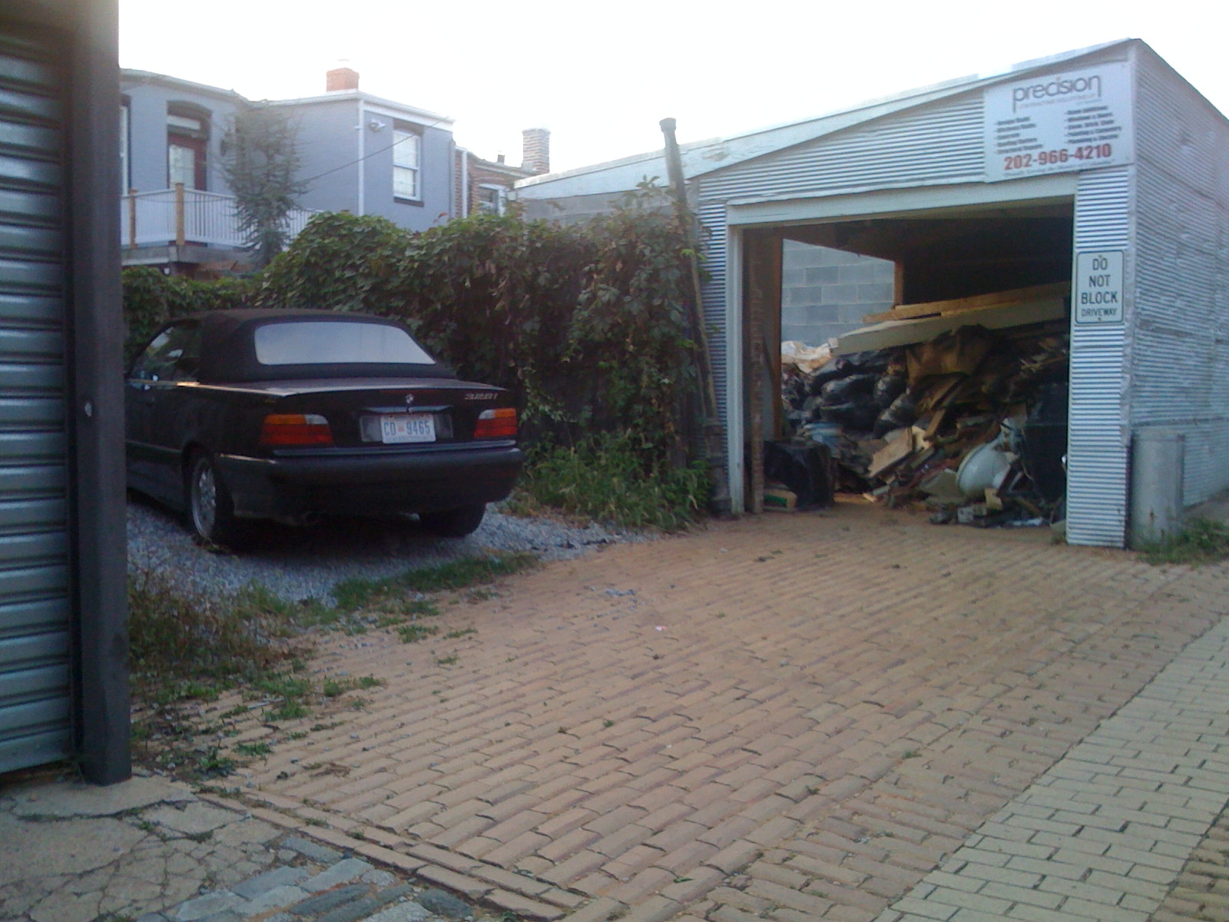
Mr. Fiore’s current garage. Zero setback; the 4’ extension is Mr. Fiore’s property
This area is public space. Mr. Fiore would access his garage from this angle

3. SO 06-5762 Alley Closing behind 1359 H ST NE. This is a continuation of the case heard
on Jan and Feb 2007, a discussion is available on the http://www.anc6a.org website.

Representing this case was Sully Callahan of Sealander Brokerage Ltd.

In 2006, Ms. Shante Parker submitted an application to close the section of alley pictured below, which is behind 1359 H St. NE. In March 2007, ANC 6A opposed this application for the following reasons:

- There was no evidence that Shante parker was the owner’s agent
- The application was incomplete
- No letters of support from adjacent property owners for the alley closing were provided
- The issues of loitering and unwanted activities cited in the application should first be dealt with by MPD and other city agencies.

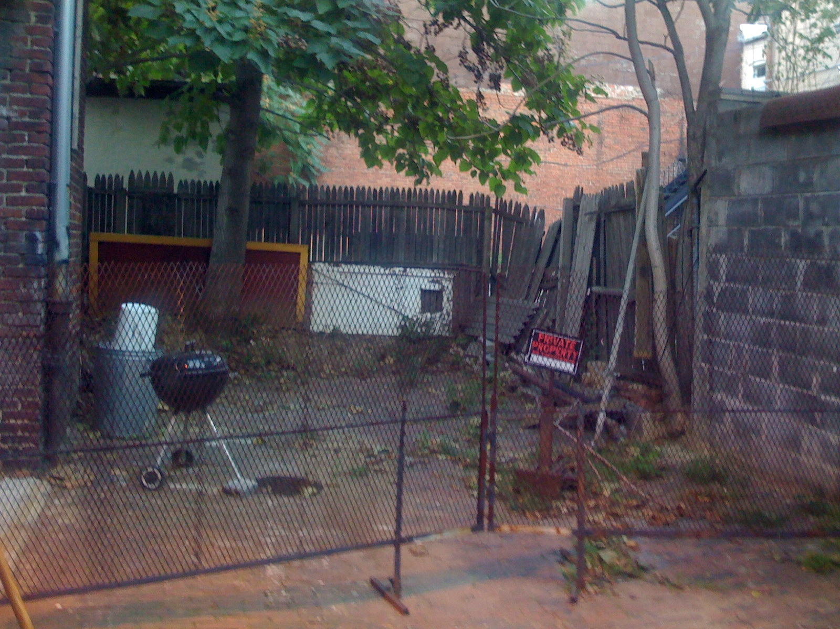

Mr. Callahan introduced himself as the owner’s agent and informed the ED&Z Committee that he would be taking up the application to close this portion of the alley behind 1359 H Street NE. 1359 H Street NE is now occupied by the Sova coffee shop. Sova would like to be able to use the space behind the coffee shop for a patio or deck for its patrons. The goal is to unify the pace to make it more usable to the current and future tenants.

The photo above shows the alley space in question.

The ED&Z committee expressed that they would be happy to work with Mr. Callahan when he presents the new application.

4. HPA (145 Tennessee Ave NE). Applicant seeks to add a 3rd story to his property in the
Capitol Hill historic district.

Representing this case were
Mr. Reco Coates and Karen Coates, homeowners of 145 Tennessee Ave. NE
Mr. jeff Patterson, Developer

145 Tennessee Ave. NE is the end unit, forming something of an “esthetic anchor” to the group of houses on that block.

A stop work order was issued at this location when neighbors noticed and complained that the roof was being raised at this address. Construction to “pop up” the roof had commenced without the appropriate permits.

Mr. Coates stated that the work on his roof and the “pop up” started as a simple roof repair. The roof was leaking. He stated that the front part of the attic space is approximately 7’ high and the back is 3’ high. When they found the leak, they also discovered that the load-bearing beam that holds the steeple was cracking. As the work progressed, they thought to hack up the back of the roof, making the attic usable throughout. This work would involve:

19” pop-up at the front of the house
Raise the back portion of the roof 4 ½’ to make a fully 8 ½’ legal height
The existing front roof line and architectural details would remain

Mr. Patterson stated that he had been engaged to repair the roof and reinforce/replace the beam. No permits are required for standard roof replacement.

It was noted during discussions of the plans that interior renovation of 145 Tennessee Ave. had also been completed without proper permits.

The ED&Z Committee’s standing is that any pop-up should not be visible from the street and that the front view of the house should not be modified. Because 145 Tennessee Ave. is an end unit, the committee also feels that it is important that the design not disrupt the view from the north side line to a large degree.

Next Scheduled ED&Z Committee Meeting:
Wednesday, October 15, 2008
7-9 PM
640 10th Street, NE
2nd Floor - Sherwood Recreation Center

