**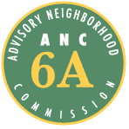Advisory Neighborhood Commission (ANC) 6A**

**Grant Request Application Form**

## 1. Date of Application 2. Date of Project or Activity

09/ 18 / 2017 Upon receipt of funds

**3. Applicant Organization Name and Address 4. EIN (Tax ID number)++**

Miner Parent Teacher Organization 46-2524347

601 15th St NE

**5. Contact Name 6. Title**

Lindsey Jones-Renaud, Fundraising and Grants Committee Chair

**7. Address (if different from above)**

# 8. Telephone 8. Fax

(202) 286-8711 ( ) -

# 10. E-mail Address

LJonesRenaud@gmail.com

**11. Brief Description of Proposed Project/Activity – Detailed Information on Separate Page (See Instructions)**

The Miner Parent Teacher Organization (PTO) is requesting funds from ANC6a to support the Miner Elementary School Grounds Improvement Project. We are purchasing picnic tables for the Miner Elementary School campus.

# 12. Projected Total Cost 13. Amount Requested

$3,899.47 $899.47

**14. Other Sources of Funding (Brief) – Detailed Information Required on Separate Page (See Instructions)**

$2,500 from Capitol Hill Community Foundation, pending application for funding

$500 from Miner PTO Fundraiser

**15. Statement of Benefit (Brief Description) – Detailed Information required on Separate Page (See Instructions)**

This project will benefit all 330 Miner students plus their families, teachers, faculty, and members of the community who use the school campus. Miner ES is located within ANC 6A, the school is in-boundary for many ANC 6A families and a high percentage of students are ANC 6A residents. The picnic tables will create an environment that fosters community and supports outside learning. Two of the picnic tables will be accessible to people in wheelchairs and the other two will be accessible to young children..

|  |  |
| --- | --- |
| ++ Organizations exempt under 501(c)(3) but not required to request a ruling from the IRS ruling (see excerpt from tax code below) may provide documentation (including a financial statement) demonstrating that they meet the criteria in lieu of providing an EIN.Organizations Not Required to File Form 1023 | |
| |  | | --- | | Churches and organizations (other than private foundations) with annual gross receipts normally $5,000 or less are not required to file Form 1023 and obtain recognition of tax exemption for contributors' contributions to them to be tax deductible. Although there is no requirement to do so, many churches and small organizations seek IRS recognition because recognition assures contributors that contributions are deductible. For more information, see [Publication 1828](http://www.irs.gov/pub/irs-pdf/p1828.pdf), Tax Guide for Churches and Religious Organizations, and [Public Charity - Exemption Application](http://www.irs.gov/charities/charitable/article/0,,id=123067,00.html). To apply <http://www.irs.gov/pub/irs-pdf/f1023.pdf> | | |

ANC6A Grant Proposal

Miner Parent Teacher Organization (PTO)

School Grounds Improvement Project

September 18, 2017

**Project Description and Goals**

*Describe the proposed project/activity, what the organization wants to accomplish, and the intended beneficiaries of the project, i.e. seniors, students, community. Include a summary of the purpose and goals; a description of the location(s), and the process/activities, materials and volunteers required to complete the project. These should be specific, measurable, attainable and relevant to ANC 6A. Show that the services/benefits do not duplicate those already performed by the District Government.*

The Miner Parent Teacher Organization (PTO) is requesting funds from ANC 6A to purchase four outdoor picnic tables and three outdoor benches for the Miner Elementary School campus grounds.

These items will help foster an eco-friendly environment at Miner Elementary School that encourages outside learning, builds a sense of community, and increases social engagement. Currently there are no picnic tables on the upper grade playgrounds and only one picnic table on the early childhood education (ECE) playground. There are not enough places for students, teachers, or parents to sit together when they are outside on the main playground. During community days, picnic tables would create a place for families to sit and talk to each other. During recess and aftercare, they could be a space for teachers and students to rest and build relationships with each other. Teachers need a place to sit to supervise the students when they are not playing with them. Currently, they bring chairs from the lunchroom outside since there is no place to sit.

We want the picnic tables to be accessible to everyone, including young children and people in wheelchairs. Therefore, we will purchase two universally accessible picnic tables so that students and family members whose mobility requires a wheelchair will be able to use the tables. We will purchase another two picnic tables that are the appropriate size for pre-school-aged children. One will go on the Early Childhood Education (ECE) playground and the other will go on the upper grade playground, so that there is a place for the pre-school children to sit during community days and weekend school-sponsored playdates.

Miner’s administration confirms that picnic tables and benches are not something that DC Department of General Services will provide for the school, and there are no line items in our school budget from DCPS to purchase these items.

**Statement of Benefit**

*Describe the expected/desired short and long-term objective of the project, and the anticipated benefit of the project to the target audience, i.e. seniors, public space, the environment, students. Explain how the project will be deemed ‘successful’, i.e. by the number of participants; by collecting public comments, enrollment figures, etc. Outline how this benefit will be documented in the required Final Project Report, i.e. survey, photos/videos, artwork, letters/testimonials, news clippings, participant or beneficiary interviews, etc.*

This project will benefit all 330 Miner students plus their families, teachers, faculty, and members of the community who use the school campus. Miner has had declining enrollment for the past several years. Our enrollment decreased from around 380 in the 2016-17 school year to 330. We need support from our neighborhood partners to build a stronger school community.

The PTO will document the success through photos of Miner students and their families sitting at the picnic tables and enjoying each other’s company. The PTO and Miner Elementary faculty will also document art and science projects that can be conducted while using the picnic tables. By allowing students to participate in various projects and classroom lessons outside of the school walls can be more impactful in learning and academic growth. The faculty and staff will document the increase in student engagement during participation of such assignments.

**Timeline**

*Include the expected start and completion dates and significant milestones.*

Upon being awarded the grant, the picnic tables and benches will be purchased within two weeks. Additionally, upon receiving notice that Miner is awarded the grant, the PTO will solicit volunteers during the monthly general body meeting. The volunteers will be responsible for receiving and assembling the picnic tables and benches for placement on the playgrounds.

The goal is to have the items available for use as soon as possible.

**Description of the requesting organization**

*Describe the purpose of the organization, how it currently serves ANC 6A residents, and any prior experience with similar projects. Describe the leadership/membership and how they will participate. If partnering with another group, include contact information and a description of the organization and any pertinent experience.*

# The Miner Parent Teacher Organization (PTO) is a 501C3 non-profit organization made up of families, educators, and staff who work together to support the students at Miner Elementary School. Miner is within the ANC 6A boundaries and serves a student body of nearly 400 students. Miner is a Title 1 school with a high percentage of students from low-income families. Given this challenging background, the Miner PTO plays an important role in providing additional support, financial resources, and positive experiences for the students, families, teachers and staff who are part of the school family.

# The PTO’s objectives are to enhance and support the educational experience at Miner; to develop a closer connection between school and home by encouraging family and teacher involvement; and to improve the academic and social environment at Miner through volunteer and financial support. Over the past two years the PTO has grown immensely in parental, teacher, and staff participation and engagement, as well as in the resources it provides to students, teachers, and families in need. The PTO is made up entirely of volunteers; there are no paid staff.

# To achieve its mission and objectives, the Miner PTO implements a range of activities. Family engagement activities – such as family picnics, festivals, clothing drives, and food drives – foster a sense of community by providing fun ways for families to connect while also helping those in need. The PTO raises funds to support field trips, its fruit and vegetable garden, afterschool clubs, books and technology for the school library, participation in spelling bees and other competitions, and more. The PTO also sponsors teacher appreciation activities to show the community’s support and gratitude to Miner’s administration, staff and teachers.

In December of 2015, the Miner PTO was approved to receive an ANC 6A community grant to fund promotional materials to enable Miner to better and more effectively conduct outreach and promote Miner throughout the community. The final report for that project was submitted on November 15, 2016.

**Other Materials**

*Provide examples of similar projects, photos of project site, newspaper clippings, architectural drawings, descriptions of products/materials, screen grabs etc. Scan the items in PDF format and email with the application package.*

See attached

**Miner Parent Teacher Organization (PTO)**

**School Grounds Improvement Project**

**September 18, 2017**

**Budget Summary**

**(these or similar items)**

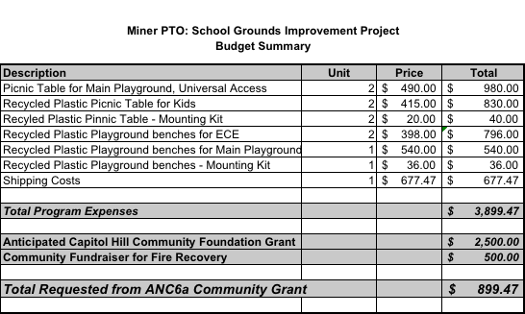

**Budget Narrative**

**Universal Accessible Picnic Tables**

We will purchase two universally accessible (i.e., handicap accessible) picnic tables for the main playground that is used by grades 1st-5th. We will order them from Belson.com at $490 each plus shipping. Link: <http://www.belson.com/Park-Master-Picnic-Tables-Wood>

|  |  |  |  |
| --- | --- | --- | --- |
| **A Logo** |  |  |  |
|  |  |  |  |

**Recycled Plastic Picnic Table for Kids**

We will purchase two high quality commercial grade picnic tables that will be placed in both the upper and ECE playgrounds. Weather permitting, the picnic tables will allow students and staff the opportunity for outside dining and conducting various educational activities. The picnic tables will be purchased at belson.com and cost $415 plus shipping. The purchase of two mounting kits for $20 each is recommended.

Detailed product descriptions may be found at <http://www.belson.com/Childrens-Picnic-Table-A-Frame-Recycled-Plastic>

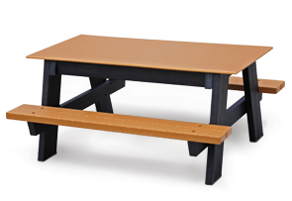

**Recycled Plastic Benches**

We will purchase one high quality, recycled plastic benches for the Main Playground. This will provide a place for parents, caregivers, teachers, and students to sit, such as when they are waiting to get into the school, supervising play, or enjoying the day at our community school. Providing the look of cast iron, the designer frame bases are eco-friendly, splinter free, and will not corrode or rot. It recommends purchasing a mounting kit for $36. Detailed product descriptions may be found at

[**http://www.belson.com/Cambridge-Style-Park-Benches-with-Recycled-Plastic-Frames**](http://www.belson.com/Cambridge-Style-Park-Benches-with-Recycled-Plastic-Frames)

**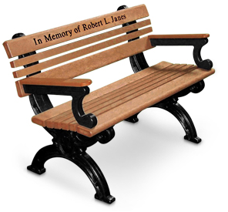**

**Shipping Costs**

Shipping costs for the above items is estimated to be $677.47.

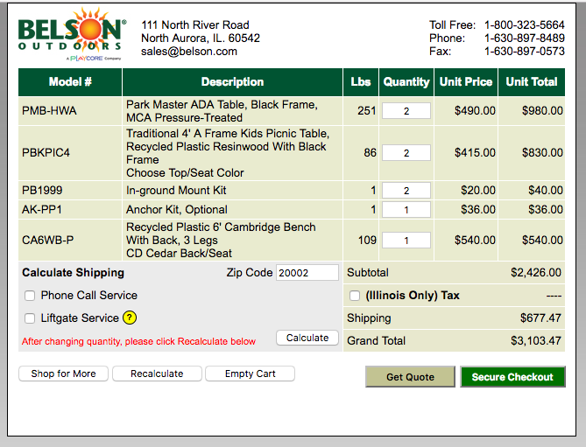

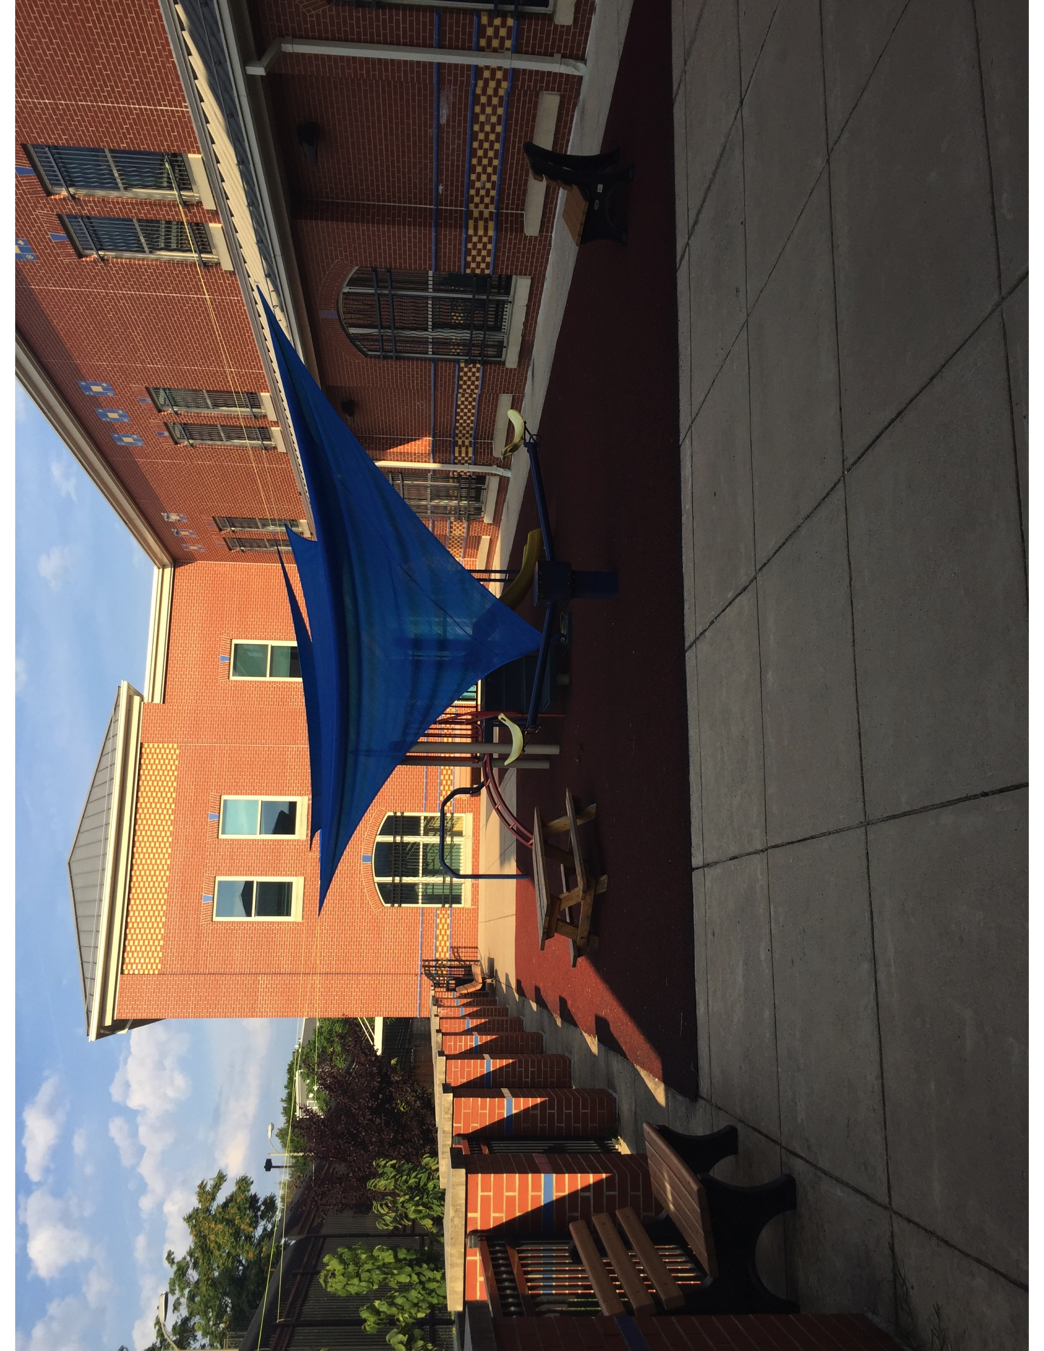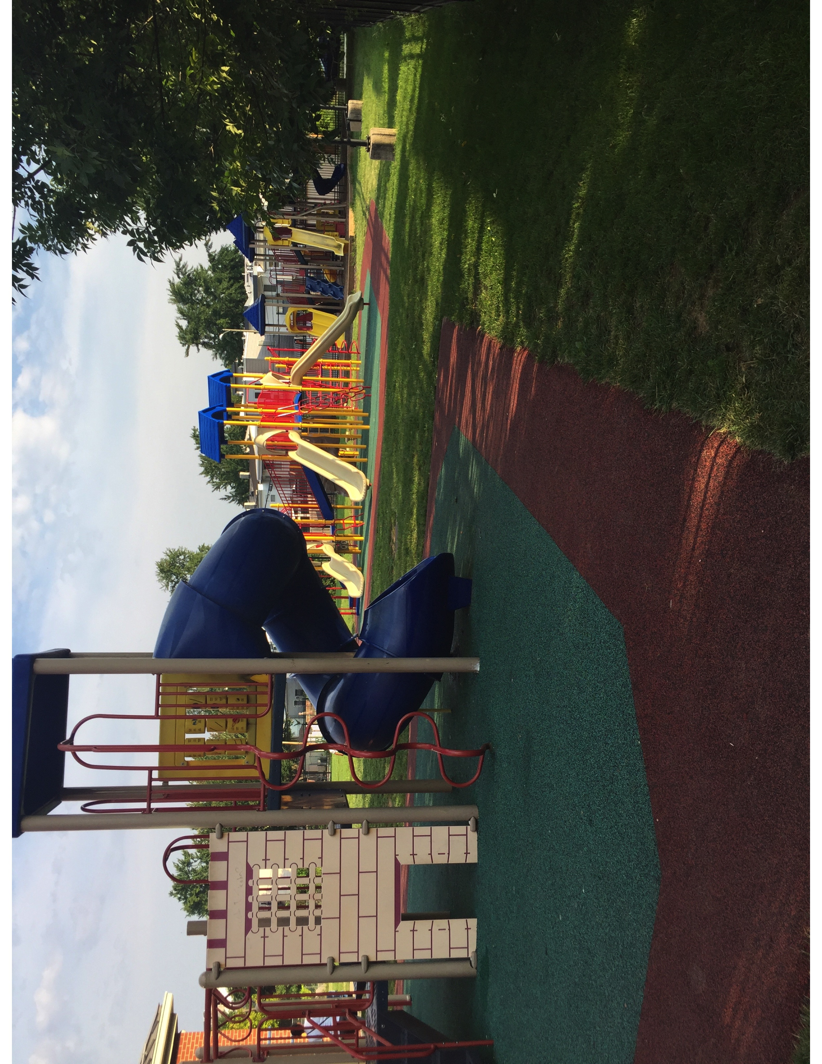Macintosh HD:Users:Elizabeth:Downloads:MinerPTO ANC6A Grant Sept2017 :Letter of Support_Treat.pdf