Advisory Neighborhood Commission (ANC) 6A
Grant Request Application Form

1. Date of Application 2. Date of Project or Activity
10 / 09 / 2018 Upon Receipt of Funds

3. Applicant Organization Name and Address 4. EIN (Tax ID number)++
Miner Elementary School 46-2524347
601 15th Street NE Washington, DC 20002

5. Contact Name 6. Title
Margaret Ben-Or Fundraising & Grants Chair

7. Address (if different from above)

8. Telephone 9. Fax
(202 ) 397 - 3960 ( ) -

10. E-mail Address
margaret.giovannetti@gmail.com

11. Brief Description of Proposed Project/Activity – Detailed Information on Separate Page (See Instructions)
The Miner Elementary School PTO is seeking funding to upgrade our classroom technology by purchasing 7 laptops.
Miner Elementary School is located within ANC 6A and is in-boundaries for ANC 6A residents. It currently serves 359 students, with the capacity to serve approximately 450. These laptops will benefit at least 240 students because they will be shared among multiple K - 5th grade classrooms.

12. Projected Total Cost 13. Amount Requested
$4,084 $899

14. Other Sources of Funding (Brief) – Detailed Information Required on Separate Page (See Instructions)
Application submitted to the CHCF Fall Grant for $2,485. The Miner PTO will contribute $700 raised through the Bear Paw Fund fall fundraising campaign. If partial funding is received, the PTO will still be able to make good use of that funding by purchasing fewer laptops.

15. Statement of Benefit (Brief Description) – Detailed Information required on Separate Page (See Instructions)
The purchase of the 7 laptops will increase students’ access to technology and improve instructional quality and efficiency. While kept secure when not in use, they will also be available for parent and community use. This will benefit adult community members, especially parents who need to engage in DCPS schools’ related internet needs. Indeed all area residents – the community as a whole - will benefit from the improved school environment and culture, as an educated population and desirable schools are essential to a well-functioning and financially stable community.

ANC6A Grant Proposal
Miner Parent Teacher Organization (PTO)
School Grounds Improvement Project
October 9, 2018

Project Description and Goals
Describe the proposed project/activity, what the organization wants to accomplish, and the intended beneficiaries of the project, i.e. seniors, students, community. Include a summary of the purpose and goals; a description of the location(s), and the process/activities, materials and volunteers required to complete the project. These should be specific, measurable, attainable and relevant to ANC 6A. Show that the services/benefits do not duplicate those already performed by the District Government.

The Miner Parent Teacher Organization (PTO) is requesting funds from ANC 6A to purchase seven laptops to upgrade the technology footprint at Miner Elementary School.

Statement of Benefit
Describe the expected/desired short and long-term objective of the project, and the anticipated benefit of the project to the target audience, i.e. seniors, public space, the environment, students. Explain how the project will be deemed ‘successful’, i.e. by the number of participants; by collecting public comments, enrollment figures, etc. Outline how this benefit will be documented in the required Final Project Report, i.e. survey, photos/videos, artwork, letters/testimonials, news clippings, participant or beneficiary interviews, etc.

This Miner PTO Classroom Technology Upgrade Project: Phase II will benefit approximately 240 out of the 359 Miner students and faculty. Over the past several years Miner has experienced declining enrollment. It wasn’t until this current academic year where Miner has seen an increase in enrollment and family engagement due to an active PTO and a committed new administration.

The purchase of these seven laptops will ease a noticeable pain point with the upper grade levels currently experiencing device shortages. The lack of available laptops causes students to often share devices during instruction or in some cases be unable to participate. This shortage issue is currently hindering Miner’s upward trajectory in academic performance; for example, PARCC testing is done on computers so students who do not have much experience using laptops are at a disadvantage in taking these standardized tests. DCPS will not provide laptops and Miner ES has not been given funding by DCPS to purchase them.

This additional educational resource will improve every aspect of school function and climate. In turn, effective and high ranking schools: increase property values throughout the neighborhood; increase stability within the neighborhood as families feel comfortable with the schools and so stay in the neighborhood. This, in turn, will help Miner to attract children from the diverse families residing within the school boundary. And, diverse, multi-generational neighborhoods function better. In this way, the laptops will benefit the community as a whole in addition to the children using them directly.

If awarded the grant, the Miner PTO will document the success through photos of Miner students and faculty using the new laptops during school hours. We will also track student usage through various logging documentation as well as tracking academic performance through progress reporting.
Additionally, if awarded the grant, the laptops will be kept alongside existing devices on a charging cart that is locked in a secured technology closet only accessed by senior level school administrators.

Below is the proposed budget for Phase II of the technology upgrade, including seven laptops and shipping costs. We will purchase Dell Latitude 3380 Non-Touch Laptops, which are compatible with DCPS technology guidelines. The estimated cost per laptop is $562 based on DCPS published technology guidelines.

Funding for the project is heavily dependent on the CHCF and the ANC 6A Community Grant. If we are unable to secure CHCF funds from the fall funding cycle, we will meet with CHCF to discuss how our application may be strengthened and consider resubmitting for the spring funding cycle. Additionally, we will explore whether the PTO budget can cover all or a portion of the funding gap once the calendar year's fundraising activities have concluded. Finally, we will seek out additional grant opportunities from other foundations that support access to technology for grade school students. Although the goal is to acquire seven laptops, if insufficient funds are received, Miner ES will still be able to make good use of a smaller number of laptops.

Budget (these or similar items)

Miner PTO Classroom Technology Upgrade Project: Phase II
Budget Summary
Description | Price | Phase II Unit | Phase II Total
Dell Latitude 3380 Non-Touch Laptop | $562.00 | 7 | $3,934.00
Shipping Costs |  |  | $150.00
Total Phase II Expenses |  |  | $4,084.00
Anticipated CHCH Grant Funds |  |  | $2,485.00
Bear Paw Fund Fall Campaign Funds |  |  | $700.00
Total Anticipated Additional Funding |  |  | $3,185.00
Total ANC 6A Funding Request |  |  | $899.00

Timeline
Include the expected start and completion dates and significant milestones.
Upon being awarded the grant, the laptops will be purchased within two weeks.
The goal is to have the items available for use as soon as possible.

Description of the requesting organization
Describe the purpose of the organization, how it currently serves ANC 6A residents, and any prior experience with similar projects. Describe the leadership/membership and how they will participate. If partnering with another group, include contact information and a description of the organization and any pertinent experience.

The Miner Parent Teacher Organization (PTO) is a 501C3 non-profit organization made up of families, educators, and staff who work together to support the students at Miner Elementary School. Miner is within the ANC6a boundaries and serves a student body of more than 339 students. Miner is a Title 1 school with a high percentage of students from low-income families. Given this challenging background, the Miner PTO plays an important role in providing additional support, financial resources, and positive experiences for the students, families, teachers and staff who are part of the school family.

The PTO’s objectives are to enhance and support the educational experience at Miner; to develop a closer connection between school and home by encouraging family and teacher involvement; and to improve the academic and social environment at Miner through volunteer and financial support. Over the past two years the PTO has grown immensely in parental, teacher, and staff participation and engagement, as well as in the resources it provides to students, teachers, and families in need. The PTO is made up entirely of volunteers; there are no paid staff.

To achieve its mission and objectives, the Miner PTO implements a range of activities. Family engagement activities – such as family picnics, festivals, clothing drives, and food drives – foster a sense of community by providing fun ways for families to connect while also helping those in need. The PTO raises funds to support field trips, its fruit and vegetable garden, afterschool clubs, books and technology for the school library, participation in spelling bees and other competitions, and more. The PTO also sponsors teacher appreciation activities to show the community’s support and gratitude to Miner’s administration, staff and teachers.
At the October 12, 2017 meeting of ANC6A, the Commission approved a grant request from the Miner Parent Teacher Organization (PTO) to purchase two universally-accessible picnic tables as part of the PTO’s ongoing outdoor campus improvement project. Per our grant application:

“This project will benefit all 330 Miner students plus their families, teachers, faculty, and members of the community who use the school campus. The picnic tables and benches will create an environment that fosters community and supports outside learning.”

The final report for that project was submitted September 18, 2018.

Other Materials
Provide examples of similar projects, photos of project site, newspaper clippings, architectural drawings, descriptions of products/materials, screen grabs etc. Scan the items in PDF format and email with the application package.

See attached.

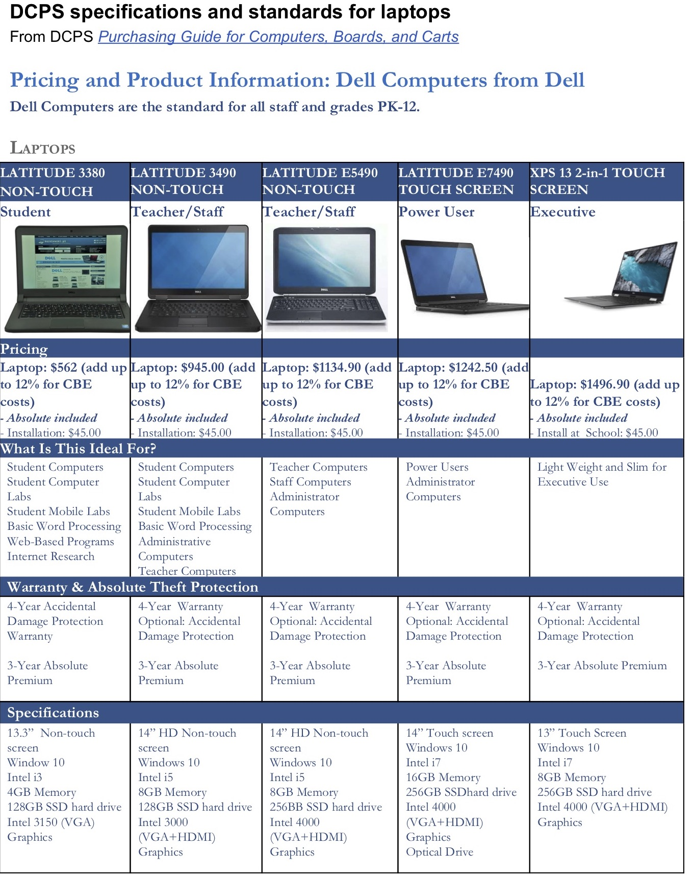

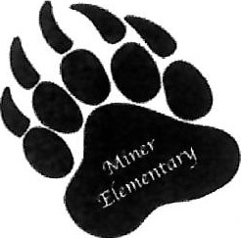
Miner Elementary School
Bruce W. Jackson —Principal Camille Townsend — Assistant Principal
Simon X King — Director, Strategy & Logistics
Miner Elementary School
601 15th St NE
Washington DC 20002
October 2, 2018
To the Advisory Neighborhood Commission 6a:
As the principal of Miner Elementary School, I endorse this application for funds from the ANC6a that will be used to purchase new Dell Latitude 3380 laptops for Miner Elementary.

Currently our Miner Teachers have to share a limited quantity of technologies. Through ANC6a's generous spring grant, we have been able to increase our inventory, and we seek to continue to do so with Phase Il of this project. With an increased inventory, our students will have greater access to technology when it is needed, which will enhance their educational experience.
Thank you very much for your consideration.

Sincerely,

Bruce W. Jackson Principal
Miner Elementary School

Miner Elementary School
601 15th St. NE
Washington DC 20002
October 8, 2018
To the Advisory Neighborhood Commission 6a:
Our world today requires students to learn 21 ^{st} Century skills that will enable them to compete in our ever-changing world. Specifically, technology has become an essential part of education. Our students are challenged academically with online assessments and mandated online literacy and mathematic interventions and programs. However, what's more challenging is integrating these programs into our classrooms because of the lack of working and out of date laptops within the school. How can we expect our students to keep up academically if we cannot provide them with the necessary tools for advancement?
I am in support of this request because our students deserve the same opportunities as schools across the city. Our teachers deserve to have enough laptops to service their classrooms effectively. Increasing our inventory will help to ensure that our students have access to information right at their fingertips. From, literacy to mathematics to STEM technology in our classrooms will help enhance the academic achievement of all students at Miner Elementary School.
Thank you for your consideration.
Sincerely,
Math Instructional Coach
Miner Elementary School

Miner Elementary School
601 15th St NE
Washington DC 20002
October 8, 2018
To the Advisory Neighborhood Commission 6a:
As a 5th grade teacher at Miner Elementary School, I endorse this application for funds from the ANC6a that will be used to purchase new Dell Latitude 3380 laptops for Miner Elementary.
Currently, Miner Teachers have access to a limited amount of technology. Laptops are essential to implementing quality instruction here at Miner. In the 5th grade, we use laptops to engage in our blended learning programs, conduct research products, and publish student work.
Through ANC6a's generous spring grant, we have been able to increase our inventory, and we seek to continue to do so with Phase Il of this project. With an increased inventory, our students will have greater access to technology when it is needed, which will enhance their educational experience. Thank you very much for your consideration.
Sincerely,
Katherine Unger
5th Grade Teacher

