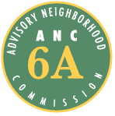
Advisory Neighborhood Commission (ANC) 6A
Grant Request Application Form

1. Date of Application 2. Date of Project or Activity
11 /23 / 2015 12 /15 /15

3. Applicant Organization Name and Address 4. EIN (Tax ID number)++
Miner Elementary PTO 46-2524347
601 15th St. NE 20002

5. Contact Name 6. Title
Andrew Curry, Fundraising Chair

7. Address (if different from above)
Home 641 14th PL NE 20002

8. Telephone 8. Fax
(703 )629 - 2255 ( ) -

10. E-mail Address
minerpto.fundraising@gmail.com

11. Brief Description of Proposed Project/Activity – Detailed Information on Separate Page (See Instructions)
Procure components and signage for a mobile promotional and display “booth” (e.g. table and display items). To be used by Miner staff or PTO representative manning tables at school and community events. Also large outdoor vinyl banners to advertise upcoming PTO meetings.

12. Projected Total Cost 13. Amount Requested
$760 $760

14. Other Sources of Funding (Brief) – Detailed Information Required on Separate Page (See Instructions)
PTO general fund

15. Statement of Benefit (Brief Description) – Detailed Information required on Separate Page (See Instructions)
Assist efforts of Miner Elementary in its outreach to the community at-large.

Proposal
- Project Description and Goals
Project/Activity: The Miner Elementary School (E.S.) Parent-Teacher Organization (PTO) seeks funding for various display and signage materials to be used at school events, community meetings, sporting and social events and at other outreach opportunities this year and in the future. The Myrtilla Miner E.S. is a DC Public School located ANC 6A at 601 15th Street NE, Washington, DC 20002 with grades Pre-K3 through the 5th grade.
Goals of Project: The Miner community of parents, teachers, and administrators is working hard to make the school into one that more of our eligible ANC 6A neighbors will choose for their children. Much of a school’s success comes from high levels of community and parent involvement. Miner PTO aims to showcase the successes at the school and promote the hopes for future growth and academic achievement to the wider community, increase visibility, and draw support from neighbors in the ANC. The Miner E.S. PTO serves as an advocate for the school, students, parents, and teachers to a variety of audiences, including parents of eligible students in the ANC, the greater ANC 6A community, DC Public School and other DC government officials.
The display materials will be used at outreach events this year and in the future at formal open-house and informational events such as the Capitol Hill School Information Night (November); DCPS EdFest (December), and four DCPS Open House events; as well as at Miner school events, games, and community and social gatherings in ANC6A.
Materials/Volunteers: Miner PTO will source and purchase presentation/booth materials for use at the formal and informal events. Not every event will have tables available, thus the inclusion of a lightweight portable table and chairs. The materials will be made available to both PTO volunteers and paid school personnel alike.
- 4 (Four) – Clear Acrylic brochure holders – tabletop.
- 4 (Four) – Clear Acrylic upright page displays -- tabletop
- 1 (One) – Vinyl banner 4’ – to hang behind table at PTO events.
- 2 (Two) Printed vinyl banners (3’x6’) – In addition to booth materials, two vinyl banners will be used to advertise upcoming PTO meetings, one at each side of the school. Copy: “PTO Meeting __<hand written date>__School Cafeteria 6pm to 7pm – childcare provided!” Graphics: Miner Logo, etc.
- 2 (Two) Printed fabric table runner 30” wide – a table runner printed with Miner graphics would fit a wide variety of table sizes.
- 1 (One) polyester tablecloth – plain, not fitted to a particular table size.
- 2x Portable display easels – to display informational graphics in different configurations (full height on the floor, tabletop, multiple combinations, etc.)
- 1x Folding hand truck – to help move display and printed materials in/out of events.
- 2 (Two) - Portable tables (2’x6’) – for use at impromptu deployments (soccer games etc.) that may not provide tables.
PTO volunteers will source and purchase the materials, permanently label them as Miner PTO property, secure their safe storage, and make arrangements for their availability to school personnel and PTO volunteers.
Items will be purchased with PTO funds, which the grant funds will reimburse. All items will be purchased as soon as possible. Items requiring printed graphics may see a slight delay due to the design process. The materials will be assembled into a “kit” and maintained and managed for long-term use.
The Miner PTO does not receive any funding/materials from the DC government. The requested items are not duplicative of any other DC government services or materials.
- Statement of Benefit:
The combined efforts of the Miner parent volunteers and school professionals are aided by increased community involvement. In nearly every Miner PTO or school initiative, outreach plays a key role. A conspicuous, professional, inviting presence draws people in to learn more and find ways to contribute. Parental involvement is growing at Miner. We expect increased visibility at a variety of events will help remind people that the Miner community is ACTIVE and INCLUSIVE. The short- and long-term goals are to increase PTO membership and volunteering by parents and community members, and building a stronger and more sustainable organization for the future; and to attract and retain more students from ANC 6A.
A successful project will be measured by growth in PTO membership and volunteer participation; as well as a larger number of contacts/outreach at school and community events. While membership growth may take some time, the Final Report will compare membership in 2014/15 versus 2015/16 at the time of the report. In addition, we will provide photographs of outreach/contacts while using the display materials at various events.
- Timeline
Once the PTO receives approval of the grant by the ANC, all the items will be selected and purchased expeditiously, since some items take longer because of the design process for printed items. The entire display “kit” should be ready for deployment within 4 to 6 weeks of approval of the grant by the ANC.
- Description of the requesting organization:
Miner PTO is a 501c3 non-profit organization as of January 2015. The organization has been active for five years prior to receiving non-profit classification. There is no membership fee. Miner PTO supports fundraising and other outreach efforts that aid school personnel and families alike.
The 2015/16 PTO consists of an elected, dedicated leadership team, and a broad range of parent and teacher volunteers. Leadership includes:
- Co-Presidents: Tammy Alexander, David Treat
- Co-Treasurers: Dan Harper, Michelle Peyton
- Communications: Holly Harper
- Fundraising: Andrew Curry
- Co-Secretaries: Colleen Chamberlain, Samantha McFadden
- Teacher Reps: Teresa Dorsey (PK3), Sarah Jensen (3rd)
Two or more PTO leaders (Communications, Co-President, Fundraising) will be responsible for sourcing the materials, processing them, and making arrangements for their use.
- Other Materials:
Photos of some of the items requested (acrylic brochure holder, folding table, easel, handcart, printed table runner in white)
 | 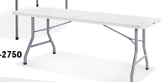 | 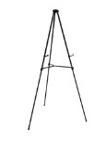 | 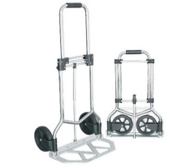
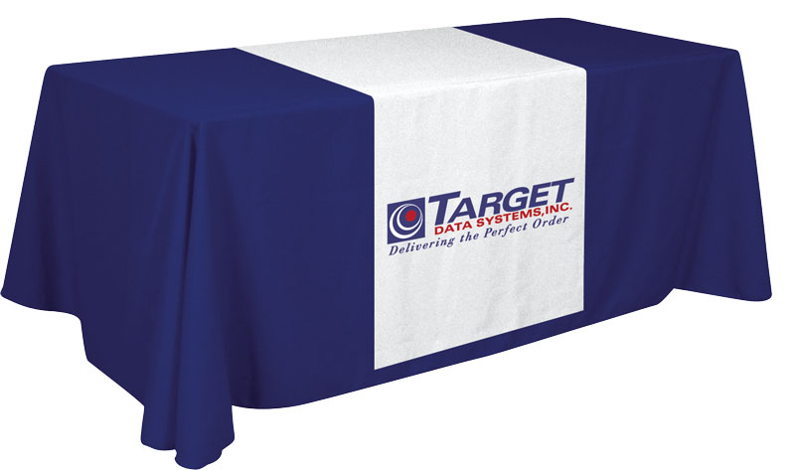

Budget (Narrative and Table)
The Miner PTO is requesting a total of $760 for materials, printing, shipping and handling from ANC 6A.
The ANC6A Grant will fund the purchase of the permanent hard-goods associated with the promotional event display kit. The items will be purchased online (Amazon.com, ULine, Displays2Go) using one or more leadership member’s personal credit cards. The PTO will reimburse the individuals in the form of a check on a receipt basis ASAP.
The PTO will submit the final total amount spent (with receipts) to the ANC Treasurer, with appropriate documentation, not to exceed the total grant funding. Price estimates in the table below include shipping, which may not be as expensive if a single vendor can supply multiple items. The Grant will not fund disposable or temporary items such as printed brochures, poster graphics, or supplies such as pens and tape.

ITEM | Unit | Shipping | Extended
4x Acrylic Brochure holders | $10 | Included | $40
4x Acrylic Upright displays | $10 | Included | $40
2x Printed banner (advertising next PTO meeting…) for outdoor display | $50 | Included | $100
1x 4’ vinyl PTO banner | $45 | Included | $45
2x Printed table runners | $75 | Included | $150
2x folding tables (approx 3’x3’ or 2’x6’) | $110 | Included | $220
1x tablecloth - polyester | $50 | Included | $50
2x easel to prop up poster-size graphics | $30 | Included | $60
1x folding hand truck | $55 | Included | $55
TOTAL |  |  | $760

Grant requirement acceptance:
Miner PTO understands and agrees to the requirements to receive an ANC 6A grant. This includes signing an ANC 6A Grant Agreement, committing the PTO to all requirements, including a). that all grant money be spent within sixty (60) days of disbursement, unless there are extenuating circumstances; b). submission of a Final Project Report, as described in the grant application, within sixty (60) days from the date the grant money is disbursed.

Supporting Documents
Other required (as listed below) are being provided separately.
A. Required: A copy of the IRS 501(c)(3) non-profit status letter and identification number in PDF format, labelled “Proof of 501(c)(3) Status”
B. Required: Letter of support from Miner PTO Co-President, David Treat

