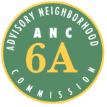
Advisory Neighborhood Commission (ANC) 6A
Grant Request Application Form

1. Date of Application 2. Date of Project or Activity
8 / 14 / 2011 ongoing Oct. 2011 - March 2012

3. Applicant Organization Name and Address
Sherwood Neighborhood Volunteers
funds administered by the Capitol Hill Garden Club
646 9th St NE, Washington, DC 20002
4. Contact Name 5. Title
Edna Jane Truax President

6. Address (if different from above)

7. Telephone 8. Fax
( 202 ) 546 - 7638 ( 202 ) 698 - 3397

9. E-mail Address
Truax1934@verizon.net & ptoomajian@gmail.com

10. Brief Description of Proposed Project/Activity
We will plant a series of bushes along the exterior fence of the entrance at the Sherwood
Recreation Center (640 10th St NE). The project will add a raised bed just outside the gate on the north side of the entrance and decorative shrubs on the south side of the entrance, likely to include a dozen bushes, grasses, mulch, fencing/timbers, top soil and a sprinkler.

11. Projected Total Cost 12. Amount Requested
$ 1500 $ 1500

13. Other Sources of Funding (be specific, provide names)
Capitol Hill Community Foundation, Frager’s, Ginko Gardens, individual contributions.

14. Statement of Benefit (detailed description of project or activity, who will benefit and in what way)
The Recreation Center provides physical & educational programs for children and adults. It is located in ANC6A and heavily used by ANC6A residents. The new plantings will help beautify the Center & its surrounding neighborhood for those who use the Center and will make the entrance more welcoming to those who walk by it. The will also reduce the carbon footprint of the grounds.

The Sherwood Neighborhood Volunteers have been developing the grounds & gardens at the Sherwood Recreation Center over the past two years. We have removed old clay and trash, turned the soil, added bulbs, small perennials, trees, and bushes near the entrance to the Center over the course of our involvement. Our work has involved dozens of local volunteers from the neighborhood and we have partnered with other local organizations including the Capitol Hill Garden Club and Casey Trees to bring more investment to our neighborhood Recreation Center.

We have successfully maintained the new plants and the improvements we have made to the landscaping on the grounds have received rave reviews. In particular, we’ve overseen the planting of 16 new trees on the grounds, 4 new trees on the street in front of the building, and 3 new beds of perennials and bushes on the grounds.

We are now seeking ANC6A funding to pay for additional materials to create and populate additional planting areas. We have particularly targeted the area along the fence near the entrance to the Center. This area is currently devoid of any growth, but should be one of the most attractive areas in light of its visibility to all who enter the Center. These improvements are outside the scope of the Center’s groundskeeping plan and are not included in DPR’s budget.

Budget for ANC6A funding:
These or similar items cost approximately:

Spring Bulbs $75
Hose $25 (to water trees outside the fence)
Sprinkler $25 (to ease watering burden)
Timbers $300 (to protect the new bed)
Grasses $250
Bushes $475
Top Soil $150
Mulch $200

Total: $1500

Durable items including the sprinkler, hose or other tools would be stored in the Recreation Center’s storage room.
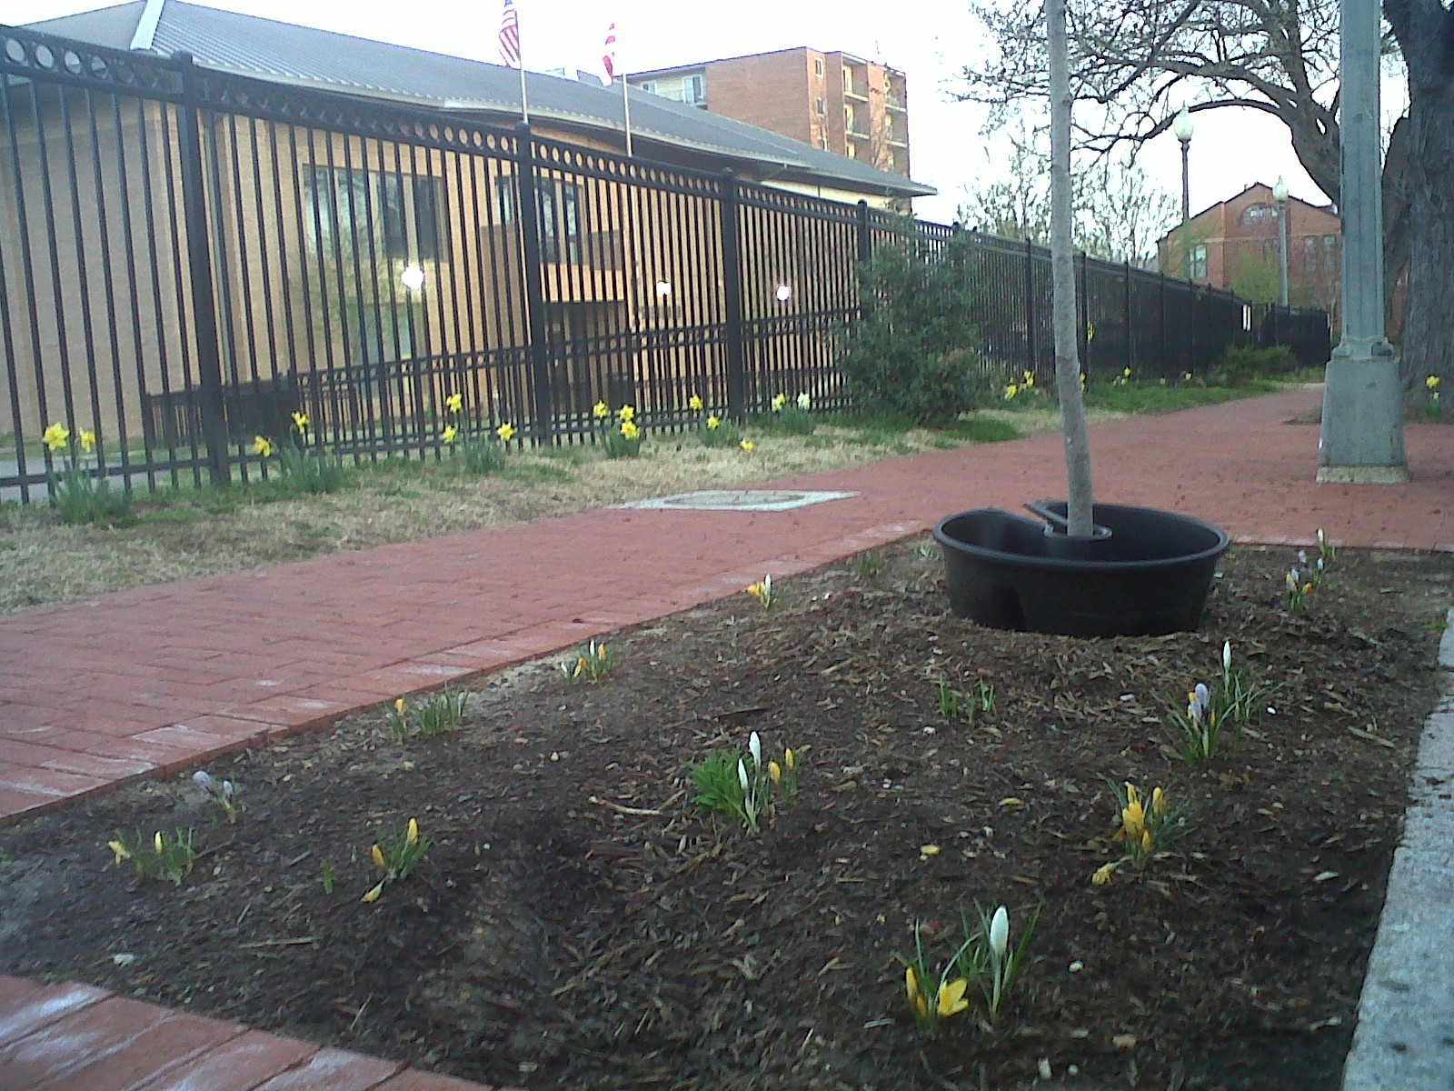

View of planting beds. Bulbs planted last year.



