Draft Agenda for Thursday, February 10, 2005, at Miner Elementary School
7:00pm Call the meeting to order, adopt agenda and approve previous meeting’s minutes.
Community Comments (2 minutes each)
7:10 Commissioner’s Single Member District reports (2 minutes each)
7:20 Officer Reports:
1. Chair, Vice-Chair, Secretary (as required)
2. Treasurer
A. Approve monthly treasurer’s report and approve previous month’s disbursements.
B. Approve photocopying expenses.
C. Approve financial report for the 1st Quarter of FY 2005.
7:30 Standing Committee Reports:
1. Alcohol Beverage Licensing (3 minutes)
A. Recommendation: Each licensee is invited to ABL committee 2 months before license renewal date
B. Committee Members
C. Accept Committee Report - December.
2. Economic Development and Zoning (10 minutes)
A. Update on H Street Zoning Overlay
B. Recommendation for draft committee goals
C. HPA #05-113 (1319 Constitution Avenue, NE): Recommendation: send letter to HPRB
D. HPA #04-331 (326 12th St, NE): Recommendation: send letter to HPRB
E. Committee Members
F. Accept Committee Report - January
3. Community Outreach (5 minutes)
- Discuss ANC Draft Flyer
B. Committee Members
C. Accept Committee Reports – December.
4. Public Safety (2 minutes)
A. Committee Members
- Schools Committee (5 minutes)
A. Recommendation: affirm mission statement.
B. Recommendation: affirm initial committee tasks.
C. Recommendation: No formal committee members for now.
D. Accept Committee Report - January.
8:00 Unfinished Business
- 1341 Maryland Avenue – Firehouse (Borbely) (initial 30 minute limit)
- Letter to DDOT requesting removal of AM/PM rush hour parking restrictions on H St. (Rice) (2 minutes)
- Joint PSA Advertisement with ANC 6C - not to exceed $250 (Fengler) (2 minutes)
8:40 New Business.
- Discussion of voluntary agreement for S&T Supermarket and Deli – 201 15th Street, NE (Alberti) (12 min)
- H Street Liquor Store License Negotiations and ANC Representation (3 minutes)
- Letter of concurrence for female ginko tree removal on 200 block of 12th Pl NE (Rice) (3 minutes)
8:55 Community comments – Round 2 (if time permits)
9:00 Adjourn
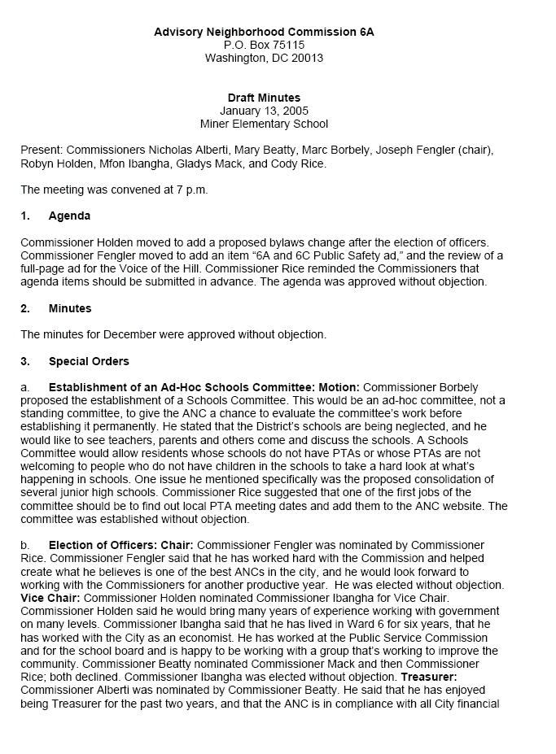
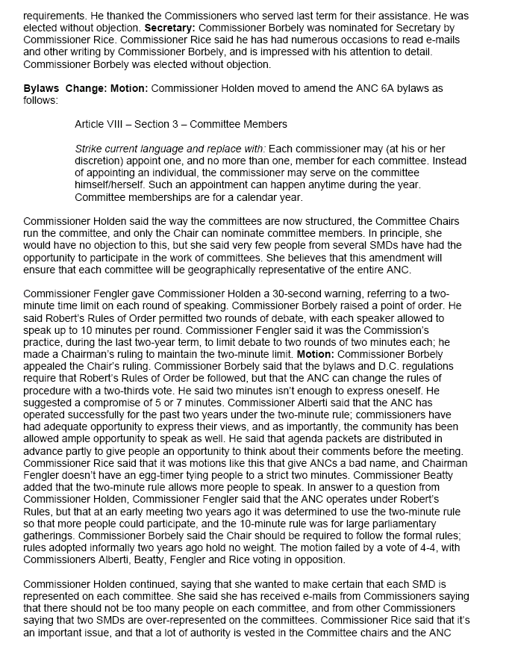
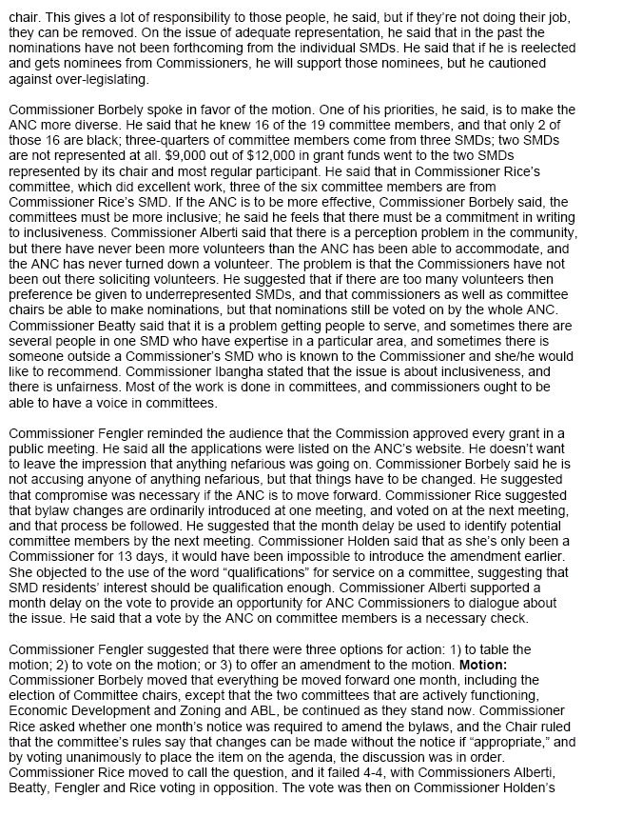
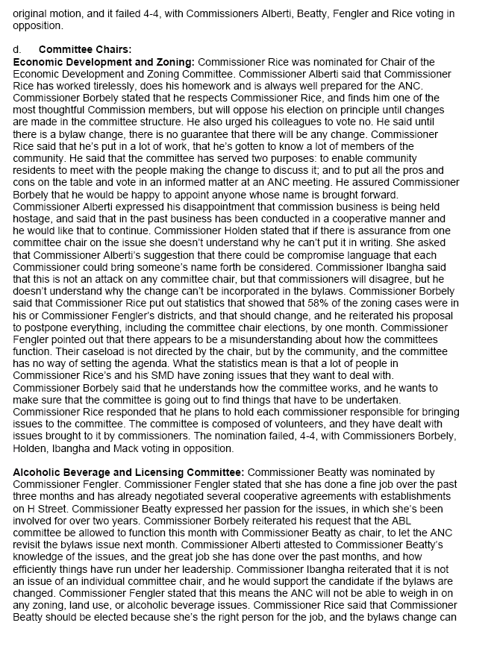
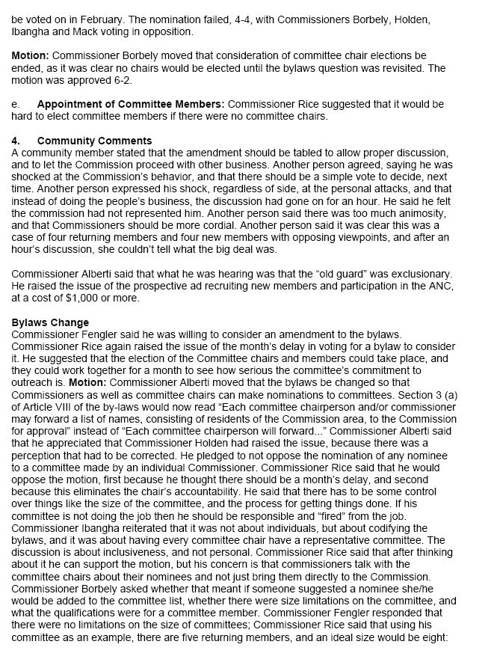
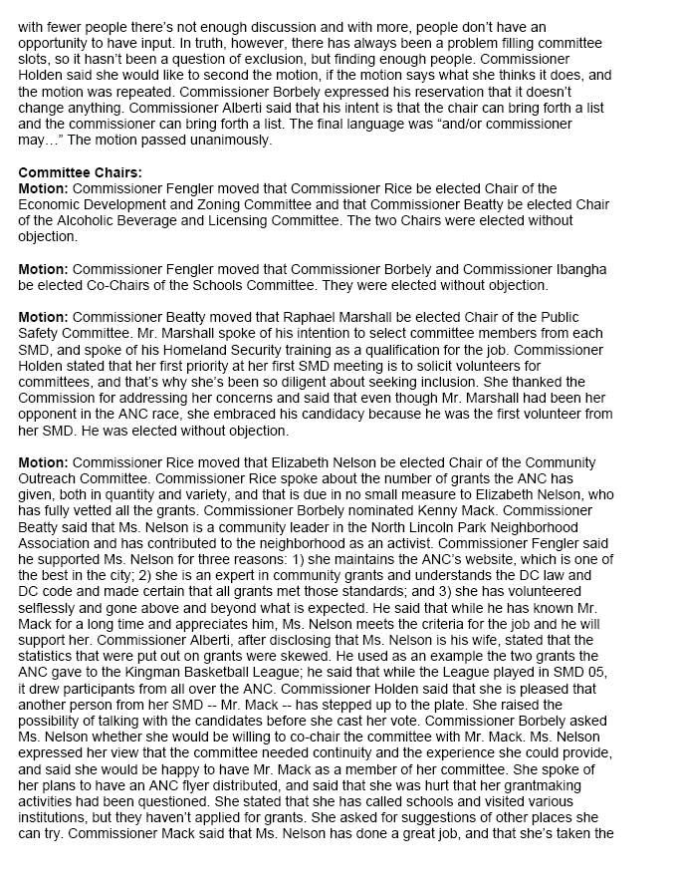
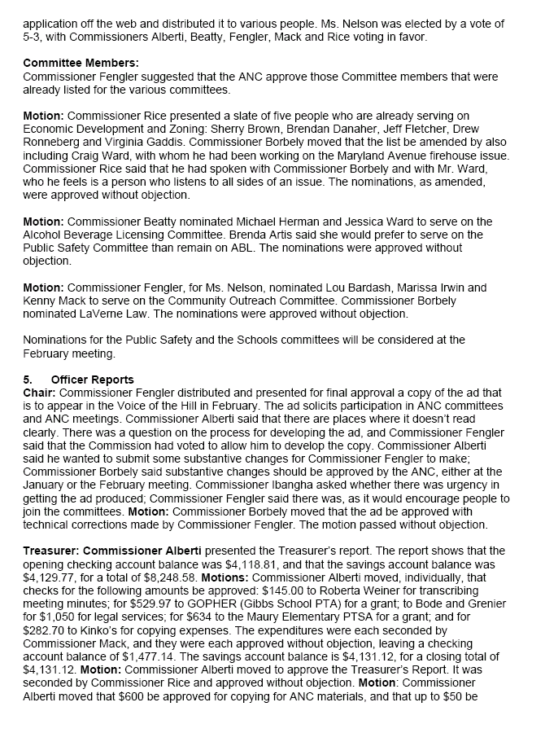

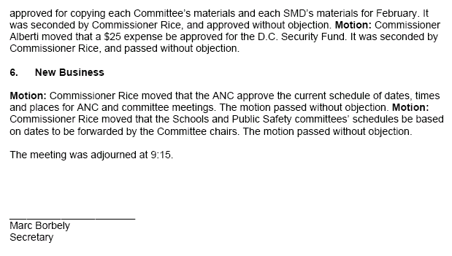

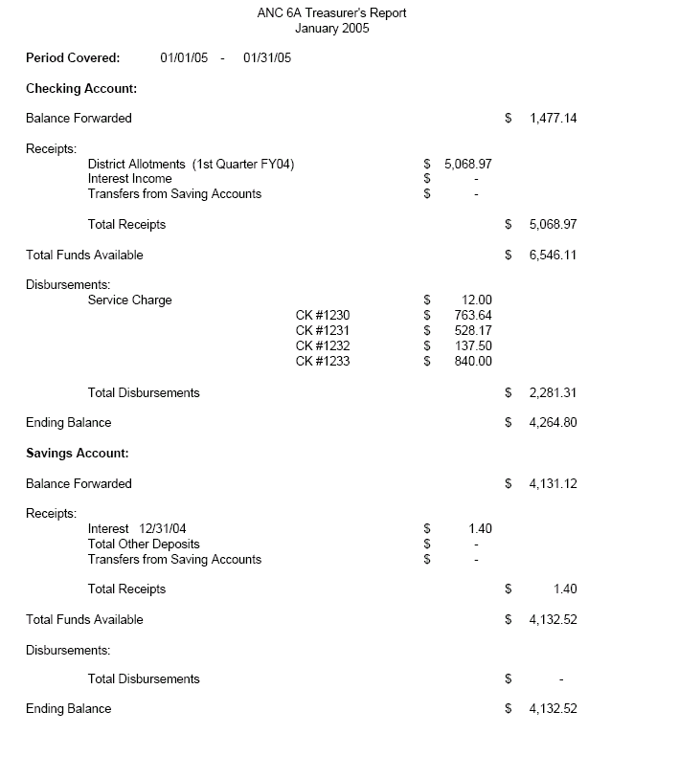

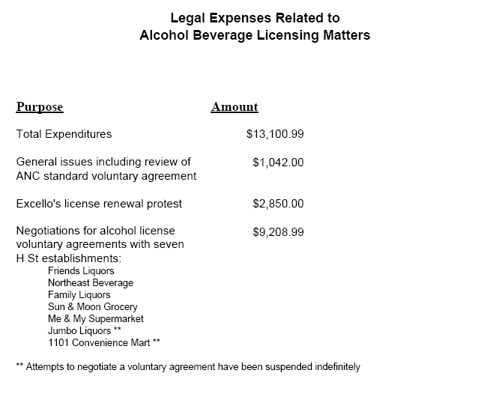

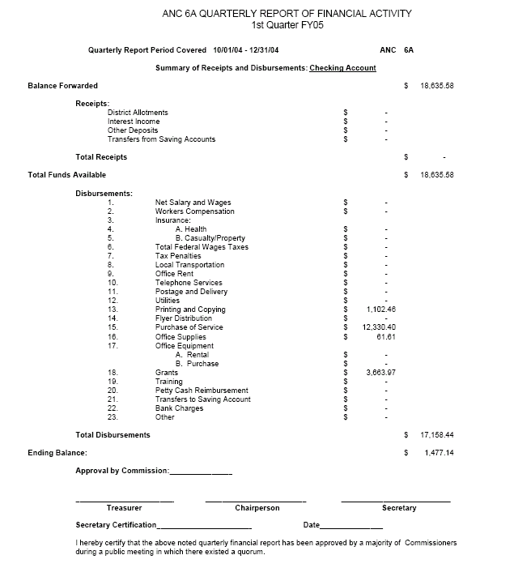

REPORT OF THE
ALCOHOLIC BEVERAGE LICENSING COMMITTEE

December 21, 2004
Sherwood Recreation Center
7 p.m.

COMMITEE ATTENDANCE

Mary Beatty Committee Member, Chairman
Marc Borbely Committee Member, Secretary
Michael Herman Committee Member

Brenda Artis and Richard Sundberg were absent.

COMMISSIONER ATTENDANCE

Nick Alberti 6A04

COMMUNITY ATTENDANCE

(none)

CALL TO ORDER

Mr. Borbely entered at 7:20 p.m., whereupon a quorum was established and Ms. Beatty called the meeting to order.

APPROVAL OF THE MINUTES

MOTION: Mr. Herman moved, Ms. Beatty seconded, to approve the minutes of November 16, 2004. The motion passed unanimously (3-0-0).

OLD BUSINESS

I. Family Liquors

Ms. Beatty reported that ANC Chairman Joe Fengler sent a letter to the Alcoholic Beverage Regulation Administration, rescinding the ANC’s support for Family Liquors.

II. Olympic/Showbar

Ms. Beatty presented a letter dated December 17 by ANC Chairman Joe Fengler to the Alcoholic Beverage Control Board, reporting the ANC’s decision to enter into a voluntary agreement for the Showbar (1210 H St. NE) and the Olympic (1206 H St. NE), with the understanding that the ABC Board would, at the applicant’s request, amend both of the liquor license applications from CN to CT. Commissioner Fengler’s letter said that the ANC reserves its right to protest if the amendments are not accepted by the Board.

Mr. Borbely raised a concern whether Commissioner Fengler’s letter would serve adequately as protest, because it didn’t list reasons for protest, as Mr. Borbely thought was required by law. Ms. Beatty and Commissioner Alberti said they had assurances from Chuck Burger, chairman of the Alcoholic Beverage Control Board, and ABRA general counsel Fred Moosally that the Board would find a way to accept the amendments to CT, especially since Joe Englert, the applicant, had also expressed strong support for the amendments.

III. Majestic

Ms. Beatty reported that some lease issues are holding up the Majestic’s (1368 H St. NE) efforts to negotiate a voluntary agreement with the ANC. She said the Majestic has not yet begun placarding its license application.

NEW BUSINESS

I. Update: Voluntary Agreement with Anita’s (201 15th St. NE)

Commissioner Alberti presented a voluntary agreement signed by Assefa Arefaine (12/8/04), the owner of Anita’s, Commissioner Alberti (12/6/04), representing his Single-Member District, Commissioner Fengler (12/12/04), representing the ANC, and Heather Scott (12/6/04), representing a community citizen group.

Commissioner Alberti pointed out that the voluntary agreement has a no-chilled-singles provision, as well as a no-singles-of-malt-liquor provision, among other provisions.

Mr. Borbely asked whether the ANC had authorized Commissioners Alberti and Fengler to sign the agreement on behalf of the ANC. Mr. Alberti said that the ANC had authorized him to negotiate with Anita’s, and that this gave him the authority to reach an agreement on behalf of the ANC. He suggested that the question is uncharted territory but could be clarified for the future.

II. Scheduled Committee Appearances by Liquor Licensees

Mr. Borbely proposed that each liquor licensee be asked to attend an ABL committee meeting a few months before its licenses is up for renewal. Mr. Herman said this would give business owners a chance to dialogue with neighbors. Ms. Beatty said one downside would be that for every licensee, there would be neighbors in support and neighbors in opposition, so it would be hard for the committee to get a full picture. Commissioner Alberti said a schedule would be useful, as it would take the onus off of individual Commissioners to find out which licensees are coming up for renewal.

Ms. Beatty agreed to contact ABRA for a list of licensees in the area, with their renewal dates. If she is unable to obtain such an overall list, she will request that each commissioner provide her with a list of licensees, which she’ll then use to obtain the individual renewal dates, from ABRA.

MOTION: Ms. Beatty moved, Mr. Herman seconded, to recommend to the ANC that it adopt a process whereby each licensee up for renewal be invited to come before the ABL committee approximately two months before its renewal date, to give the public an opportunity to air concerns. For each occasion requiring placarding (such as transfers or substantial changes of business), the ABL will also strive to offer the community an opportunity to air concerns in a timely manner. The motion passed unanimously (3-0-0).

III. Guidelines for When the ANC Should Join a Renewal Protest

Mr. Borbely proposed that the committee establish some guidelines for what circumstances, in general, the ANC would join a community protest of a license renewal. Among the possible criteria: whether community members have gathered a certain number of signatures from neighbors; whether a certain number of neighbors have attended a committee meeting to state their position; whether one or more neighbors are willing to lead the effort. Such guidelines would inform community members what they should do to seek ANC support of a protest; they would also help ensure that the ANC joins only those protests where there are sufficient community members to carry on the protest without huge expenditures of money and energy from the ANC itself.

Ms. Beatty expressed concern that such guidelines would tie the committee’s hands and not allow the committee to treat each possible protest on a case-by-case basis. Mr. Herman added that sometimes the ANC might want to join a protest to maintain its ability to negotiate, especially when other groups are already protesting.

Commissioner Alberti suggested that instead of thinking of “guidelines,” the committee might consider offering “guidance,” such as stating that the ANC usually cannot commit itself to a protest unless there is evidence that there is a committed group of citizens who will be involved. He suggested seeking input from other commissioners on this question.

IV. Recruitment of New Members

The committee discussed its future composition. Mr. Borbely suggested that the committee include one representative from each Single Member District. Currently, three committee members are from 6A05, one is from 6A06, and one is from 6A07. Commissioner Alberti said he supported this idea in principle, but worried that a quorum would be difficult to attain under those circumstances. He also expressed a desire not to tinker with a well-functioning committee and set it up for failure. He indicated support for the three members from 6A05, and for their contributions to the committee. Ms. Beatty suggested adding two more committee members from two additional SMDs.
Mr. Borbely suggested that one alternative would be for Mr. Alberti to nominate one of the 6A05 members to the committee instead of someone from his SMD but to still aim for one representative from each SMD.

ADJOURNMENT

MOTION: At 8:57 p.m., Ms. Beatty moved, Mr. Borbely seconded, to adjourn the meeting. The motion passed unanimously (3-0-0).

Respectfully submitted by Marc Borbely, Secretary

REPORT OF THE
ECONOMIC DEVELOPMENT AND ZONING COMMITTEE
OF ANC 6A
January 25, 2005
Present: Commissioners Nick Alberti, Mary Beatty, Gladys Mack, and Cody Rice; Resident Members Sherry Brown, Brendan Danaher, Jeff Fletcher, and Craig Ward.

Commissioner Rice chaired the meeting.

Updates and Announcements

- Pilgrim A.M.E. Church received approval from BZA (Case 17256) for a special exception to allow a church program use in an existing church and variances from the lot occupancy requirements and rear yard requirements to construct a two story addition at the rear of the church in the R-4 District at 612 17th Street, NE. The ANC provided a letter of support.

- Office of Planning is leading an effort to revise and update the city’s Comprehensive Plan. Residents can learn more about this effort and sign up for a mailing list at www.inclusivecity.org. Virginia Gaddis was absent from the committee meeting so she could attend an information session and report back to the committee.

- The H Street NE Zoning Overlay was approved for set-down by the Zoning Commission on October 25, 2004. The next step is for Office of Planning to publish a notice and proposal in the DC Register. The Zoning Commission will hold a public hearing in April.

- The DC Council is considering legislation for “inclusionary zoning” which would grant additional density to developers who build affordable housing in new developments for persons with low to moderate income. There is an article in the Washington Post at http://www.washingtonpost.com/wp-dyn/articles/A36441-2005Jan25.html

- Sherry Brown asked about progress on 1125 G St, NE. Commissioner Rice said he wasn’t aware of any new communications to the ANC on the property, but that Commissioner Fengler might have more information.

- Commissioner Mack announced that she is kicking off an effort to get the city to build a new recreation center at the site of the existing Rosedale Recreation Center at 17th and Gales Sts., NE. She is starting with surveys of kids and other residents.

- Brendan Danaher announced that the H Street Main Street façade improvement program will provide assistance to revitalize buildings on the H Street corridor. This program will help property owners and tenants rehabilitate and restore the exterior of existing structures. H Street Main Street will establish a grant application program for merchants and/or property owners. It will allow interested parties to apply for financial assistance to improve their property. The program will use funding from a variety of grant sources to leverage financial contributions of the merchants and/or property owners. The façade improvement program will finance a variety of enhancements, such as brick repointing, door and window replacement, exterior painting, and installation of awnings, see-through grates, signage, and lighting. To be eligible for the façade improvement program, a building should be used for commercial or cultural purposes and must be located within the boundaries of the H Street corridor.

- Brendan Danaher also announced the H Street Main Street plans to establish a maintenance squad to patrol the 13-block H Street corridor. The team will maintain a clean, safe, and friendly environment for the H Street community. This program will be modeled after similar efforts underway with the Capitol Hill and Downtown DC business improvement districts. Members of the maintenance team will be provided with uniforms featuring the logos of sponsoring organizations. Each person will be outfitted with a trashcan, broom, shovel, trash bags, and other cleaning materials. The Main Street team will keep the streets and sidewalks clean, remove graffiti, provide information to pedestrians and shoppers, and coordinate with the Metropolitan Police Department to report any problems. They will receive extensive training in public safety and crime prevention, customer service, District of Columbia city services, neighborhood attractions, and other important information. The maintenance service will be provided through a contract with a nonprofit organization that operates an employment training program. Several nonprofit organizations have programs that serve the formerly homeless and substance abusers. Typically, these programs provide job training, paid employment, and social services. The preliminary budget would pay for five maintenance workers to work three to four days each week.

Discussion of committee goals for 2005

The committee discussed committee goals for 2005 (see attachment). These are identical to the 2004 goals with the exception of 1) more explicit language that the committee may bring forward items that affect ANC 6A but are not located in ANC 6A and 2) adding language on tracking of implementation of OP and DDOT plans for H St NE. There was some discussion of the possibility of forming workgroups or subcommittees to work on particular topics such as abandoned buildings or affordable housing if there is a great deal of interest from residents in the committee.

Committee Recommendation: That the ANC approve the draft committee goals for 2005.

HPA #05-113: 1319 Constitution Avenue, NE

The committee heard a presentation by Lisa Rigazio of S.G.A. Architects, Inc. on a concept that will be presented to the Historic Preservation Review Board on January 27, 2005. The design is for a new 2-unit, 3-story (with roof terrace) residential building. The new building would be constructed approximately 14 feet behind the existing façade of a single story 1920s store front that would be converted into an architectural gateway for the property.

The existing façade is part of a dilapidated building that Historic Preservation Staff has determined to be non-contributing. Based on this finding, the developer has the flexibility to demolish the entire building, including the façade. Originally, the architect had planned to submit a design with the front of the new building starting even with the neighboring properties. However, at the request of the Capitol Hill Restoration Society, the architect developed the plans presented to the committee retaining the existing façade.

As presented, the masonry of the existing façade would be reinforced, re-pointed and repainted. One of the two missing bayfront window openings and the existing doors would be replaced with a stained wood lattice. The other missing bayfront window opening would serve as a gateway into a small landscaped garden between the existing façade and the new building.

A next-door neighbor of the property presented the attached letter of opposition to the current design. In brief, he argued that the historic character of the street would be better preserved by a flat front building beginning at the property line so that it would be flush with the neighboring properties on either side. He stated that there is not much to restore of the existing storefront aside from the cornice. The building and façade are in very poor condition and the façade no longer includes two bayfront store windows that were ripped off some time in the past and are now boarded up flush with the façade. He also noted that the 15 foot setback would push the new building well beyond the rear of his property. Although within matter-of-right zoning limits, the rear of his house would be hemmed in by the new 3-story building and the existing building on the other side. Starting the new building without a 15 foot setback would mitigate this situation to some extent.

Committee members agreed with this reasoning, as did Commissioner Alberti whose Single Member District contains this property. Some members of the committee thought this design could work in theory, but does not work in this particular location considering the adjoining property and the poor condition and relatively limited contribution of the existing building to the block. There was no enthusiasm for the idea of pasting the façade of the old building onto the new building. There was also discussion of whether a design like this would just call even more attention to the more contemporary architecture of the new building. As for the rear of the property, pulling the building forward may also provide an opportunity for more open space in the rear of the property which, as currently designed, has 2 parking spaces and a small garden.

Committee Recommendation: That the ANC send a letter to HPRB recommending that the existing façade be demolished, the designed footprint of the building pulled forward to be even with the front of the neighboring properties, and that any design changes to windows or other architectural elements that are necessary based on the new configuration be made.

HPA #04-331: 326 12th St, NE

The committee heard a presentation by Michel Regignano on a concept that will be presented to the Historic Preservation Review Board on February 24, 2005. The design is for a new 4-unit, 3-story residential building. The new building would replace an existing, vacant 5 unit apartment building. In May 2003, ANC 6A voted unanimously send a letter of support for demolition of the existing “non-contributing” building, but asked that the developer return with plans for the new building.

The main change from existing conditions will be that the new building will be pulled forward to the property line nearest the street with parking for 4 vehicles from the alley in the year. The existing building has a very deep setback with a driveway from 12th St NE. The new building would be built from side lot line to side lot line, and be flush with the property to the south. There would be a 6 foot 7 inch gap with the property on the north side since it is not built to its own lot line. No residents appeared in support or opposition, and Commissioner Beatty indicated that she had no objections.

Committee Recommendation: That the ANC send a letter of support to HPRB.

Next Scheduled ED&Z Committee Meeting:
Tuesday, February 22, 2005
7-9 PM
900 G Street, NE
Community Room of the Capitol Hill Towers

_______________________________________________________________________

DRAFT 2005 Goals for ANC 6A Economic Development & Zoning Committee

- Provide a regular public forum for Commissioners and residents to obtain information and discuss land use issues in the ANC 6A area or that affect the ANC 6A area.

- Review and report to the ANC on all significant activities by the Board of Zoning Adjustment, Zoning Commission, Historic Preservation Review Board, Office of Planning, District Department of Transportation, National Capital Planning Commission, and other agencies that affect land use in the ANC 6A area.

- Make informed recommendations to the ANC that permit timely participation in city decisions on zoning, historic preservation, economic development, and other topics related to land use in the ANC 6A area.

- For the H Street NE neighborhood commercial corridor, monitor and assess public and private development activities for consistency with the H Street Strategic Development Plan. Track progress by Office of Planning to implement a zoning overlay through the Zoning Commission. Track progress by the District Department of Transportation to implement the H Street NE Corridor Transportation and Streetscape Study.

- As needed, schedule speakers from city or federal agencies who can address the interests or concerns of residents related to land use in the ANC 6A area.

- As requested by Commissioners and/or residents, assist in gathering information and resolving concerns related to specific properties (e.g., abating problems associated with vacant/abandoned/underutilized properties.)
Ms. Emily Paulus
Historic Preservation Planner
Historic Preservation Division
Office of Planning

Re: Proposed Development of 1319 Constitution Avenue, NE

Dear Ms. Paulus:

I am writing today to express my opposition to the development of 1319 Constitution Avenue, NE as currently proposed. I own and live in the premises at 1317 Constitution Avenue, NE. This proposal calls for a three story apartment building where the existing structure is a one story building. Certain changes in the proposal need to be initiated in order to make it compatible with the existing neighborhood character.

The proposal intends to preserve the original façade of the existing structure and construct the new building 15 feet behind the façade. This “original façade” has already been partially destroyed, is in complete disrepair, and adds nothing to the character of the neighboring properties or streetscape. The character of the street would much better be preserved by building a flat front building at the property line, flush with the front of the existing neighboring properties at 1317 and 1321 Constitution.

This proposal would increase the height of the building by two stories and cause it to be taller than the neighboring properties. In addition, increasing the height beyond one story will significantly diminish the air and light to the rear of my property, and at 1321 Constitution Avenue, with the accompanying loss of property value. I believe the purpose of the historic preservation laws is to preserve both the character and value of the historic neighborhoods. This proposal would do the opposite.

I would respectfully request the Division to oppose this proposal as currently designed, and to require the building to extend no further in the rear than the adjacent buildings on either side, above the first story. This would ensure the preservation of the original character of the neighborhood, which is small single family, duplex and single story commercial uses.

Much of this request could be granted by requiring the building to be built flush with the adjacent front facades, by either demolishing the existing façade, or incorporating what little historic detail that remains of it into the new façade. This single change would at least mitigate the loss of air and light from my property.

The proposal also considers adding a roof deck to the building. This would add to the height of the construction further and detract from the size, mass, rhythm and flow of the neighboring properties.

I am also concerned that their will not be adequate parking as envisioned by this plan. The proposal is for two three bedroom flats. Depending on tenants (owners) this could result in the need for up to six additional parking spaces on a street with very little on-street parking due to being limited to the north side of Constitution Avenue.

I have several other concerns and questions that may be beyond the jurisdiction of this division that I would like to have included in the record.

- My house is well over 100 years old.
  - Is there a requirement that the developer obtain insurance or post bond to insure against damage to adjoining properties caused by excavation and construction of the project?
  - If walls become cracked, fixtures are broken, or more serious structural damage should occur to my property, what is the developer’s responsibility?
  - What is the developer’s responsibility for damage to my property caused by falling debris, trees or other results of construction?

- This proposal would excavate a basement.
  - I don’t believe any property on that side of the block currently has a basement. Mine does not.
  - My adjoining property is built on a hill adjacent to the proposed development. My foundation may not be as deep as the proposal seeks to excavate.
  - Has the developer performed any study of the depth of neighboring foundations and the possible need for shoring up these buildings prior to excavation?
  - What types of guarantees (Bond or other insurance) can the developer give me that my home will not be damaged by this excavation?

I support reasonable development of my neighborhood, and hope that I can work with all parties involved to ensure that this development is a step forward, while preserving the character of the street and the properties of existing homeowners.

In conclusion, I hope the Division will require the developer to initiate the appropriate changes discussed above. I appreciate your consideration.

Sincerely,

Edward C. Miller

REPORT OF THE COMMUNITY OUTREACH COMMITTEE
Minutes: December 20, 2004
The Committee convened at 7 PM, at the Church of the Lord Jesus Christ of the Apostolic Faith annex, 1235 C St. NE.

Attending members: M. Irwin, E. Nelson. Absent: L. Barbash, J. Rodriguez, M. Musante

Unfinished Business

- Draft ANC flyer: Drafts by M. Irwin and E. Nelson and text by L. Barbash were discussed and consolidated.
  - A draft of the flyer will be emailed to the commissioners for possible approval at the January ANC meeting, pending finalization of committee and commissioner contact information and any additional agenda pick-up locations. E. Nelson will attend the January meeting to present the proposal and solicit missing contact information from the commissioners, confirm the identity of the Chairs for the various committees as well as their contact information and the meeting times/locations for those committees, and to request the commissioners to provide the locations of any additional agenda drop off points that they wish to add.

  - The COC will seek approval for ANC funding for copying 10,000 flyers, enough for all the households in the ANC with extras. We ask that the commissioners estimate how many would be needed for their SMDs so that we can refine this estimate and package the flyers for each commissioner.

Kinko’s, Capitol Hill estimate: 10,000 double-sided, black ink, any color paper (standard 50% recycled material) = $613.35. If folded, the cost is $930.60

  - We will request that the commissioners arrange to deliver the flyer to their constituents in whatever way and time that is convenient to them. This was previously agreed to by the Commission as it existed before the recent election but, as there are new commissioners, it may need to be re-approved. Direct mailing was considered and rejected because:\

    - It would be expensive to acquire address files and almost certainly addresses would be missed due to inaccuracies in or omissions from the files.
    - It would be impractical (and expensive) to affix a mailing label to the flyer as there is no room on the flyer to attach it. If envelopes were used there would be an additional expense to purchase the envelopes which would then have to be stuffed.
    - Distributing the flyer annually provides an opportunity for the commissioners to meet their constituents and demonstrate their willingness to do so.

  - We recommend that copies of the flyers be available to individuals at all of the ANC meetings, including committee meetings.

The meeting adjourned at approximately 7:30 pm.

Respectfully submitted,
Marissa Irwin

Draft of ANC Flyer (Page 1)

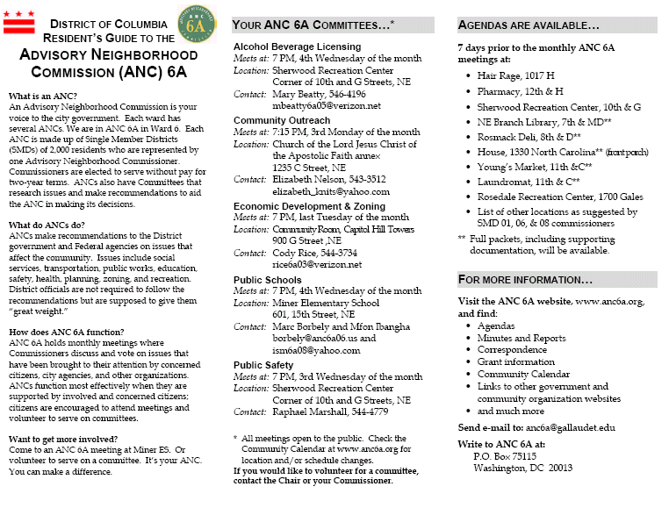

Draft of ANC Flyer (Page 2)

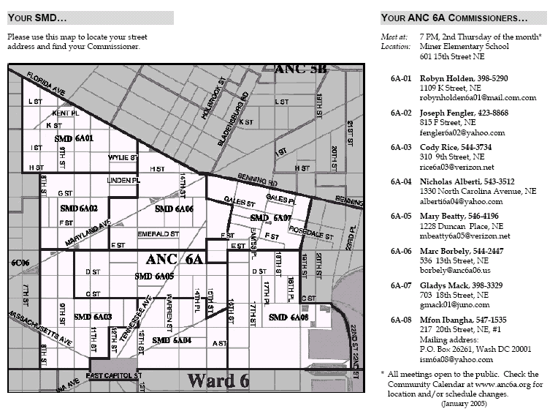

Recommendation as summarized by the Committee Chair:

That 10,000 copies of the flier (with whatever additional locations the commissioners identify) be printed at an estimated cost of $930.60, with copies to the individual commissioners as needed. Extras would be made available at all ANC meetings, including committee meetings. Commissioners would arrange to deliver the flier to their constituents in any way and time convenient to them.

REPORT OF THE
SCHOOLS COMMITTEE
January 26, 2005
Present

Commissioners: Marc Borbely (6A06), co-chair, and Mfon Ibangha (6A08), co-chair.
Residents: Mark Williams (6A04), Sam Manivong (6A04), Barbara Tierney (6A06), William Tierney (6A06), Mary Spencer (6A06), Brenda Artis (6A07) and Denise Cotten (6A07).
Guests: ANC Commissioners Mary C. Williams (6D), Lena A. Brown (6C) and Mark A. Dixon (6C).

I. Introductions

All introduced themselves and explained their interest in serving on the committee. Mr. Ibangha expressed the chairs’ desire that the committee should work to complement and offer support to already existing community efforts, including PTAs, and that the committee’s time should be spent seeking constructive solutions to problems in the public schools rather than assigning blame.

II. Mission

After a brief discussion, the committee unanimously adopted the following mission statement: “The purpose of this committee is to provide a forum where parents, teachers, students, administrators and the surrounding communities can become partners with the public schools in our neighborhood.”

III. Working Groups / Tasks

Ms. Artis and others identified the following area-wide concerns with regard to schools: attendance, supplies/textbooks, staffing, food service, facilities, excess space, programming, services to the community, equity, and the implementation of No Child Left Behind.

The committee discussed whether it should form issue-based or school-based working groups. The committee decided without objection to form school-based working groups initially, to give stakeholders at each school a chance to identify specific needs and make specific requests.

The following is the list of regular public schools whose attendance zones lie at least partially within ANC 6A and charter schools that are physically located in the ANC: Gibbs ES, Ludlow-Taylor ES, Maury ES, Miner ES, Peabody ES, Watkins ES, J.O. Wilson ES, Wheatley ES, Stuart-Hobson MS, Eliot JHS, Browne JHS, R.H. Terrell JHS, Eastern SHS, Dunbar SHS, Spingarn SHS, Two Rivers PCS, Options PCS, Sasha Bruce PCS, Friendship-Edison Junior Academy (Blow-Pierce Campus) PCS.

The co-chairs will write a letter of introduction that each working group can take to the various principals and PTA presidents. The working groups will ask the principals and PTA presidents to identify 1) some of the school’s major needs and 2) some of the opportunities available to community members interested in helping -- such as by mentoring, organizing clean-ups or donating supplies.

In reaching out to each school, each working group will also invite the school’s principal and PTA to make a presentation about the school to the committee. The presentation will be a chance to present some of the positive things happening at each school to the community, and for the community to ask questions about the school. Generally, there will be a specific focus on one school per meeting. The committee will pass out flyers announcing the meeting within the school’s attendance zone, within the ANC.

IV. Assignments and Committee Structure

The following assignments were made: Spingarn SHS (Mary Spencer); Eastern SHS (Mark Williams and Sam Manivong); Browne JHS (Mary Spencer); Stuart-Hobson Middle School (Denise Cotten); Watkins Elementary School (Denise Cotten); Peabody Elementary School (Denise Cotten); Miner Elementary School (Brenda Artis); Gibbs Elementary School (Marc Borbely); Two Rivers Public Charter School (Mark Williams and Sam Manivong).

Mr. Borbely asked if there were any objections to proceeding as an informal committee, with no members per se, and with all ANC 6A residents who are present at a meeting permitted to vote on proposed committee recommendations. Such a structure might encourage more people to participate. There were no objections.

V. Next Scheduled Schools Committee Meeting

The committee’s next meeting is scheduled for Wednesday, February 23, 2005, 7-9 p.m., at Miner Elementary School, 601 15th St. NE (15th and F NE). (For calendar year 2005, the committee will meet on the fourth Wednesday of every month, at the same time and in the same place.)

Ms. Artis will invite SHAPPE or DC Voice or both to make a presentation to the committee, in February.

Respectfully submitted by Mr. Borbely and Mr. Ibangha

Recommendations as summarized by the Committee Co-Chairs:

Recommendation: Affirm the following mission statement for the Schools Committee: "The purpose of this committee is to provide a forum where parents, teachers, students, administrators and the surrounding communities can become partners with the public schools serving our neighborhood.”

Recommendation: Affirm the initial tasks set by the Schools Committee at its January meeting: 1) to reach out to individual schools (principals, parents, teachers and students) and ask how the ANC can best support the school, with the committee's universe of schools including every public school (regular or charter) whose campus or attendance zones lie at least partially within the ANC's boundaries; 2) to invite a different school's stakeholders each month to a meeting to make a presentation about the school; and 3) to publicize that meeting within the ANC, within the school's boundaries.

Unfinished Business:

1. Discussion on 1341 Maryland Ave – Firehouse (Borbely)

Motion: The ANC requests that if the firehouse at 1341 Maryland Ave. NE is declared surplus property by the City Council, and if the Department of Housing and Community Development releases a Request for Proposals (RFP) to sell the site, then that RFP should include the following selection criteria:
  - Give strong preference to bids for mixed uses (housing and non-housing), serving broad segments of the surrounding community in a way that would appeal to more than a small segment of the population. Such uses are strongly supported by residents who live near the property. Such uses could include a resource center/library, a space where artists could live and work, a learning space for youth, a performance space, a computer center, a center offering activities to youth from the neighborhood, a place to showcase neighborhood history and culture, a bookstore, a coffee/tea shop or a movie theater. The ANC opposes any quasi-residential use such as a Community-Based Residential Facility.
  - Give strong preference to bidders who are able to show significant support from within the immediate neighborhood.
  - Give strong preference to bidders with a proven record of successful management of renovations involving asbestos, lead and other environmental hazards, unless such hazards are shown not to be present at the site, in which case such a preference is unnecessary.

This recommendation should not be interpreted as supporting or opposing DHCD's proposal to declare the property surplus. The ANC Zoning & Economic Development Committee will consider at its public meeting in January the question of whether or not the property should be declared surplus.

2. Approve Letter to DDOT asking for removal of morning and evening rush hour parking restrictions (Rice). Motion: To send a letter to DDOT asking for removal of morning and evening rush hour parking restrictions on H St NE, or identification of obstacles to implementing this recommendation.

Background:

From August 16, 2004 letter to Dan Tangherlini, Director of DDOT
"In particular, we note our support of the following major improvements to H Street, NE…removal of morning and evening rush hour parking restrictions to allow the bulb-outs/streetcar stops and increase retail opportunities."

From January 11, 2004 letter to DC Council:
"We commend the District Department of Transportation(DDOT) for its on-going planning efforts for infrastructure improvements for H Street, NE. We are pleased by the focus on creating a transit and pedestrian corridor with adequate parking for businesses and residents. . .In the short term, we strongly recommend that DDOT eliminate the rush hour parking restrictions on the corridor to improve the pedestrian environment and increase retail opportunities."

From June 12, 2003 letter to Andrew Altman, Director of Planning:
"We encourage you to work with District Department of Transportation (DDOT) regarding the H Street Transportation Study. Specifically, we have three recommendations: 1) Eliminate the rush hour parking restrictions on the corridor to improve the pedestrian environment and increase retail opportunities."
_______________________________________________________________________

New Business:

1) 1. Discussion of voluntary agreement for S&T Supermarket and Deli – 201 15th Street, NE (Alberti) — see subsequent pages.

3) Letter of concurrence for female ginko tree removal on 200 block of 12th Pl NE (Rice)

Background:

Residents of this block submitted a tree removal petition in Fall of 2003 in accordance with the requirements of the Urban Forestry Administration's Female Ginkgo Tree Removal Policy. After a long period of delay, the residents were informed that they additionally need a letter of concurrence from the ANC. This request is to remove a female ginko tree that litters the street every year with smelly, rotting fruit. It is not city policy to plant female ginko trees, but at the time these trees were planted, city arborists were unable to distinguish between the sexes of the trees. The specimen in question has been catalogued as in fair to poor condition by the Casey Trees Endowment's street tree inventory. A petition signed by 60% of homeowners (the threshold needed to be met per UFA's policy) was submitted to the ANC Commissioner, Cody Rice. The residents have requested replanting with a different species that provides more shade

Class “B” Liquor License Cooperative Agreement

Made the 6th day of Decemeber , 2004 , by and between

Assefa Areffine, (Class B Applicant)

T/A S&T Supermarket and Deli Inc.

201 15th St NE
Washington, DC 20002

and

Advisory Neighborhood Commission (ANC) 6A

and

Community Citizen Group

Preamble

Through this agreement, both parties aim to create an environment whereby the Applicant may operate as a viable contributing business to the ANC6a community, while concurrently curtailing any adverse effects a business such as the Applicant’s could have on the surrounding neighborhood.

Further, the Applicant agrees to work regularly with the ANC 6A, neighborhood associations, and residents to ensure the business operations do not adversely affect the surrounding neighborhood.

All parties believe the statements and provisions contained in this agreement are reasonable and must become wholly integrated into the day-to-day operation of the business establishment.

Witnesseth

Whereas, Applicant’s premises is within the boundaries of ANC 6A; and,

Whereas, the parties desire to enter into an agreement governing certain requirements and understandings regarding the issuance of a Retailer’s Class “B” Liquor License at the subject premises; and,

Whereas, the parties wish to state their mutual intention and commitment to promote the success, peace, order, and quiet of the community. Both parties recognize the importance of commercial districts (and limited commercial operations within residential districts) and their adjacent neighborhoods that are safe, clean, and “pedestrian friendly.”

The Parties Agree As Follows:

- Requirements for sale / provision of single containers of alcohol beverages

  - The Applicant shall not divide a manufacturer’s retail pack of more than one container of malt liquor to sell an individual container.
  - The Applicant shall not sell, give, offer, expose for sale or deliver an individual container of malt liquor i.e., a container not included as part a manufacturer’s retail package of more than one container.
  - The Applicant shall not sell a single individual container of beer or ale that has been displayed in a refrigerated case immediately prior to purchase.
  - The Applicant shall not sell, give, offer, expose for sale, or deliver an individual container of wine or fortified wine in a container with a capacity of less than 750 ml.

- Clear bags must be used for all purchases of sales of individual containers of beer, ale, malt liquor that are not packaged as part of a manufacturer’s retail package of more than one container.

- Ban on Sale/Provision of Other Items:
  - Single Cigarettes: Applicant shall not sell, give, offer, expose for sale, or deliver individual single cigarettes.
  - “Go-cups”:
    - Applicant shall not sell, give, offer, expose for sale, or deliver “go-cups” or servings of plain ice in a cup.
    - Per the Alcoholic Beverage regulations, a “go-cup” is defined as: “a drinking utensil provided at no charge or a nominal charge to a customer for the purpose of consuming alcoholic beverages off the premises of an establishment.”
  - Products associated with illegal drug activity:
    - Applicant agrees to not sell, give, offer, expose for sale, or deliver products associated with illegal drug activity.
    - These items are defined as: “cigarette rolling papers, pipes, needles, small bags, or any other items which may be regarded as drug paraphernalia.”

- Hours of Operation for Sales of Alcohol shall be restricted to the hours between 9 am and 10 pm.

- Public Space Cleanliness and Maintenance: The Applicant will maintain the public space (minimally the front sidewalk up to and including the gutter in front of the subject premises, and the alleyway behind the subject premises) adjacent to the establishment in a clean and litter-free condition by:

  - Picking up trash, including beverage bottles and cans, and all other trash a minimum of twice daily (immediately before business hours and once between 5:00 p.m. and 8:00 p.m.).
  - Exercising due diligence to prevent and/or rid vermin infestation in and around the establishment, including following, minimally, the recommendations and guidelines of the Vector Control Division of the Department of Public Works.
  - Planting, watering, and generally tending to tree boxes directly in front of the subject premises, if any.
  - Maintaining regular trash removal service. Ensure that the trash and dumpster area(s) remain clean.
  - Remove snow and/or ice from sidewalks fronting (includes sidewalks on the sides of corner buildings) within time limits set by the District of Columbia for such snow and/or ice removal.
  - Promptly removing graffiti written on the exterior walls of the property. Promptly is defined as within two (2) weeks of graffiti’s appearance.

- Signage / Loitering / Illegal Activity:
  - The Applicant will not directly or indirectly, sell or deliver alcohol to any intoxicated person or to any person who appears to be intoxicated.

  - The Applicant shall post a notice kept in good repair and visible from point of entry a sign, which states:
    - The minimum age requirement for purchase of alcohol,
    - The obligation of the patron to produce a valid identification document in order to purchase alcohol.

  - The Applicant shall make every effort to prohibit and prevent loitering and criminal activity on or in front of the establishment, to include:
    - Posting a sign kept in good repair in a highly visible location requesting customers not to contribute to panhandlers.
    - Posting a sign kept in good repair in a highly visible location announcing ‘No Loitering’.
    - Asking loiterers to move on whenever they are observed outside the establishment.
    - Calling the Metropolitan Police Department (MPD) to remove loiterers if they refuse Applicant’s request to move on.
    - Calling the Metropolitan Police Department if illegal activity is observed or when loiters refuse to leave from private property,.
    - Keeping a log (i.e. a written record of dates and times ) of when the MPD was called for assistance.

  - The Applicant agrees that the total signage for alcohol and tobacco products in the front window(s) shall be limited to 25% of the total window area.

  - The Applicant shall receive, at their request, and at no cost, a sign to post within their establishment (provided by the ANC6A ABL Committee) that outlines the primary points of this agreement

- Reporting to ANC 6A: The Applicant must appear before the ANC 6A Alcohol Beverage Licensing Committee upon request of the ANC to discuss issues and concerns related to the prior operations or the impending renewal of their license. The request must be made by the ANC in writing and delivered at least ten calendar days prior to the date of the public meeting.

- Regulations: In addition to the requirements of this agreement, the Applicant will operate in compliance with all applicable laws and regulations.

- Miscellaneous:
  - The Applicant shall deny support of the installation of pay phones around the establishment (externally). The Applicant shall have existing pay phones (if any) removed from the exterior of the establishment at the end of the current contract.
  - A person with an ABC Board certified manager’s license shall be present during all hours of operation.
  - The Applicant will comply with the DC Government Clean Hands Act regulations.

- Enforcement:
  - If any party hereto believes in good faith that the Applicant is in violation of this agreement, written notice specifying the alleged violation shall be delivered to the Applicant by Certified mail and the Applicant shall have ten (10) days after receipt of such written notice to come into compliance with this agreement or respond to said alleged notice of default.
  - The Applicant and the ANC 6A Commission agree to enter into this agreement. If the Applicant should breach the conditions of this agreement, and notice of the violation(s) has been made as prescribed in paragraph 10.A above, it is understood by all parties that the ANC 6A, or others parties with standing to file a protest may immediately petition the ABC Board for a “show cause” hearing pursuant to Title 25 of the DC Enactment and Related Amendments Act of 2001, Section 25-446.
  - This cooperative agreement is binding on the Applicant and will continue in force for all subsequent renewals of the license and for any and all subsequent Applicants operating at this location.
  - The term of this Agreement shall not be altered unless changes are agreed to by all parties or such change is required by the District of Columbia government or by rule of law.

In Witness Whereof

The parties have affixed hereto their hands and seals.

Applicant:

By: _________________________________________________________________
Date: ________________________________________________________________
Signature: ____________________________________________________________

Advisory Neighbor Commission 6A Single Member District 04 Representative:

By: _________________________________________________________________
Date: ________________________________________________________________
Signature: ____________________________________________________________

Community Citizen Group Representative:

By: _________________________________________________________________
Date: ________________________________________________________________
Signature: ____________________________________________________________

Advisory Neighbor Commission 6A Representative:

By: _________________________________________________________________
Date: ________________________________________________________________
Signature: ____________________________________________________________

